BRANDY CLARK PERFORMS “WHO YOU THOUGHT I WAS” ON “THE KELLY CLARKSON SHOW”

ACCLAIMED NEW ALBUM YOUR LIFE IS A RECORD OUT NOW
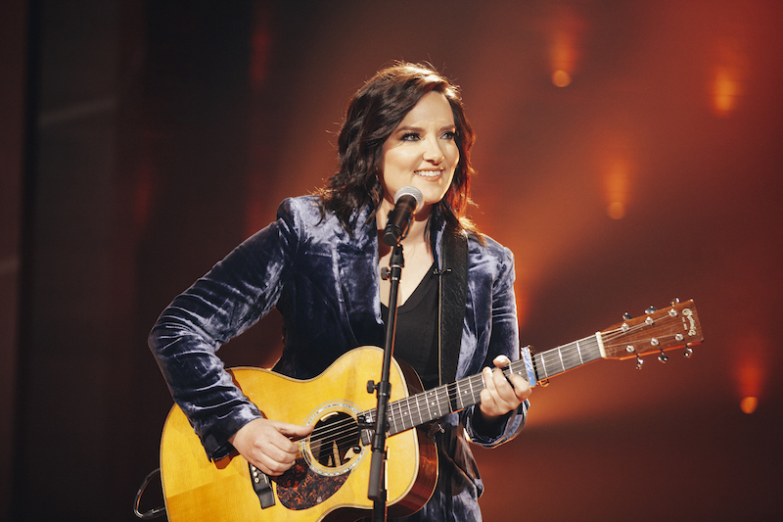
November 16, 2020 (Los Angeles, CA) — Grammy-nominated and CMA Award-winning singer, songwriter and musician Brandy Clark performed her song, “Who You Thought I Was,” this past Friday on “The Kelly Clarkson Show.” Watch/share HERE.
The performance continues a breakthrough year for Clark, who, most recently, released two new collaborations with Brandi Carlile this fall—“Like Mine” and “Same Devil.” Both produced by Carlile, the songs were recorded while working from the artists’ respective quarantines and were released to critical acclaim. Of “Same Devil,” Entertainment Weekly declares, “this haunting, acoustic ballad that conjures both dark alleys and spectral hollers as it addresses the sins and salvations that unite us, more than honors the promise of the great Brandi/y summit of 2020,” while Variety praises, “a harmonic convergence of names and voices that features the billing we might have thought possible only in fiction.”
Additionally, Clark wrote “A Beautiful Noise”—a new duet performed by Alicia Keys and Carlile—along with an all-female team of musicians including Keys, Carlile, Ruby Amanfu, Hillary Lindsey, Lori McKenna, Linda Perry and Hailey Whitters, while her new song, “Only Time of Year,” is featured on the soundtrack of Hulu’s new Christmas movie, “Happiest Season.”
The new releases follow Clark’s critically acclaimed album, Your Life is a Record, which is out now on Warner Records (stream/purchase here). Produced by Jay Joyce, the album consists of eleven new tracks including “Who You Thought I Was” and “Bigger Boat” featuring Randy Newman, of which Music Row declares, “It’s wry, jaunty and sideways philosophical. Newman’s drawl is as personality-packed as usual, and Clark’s laid-back, winking delivery is a sheer delight. It fills my heart with joy that this woman makes music. She’s a genius. That’s all.” Watch/share the official music video here.
Recent critical acclaim for Your Life is a Record…
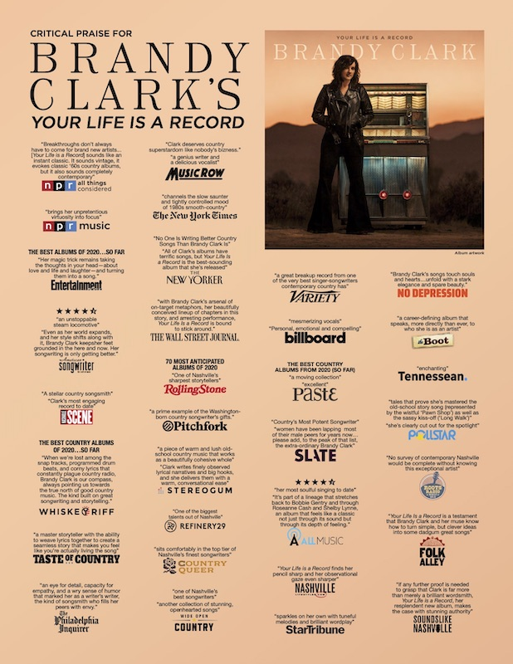
Created after the dissolution of a long-term relationship, the album features Clark’s most personal songwriting to date and was recorded largely as an intimate acoustic four-piece—featuring Clark, Joyce, Giles Reaves and Jedd Hughes—with subsequent Memphis strings and horns layered in with arrangements by Lester Snell.
In celebration of the release, Clark will embark on her extensive “Who You Thought I Was Tour” next year including stops at Nashville’s 3rd & Lindsley, Atlanta’s Smith’s Olde Bar, New York’s Bowery Ballroom, Boston’s Brighton Music Hall, Philadelphia’s Boot & Saddle, Denver’s Globe Hall, Seattle’s Neumos, Los Angeles’ Lodge Room and Austin’s The Parish among many others. See below for complete itinerary. Tickets for the tour can be purchased at www.brandyclarkmusic.com/tour.
A six-time Grammy nominee and CMA Awards “Song of the Year” recipient, Clark is one of her generation’s most respected and celebrated songwriters and musicians. Her songs include Kacey Musgraves’ “Follow Your Arrow,” Miranda Lambert’s “Mama’s Broken Heart,” The Band Perry’s “Better Dig Two” and Hailey Whitter’s “Ten Year Town,” which was just named #2 on Rolling Stone’s “25 Best Country and Americana Songs of 2019” round up. Her two solo albums—2013’s 12 Stories and 2016’s Big Day in a Small Town—each garnered immense critical acclaim landing on “Best of the Year” lists at New York Magazine, Billboard, NPR Music Entertainment Weekly, Rolling Stone, Stereogum, etc. NPR Music’s Ann Powers calls her, “a storyteller of the highest caliber,” while Rolling Stone’s Will Hermes declares, “a country visionary…the consolation of a beautiful voice delivering a well-built song, cold truth rising from it like fog off dry ice.”

YOUR LIFE IS A RECORD TRACK LIST
1. I’ll Be the Sad Song
2. Long Walk
3. Love is a Fire
4. Pawn Shop
5. Who You Thought I Was
6. Apologies
7. Bigger Boat (feat. Randy Newman)
8. Bad Car
9. Who Broke Whose Heart
10. Can We Be Strangers
11. The Past is the Past
BRANDY CLARK CONFIRMED TOUR DATES
March 21, 2021—Nashville, TN—3rd & Lindsley
March 25, 2021—Birmingham, AL—Saturn
March 26, 2021—Atlanta, GA—Smith’s Olde Bar
March 27, 2021—Charlotte, NC—McGlohon
March 30, 2021—New York, NY—Bowery Ballroom
March 31, 2021—Boston, MA—Brighton Music Hall
April 2, 2021—Philadelphia, PA—Boot & Saddle
April 3, 2021—Alexandria, VA—Birchmere
April 5, 2021—Pittsburgh, PA—The Rex
April 6, 2021—Cleveland, OH—Beachland Ballroom
April 7, 2021—Ann Arbor, MI—The Ark
April 9, 2021—Louisville, KY—Headliners
April 10, 2021—Chicago, IL—The Space
April 12, 2021—Madison, WI—Majestic Theatre
April 13, 2021—Minneapolis, MN—Fine Line
April 15, 2021—Des Moines, IA—Wooly’s
April 16, 2021—Omaha, NE—The Waiting Room
April 17, 2021—Kansas City, MO—Saloon @ Knuckleheads
April 19, 2021—Denver, CO—Globe Hall
April 21, 2021—Salt Lake City, UT—The State Room
April 23, 2021—Seattle, WA—Neumos
April 24, 2021—Portland, OR—Alberta Rose Theatre
April 26, 2021—San Francisco, CA—Great American Music Hall
April 28, 2021—Los Angeles, CA—Lodge Room
April 29, 2021—Phoenix, AZ—Musical Instrument Museum
May 3, 2021—Houston, TX—White Oak Muisc Hall
May 4, 2021—Austin, TX—The Parish
May 6, 2021—Oklahoma City, OK—Tower Theatre
May 7, 2021—St. Louis, MO—Off Broadway

www.brandyclarkmusic.com

