

**SCOTTISH ALT-ROCK GIANTS BIFFY CLYRO RETURN WITH**

**BRAND NEW SINGLE “INSTANT HISTORY” – LISTEN** [**HERE**](https://biffyclyro.co/instanthistory)

**NEW ALBUM COMING LATER THIS YEAR**

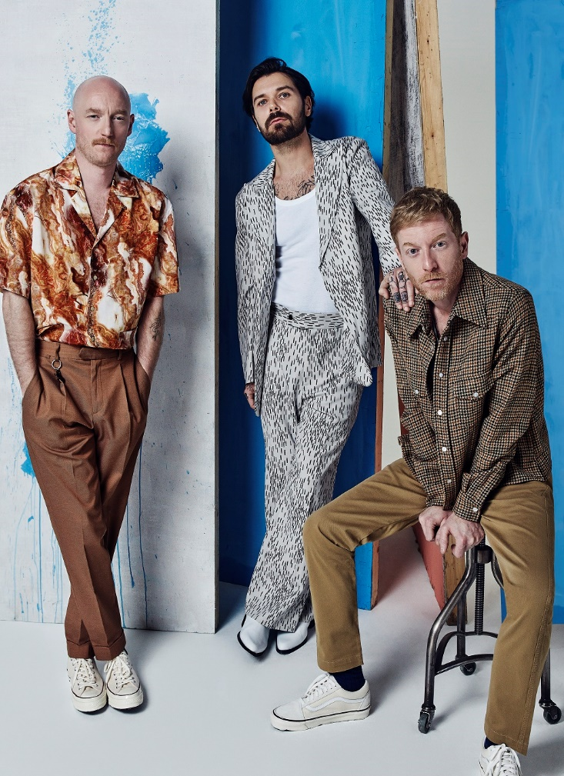

**February 20, 2020 (Los Angeles, CA) –** The U.K.’s alt-rock giants **Biffy Clyro** make a sensational return today with their new single **“Instant History,”** which is the first track to preview their forthcoming eighth studio album. Produced by the **GRAMMY**-winning **Rich** **Costey** (**Foo** **Fighters**, **Muse**, **The** **Killers**), **“Instant History”** is a striking statement of intent from “Britain’s best band” (*Kerrang!*). Always pushing the boundaries of their sound, the single captures Biffy Clyro’s collision course of melody, aggression and skyscraper hooks. “**’Instant History’** is the biggest, most slammest pop moment we’ve ever worked on,” enthuses frontman **Simon Neil**. “And thematically it’s a good pointer for what the album is about: learning from mistakes and realizing how you can move things forward. Things can be similar although they’ll never be the same, but let’s not be scared of that.”

**Listen to “Instant History”** [**HERE**](https://biffyclyro.co/instanthistory) – **“Instant History” video [HERE](https://youtu.be/WD-BGzENgDQ)**

The new album finds **Biffy Clyro** – completed by the **Johnston** brothers **James** (bass) and **Ben** (drums) – pushing everything they do best to the next level. They’ve excelled at delivering some of the most captivating choruses of their career alongside explosions of sheer visceral intensity and some stirring, evocative orchestration. That eclectic quality keeps things thrillingly unpredictable, especially as those traits often all emerge in the course of a single track.

**Biffy Clyro** have emerged from their independent beginnings to become **Britain’s** premier rock band. Their two most recent albums ***Ellipsis*** (2016) and ***Opposites*** (2013) both shot straight to **#1** in the U.K. charts with **2 Million+** copies sold, and the band boasts more than **750 Million streams** worldwide to date. The success of their huge-selling, critically-acclaimed albums is matched by the scale of their live show. In the U.S. they’ve toured arenas with the likes of **Foo Fighters** and **Muse**, in addition to sold-out headline runs, while overseas they’ve headlined leading festivals including **Reading and Leeds, Download** and **TRNSMT**, and this year will play **Radio 1’s Big Weekend** in **Dundee** in **May.** They’re part of an all-star bill that currently also features **Calvin** **Harris**, **Camilla** **Cabello**, **Dua** **Lipa** and **Harry** **Styles**. Continually supported by the press, Biffy Clyro have also won a wide range of major awards. These include four **NME Awards** (2 x **Best** **British** **Band**, **Best** **Live** **Band** and **Best** **Music** **Video**); four **Kerrang! Awards** (**Best British Band**, **Classic** **Songwriter**, **Best** **Album** and **Best** **Music** **Video**); and three **Q Awards** (**Best Live Band**, **Best** **Album** and the **Fender** **Play** **Award**). They’ve also been nominated for two **BRIT** **Awards** (both for **Best** **British** **Group**) and a **Mercury** **Prize**.

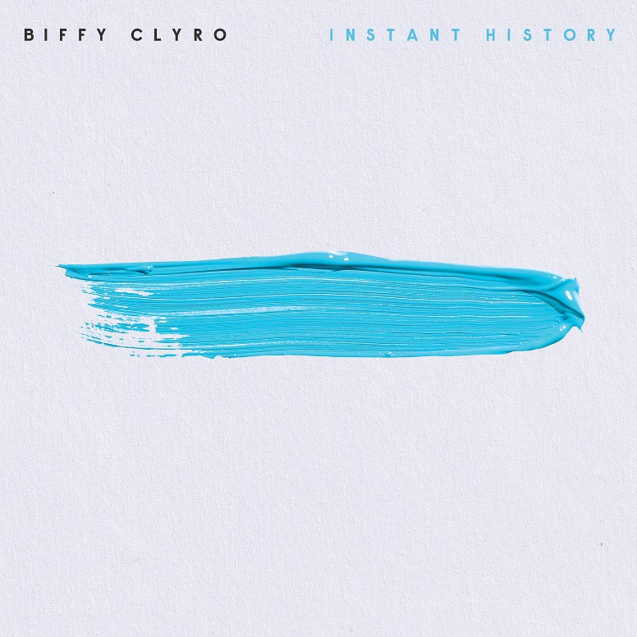

###

**For further information please contact Warner Records Publicity:**

Ceri Roberts | (212) 707-2259

[Ceri.Roberts@warnerrecords.com](mailto:Ceri.Roberts@warnerrecords.com)

**Follow Biffy Clyro:**

[**Official website**](http://www.biffyclyro.com/)**|** [**Facebook**](https://www.facebook.com/biffyclyro) **|** [**Twitter**](https://twitter.com/biffyclyro) **|** [**Instagram**](https://www.instagram.com/biffy_clyro/) **|** [**YouTube**](https://www.youtube.com/user/biffyclyro)

**cid:image004.jpg@01D5E66A.9F2C7370**