

**SCOTTISH ALT-ROCK GIANTS BIFFY CLYRO SHARE NEW TRACK**

**“WEIRD LEISURE” –** [**LISTEN HERE**](https://biffyclyro.co/WeirdLeisure)

**NEW ALBUM *A CELEBRATION OF ENDINGS* ARRIVES AUGUST 14**

**EXCLUSIVE LIVESTREAM CONCERT JUST ANNOUNCED FOR AUGUST 15**

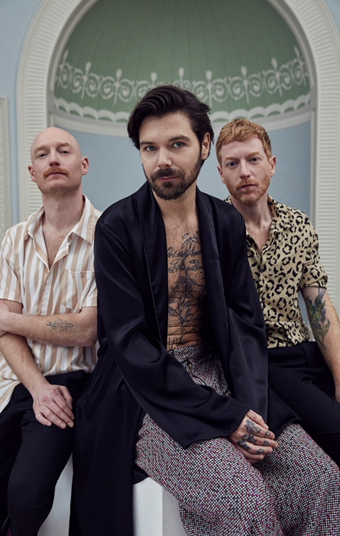

**July 31, 2020 (Los Angeles, CA) –** U.K. alt-rock giants Biffy Clyro share new track “Weird Leisure,” the latest from their highly-anticipated eighth studio album *A Celebration of Endings*, coming August 14 on Warner Records. The new 11-track album features explosive lead single “[Instant History](https://biffyclyro.co/instanthistory)” – which is currently in the Top 20 at U.S. Rock radio – as well as recently-released tracks “Tiny Indoor Fireworks” and “End Of.”

To celebrate the upcoming release, Biffy Clyro have announced an ambitious one-off, worldwide livestream performance at an iconic Glasgow venue on Saturday, August 15th at 6pm PT/9pm ET. The trio will perform the new album in its entirety for the very first time, along with a selection of their top hits, across different spaces within the venue to create a unique, fully plugged-in live set. The show will be streamed globally via YouTube, with tickets and album bundles available now at [biffyclyro.com/livestream](https://shops.ticketmasterpartners.com/biffy-clyro-livestream).

For more information on Biffy Clyro, [click here](https://press.warnerrecords.com/biffyclyro/).

###

**For further information, please contact:**

Ceri Roberts / [Ceri.Roberts@warnerrecords.com](mailto:Ceri.Roberts@warnerrecords.com)

**Follow Biffy Clyro:**

[**Official website**](http://www.biffyclyro.com/)**|** [**Facebook**](https://www.facebook.com/biffyclyro) **|** [**Twitter**](https://twitter.com/biffyclyro) **|** [**Instagram**](https://www.instagram.com/biffy_clyro/) **|** [**YouTube**](https://www.youtube.com/user/biffyclyro)

**cid:image004.jpg@01D5E66A.9F2C7370**