ERIC CLAPTON & B.B. KING RIDING WITH THE KING
20TH ANNIVERSARY EDITION AVAILABLE NOW VIA REPRISE RECORDS

LEGENDARY 2000 ALBUM NOW EXPANDED TO INCLUDE TWO PREVIOUSLY UNRELEASED TRACKS AND REMASTERED AUDIO

Previously Unreleased “Let Me Love You” Visual Here

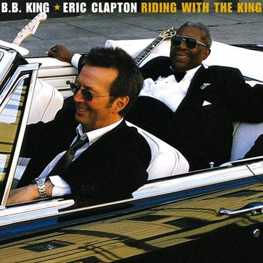
(Click here for hi-res artwork)

June 26, 2020 (Los Angeles, CA) – Eric Clapton and B.B. King first performed together in NYC in 1967. Over 30 years later, in 1999, the two longtime friends joined forces to create a collection of all new studio recordings of blues classics and contemporary songs. The resulting album Riding with the King would be released in June 2000 and go onto sell over 2 million copies in the U.S. and win the GRAMMY Award® for Best Traditional Blues Album.

To celebrate the 20th anniversary of this classic album, two additional previously unreleased tracks have been added: The blues standard “Rollin’ and Tumblin” and B.B. King’s “Let Me Love You.” Both tracks were recorded during the original sessions and were produced and mixed especially for this release by Simon Climie, who produced the original album with Clapton. The original tapes have been remastered by Bob Ludwig and is finally available again now in expanded form via Reprise Records.

Click here to view/share the visualizer for “Let Me Love You.”
Click here for “Rolling’ and Tumblin.”

The 14-track collection will be available in all formats including a 180-gram black double vinyl package. A limited edition 180-gram blue vinyl double LP set will available exclusively in Eric Clapton’s official online store and at indie retailers. The vinyl was mastered by Chris Bellman at Bernie Grundman Mastering in Los Angeles. Click here to order black vinyl, and here for limited edition blue vinyl.

The original album features four B.B. King originals, plus a selection of covers from writers as diverse as Isaac Hayes & David Porter (“Hold On I’m Coming”), Johnny Mercer & Harold Arlen (“Come Rain Or Come Shine”) and William Broonzy & Charles Seger (“Key To The Highway”). John Hiatt wrote the album’s title track.

The album features an all-star line-up of musicians, including: Andy Fairweather Low, Steve Gadd, Nathan East, Joe Sample, Doyle Bramhall II, Susannah and Wendy Melvoin, and Jim Keltner. The celebrated producer and arranger Arif Mardin contributed string arrangements and orchestration to two tracks.

Riding With The King Track Listing:
1. Riding with the King
2. Ten Long Years
3. Key To The Highway
4. Marry You
5. Three O’Clock Blues
6. Help The Poor
7. I Wanna Be
8. Worried Life Blues
9. Days of Old
10. When My Heart Beats Like A Hammer
11. Hold On I’m Coming
12. Come Rain Or Come Shine

20th Anniversary Bonus Tracks:
13. Rollin’ and Tumblin’
14. Let Me Love You
# # #
For further information, contact Rick Gershon at Warner/Reprise Records:
818-953-3473 / rick.gershon@warnerrecords.com

Follow Eric Clapton:
Official | Twitter

