ERIC CLAPTON & B.B. KING RIDING WITH THE KING
20TH ANNIVERSARY EDITION SET FOR JUNE 26TH RELEASE
VIA REPRISE RECORDS

LEGENDARY ALBUM FROM 2000 NOW EXPANDED TO INCLUDE TWO PREVIOULSY UNRELEASED TRACKS AND REMASTERED AUDIO

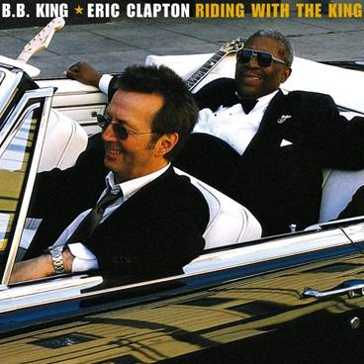
(Click here for hi-res artwork)

May 22, 2020 (Los Angeles, CA) – Two guitar legends - Eric Clapton and B.B. King - first performed together in NYC in 1967. Over 30 years later, in 1999, the two longtime friends joined forces to create a collection of all new studio recordings of blues classics and contemporary songs. The resulting album Riding with the King would be released in June 2000 and go onto sell over 2 million copies in the U.S. and win the 2000 Grammy Award © for Best Traditional Blues Album.

To celebrate the 20th anniversary of this classic album, two additional previously unreleased tracks have been added: The blues standard “Rollin’ and Tumblin’” and B.B. King’s “Let Me Love You.” Both tracks were recorded during the original sessions and were produced and mixed especially for this release by Simon Climie, who produced the original album with Clapton. The original tapes have been remastered by Bob Ludwig for release on June 26th via Reprise Records.

The 14-track collection will be available in all formats including a 180-gram black double vinyl package. A limited edition 180-gram blue vinyl double LP set will available exclusively in Eric Clapton’s official online store and at indie retailers. The vinyl was mastered by Chris Bellman at Bernie Grundman Mastering in Los Angeles. Pre-order the album now and receive an instant download of album track “Rollin’ and Tumblin.’” Click here to pre-order black vinyl, and here for blue vinyl. Click here to view and share the visualizer.

The original album features four B.B. King originals, plus a selection of covers from writers as diverse as Isaac Hayes & David Porter (“Hold On I’m Coming”), Johnny Mercer & Harold Arlen (“Come Rain Or Come Shine”) and William Broonzy & Charles Seger (“Key To The Highway”). John Hiatt wrote the album’s title track.

The album features an all-star line-up of musicians, including: Andy Fairweather Low, Steve Gadd, Nathan East, Joe Sample, Doyle Bramhall II, Susannah and Wendy Melvoin, and Jim Keltner. The celebrated producer and arranger Arif Mardin contributed string arrangements and orchestration to two tracks.

Riding With The King Track Listing:
1. Riding with the King
2. Ten Long Years
3. Key To The Highway
4. Marry You
5. Three O’Clock Blues
6. Help The Poor
7. I Wanna Be
8. Worried Life Blues
9. Days of Old
10. When My Heart Beats Like A Hammer
11. Hold On I’m Coming
12. Come Rain Or Come Shine

20th Anniversary Bonus Tracks:
13. Rollin’ and Tumblin’
14. Let Me Love You

# # #
For further information, contact Rick Gershon at Warner/Reprise Records:
818-953-3473 / rick.gershon@warnerrecords.com

Follow Eric Clapton:
Official | Twitter

