CAVETOWN RELEASES NEW SINGLE
“GROCERY STORE”

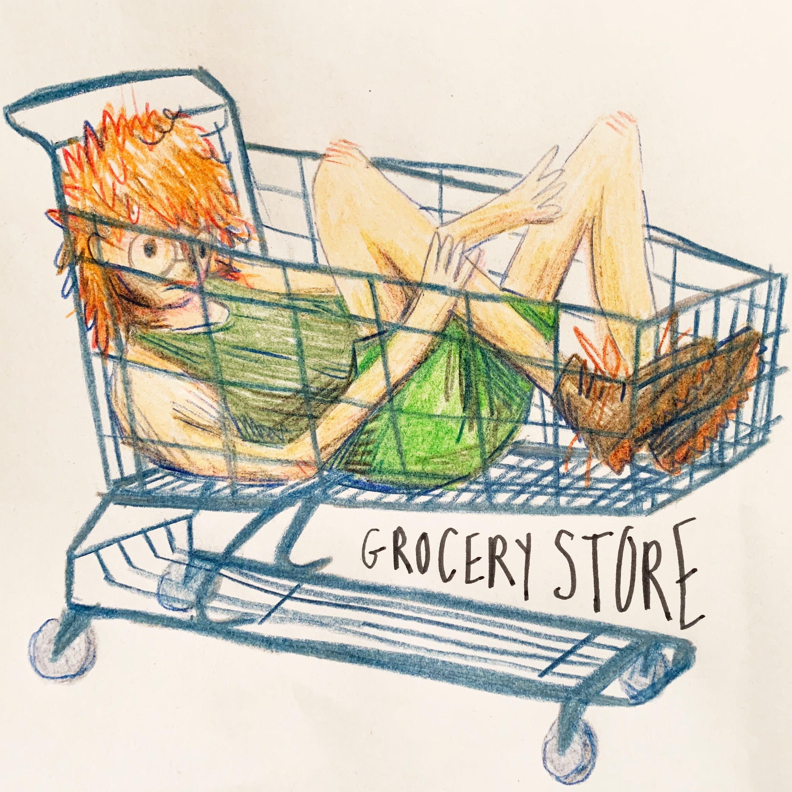
WATCH THE VISUAL HERE

Download Artwork HERE

Los Angeles, CA (July 15th, 2022) - Acclaimed singer/songwriter and producer Cavetown, also known as Robin Skinner, has released a new summer single, along with a video for song “Grocery Store” available everywhere now via Sire Records.

CLICK HERE TO LISTEN TO “GROCERY STORE”
CLICK HERE TO WATCH THE “GROCERY STORE” MUSIC VIDEO

In the new single, Robin touches on hiding in plain sight while using the grocery store as his backdrop. After writing the song, Robin initially tucked it away before sharing it with Kina Beats who put his own spin on it. The pair released “Trying Not To Cry” in 2021 and fans quickly began requesting for Robin’s own version.

On the process behind the new single, Robin shares, “Grocery Store” took a few different forms before landing where it is now. The lyrics started to come together when I was struggling with my mental health and had to go to the shop to pick up a few things. It's always so difficult being in a public space when you're feeling really awful. At first, I wasn't super inspired by what I was writing until I worked with Kina Beats. That version of the song helped me feel inspired again, so I picked the idea back up and created “Grocery Store.”

Ingredients are poured out in the new animated visual, symbolizing both the chaos and emptiness encapsulated in the lyrics of “Grocery Store.” Robin is also the creator behind the song’s cover artwork.

“Grocery Store” follows Robin’s previous release “Fall In Love With A Girl” with beabadoobee, which was featured in Billboard’s “The 25 Best Pride Songs of 2022 (So Far).” Following his tour date with Bleachers at the legendary Kia Forum in Los Angeles, CA last month, Cavetown will return to the road for a headlining EU/UK tour this Fall. The highly-anticipated run includes a sold-out show at the Eventim Apollo in London on November 5th. See full tour dates HERE.

Stay tuned for more from Cavetown soon!

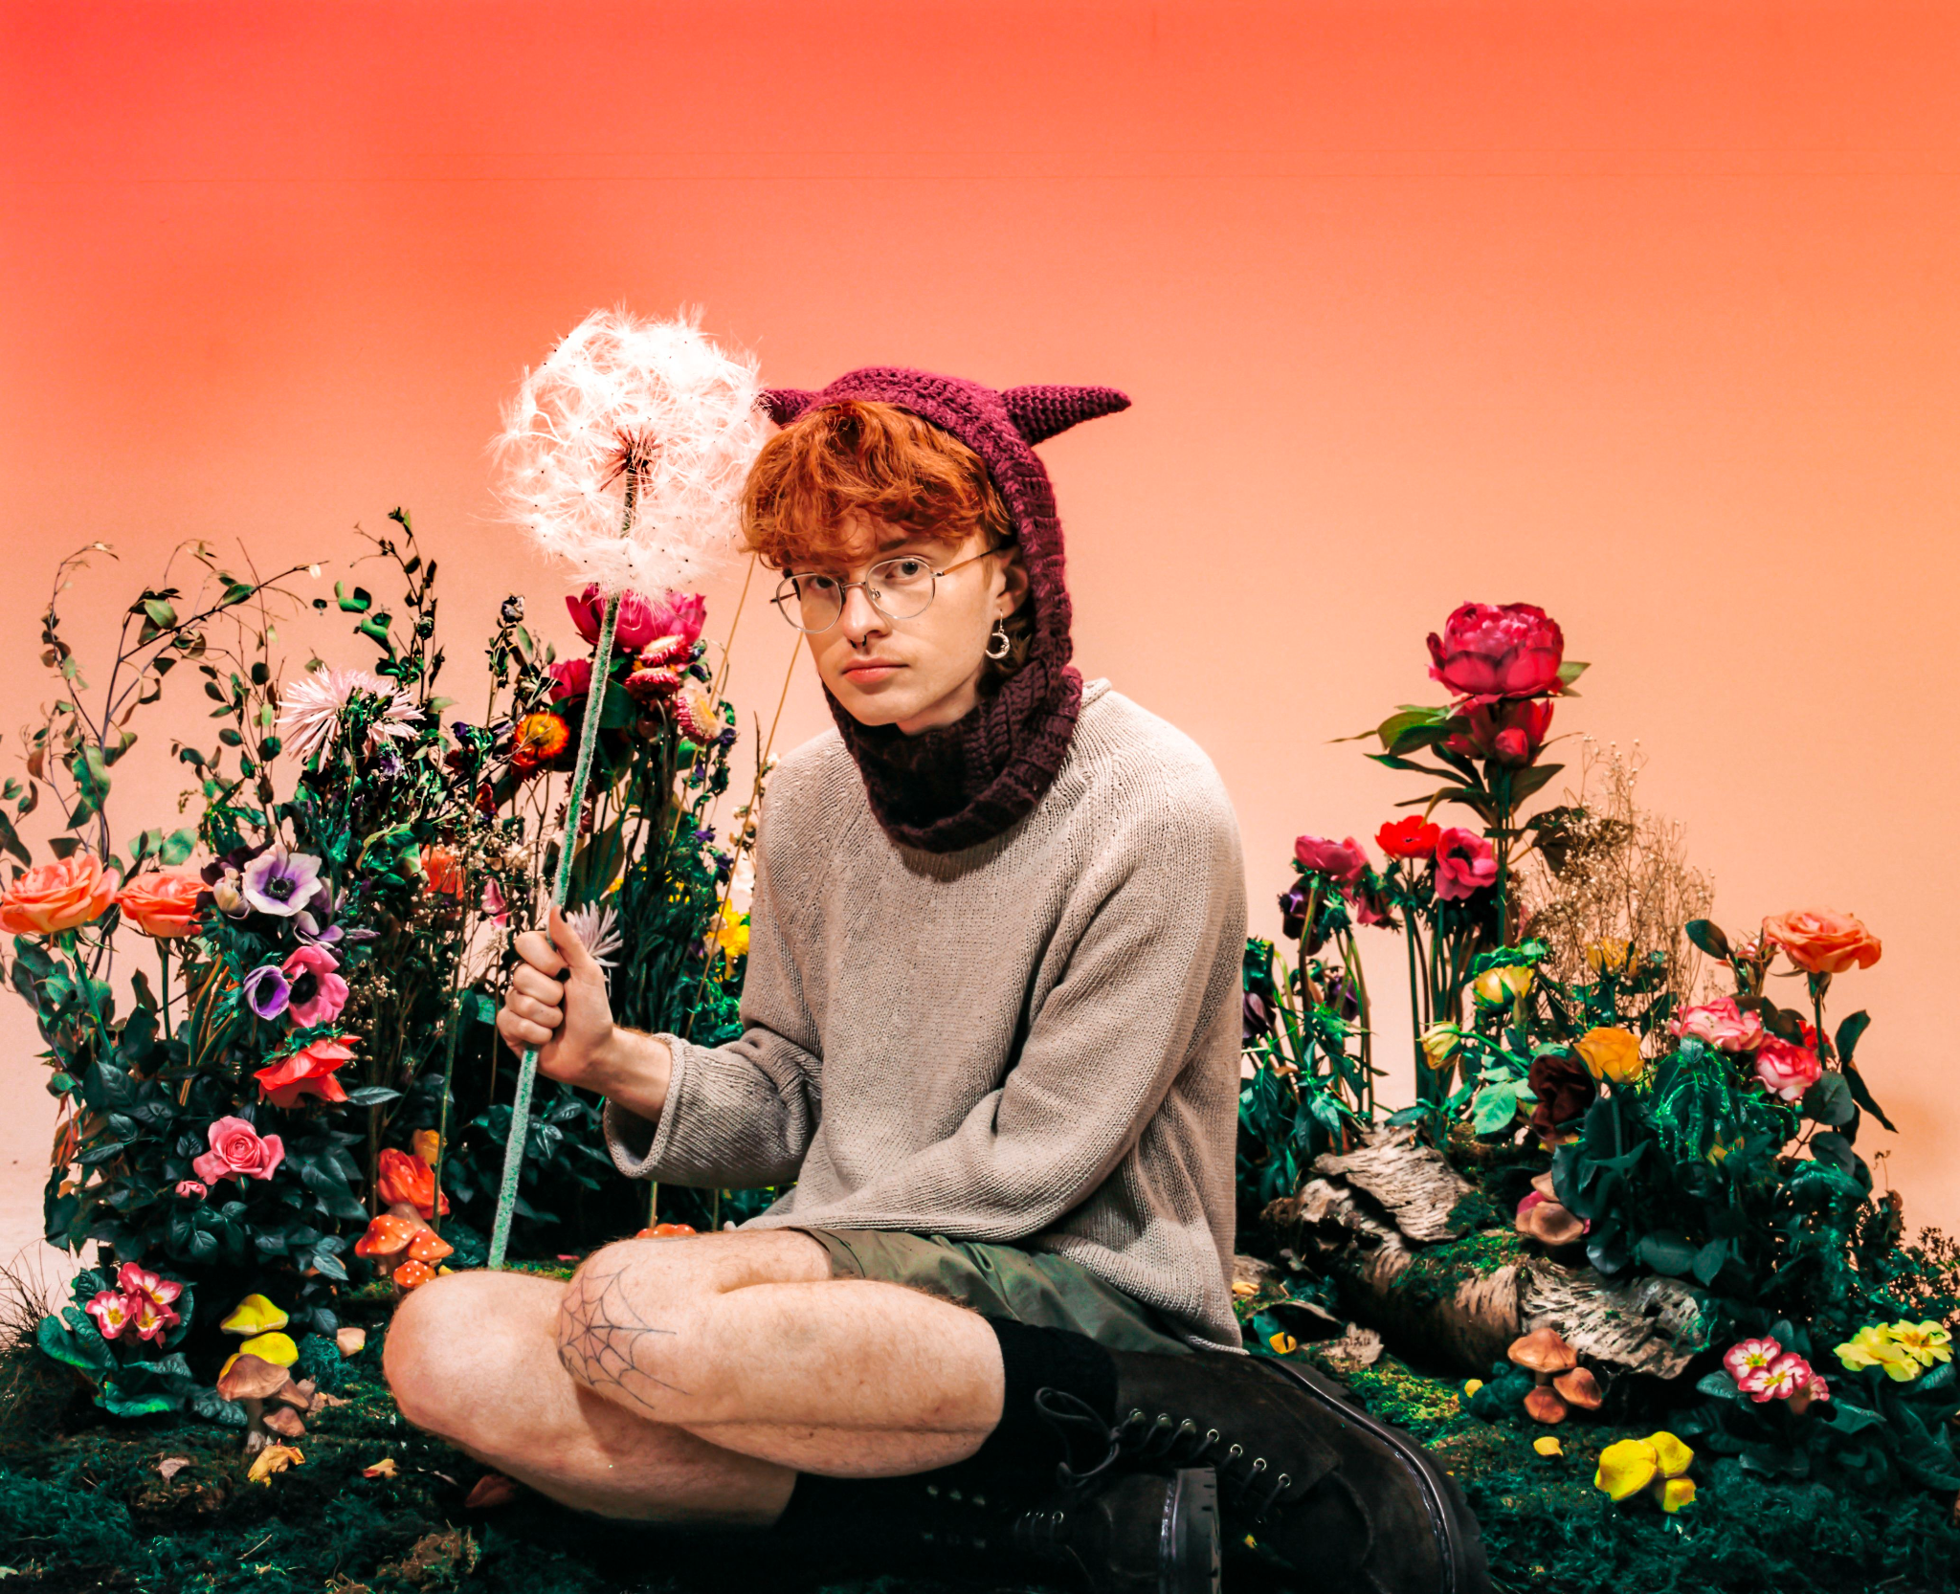
Download Press Photo HERE | Photo Credit: Amir Hoissain

ABOUT CAVETOWN:
Since the age of 14, Cavetown has created self-produced songs both intensely diaristic and touched with offbeat imagination. Now 23, the Cambridge-based artist, otherwise known as Robin Skinner, has emerged as one of the preeminent voices in the DIY bedroom pop scene, with more than 1 billion global streams to date, including nearly 8 million monthly Spotify listeners and over 2 million YouTube subscribers. He did so without a viral hit or easy gimmicks, but rather pure heart, filling his YouTube channel and Bandcamp with a mix of covers and original music he wrote and self-recorded in his bedroom. With the release of his 2018 breakthrough album Lemon Boy, Skinner’s unassuming yet captivating personality took the internet by storm, catapulting him become a go-to collaborator for bedroom pop mainstays mxmtoon, Chloe Moriondo, and Tessa Violet, plus selling out major venues across the U.S. and U.K. as well as taking the stage at leading festivals like Lollapalooza and Reading & Leeds. In 2020, he unveiled his major label debut album, SLEEPYHEAD, followed by his most critically-acclaimed EP to date, Man’s Best Friend, which earned global praise from the likes of The New York Times, The FADER, Rolling Stone, Billboard, CLASH Magazine, and many more upon its release earlier this year.

FOLLOW CAVETOWN:
Press Assets | Website | Facebook | Twitter | Instagram | YouTube

Cavetown US Press Contacts:
Chloe Walsh
chloe@theoriel.co
Amy Fennie
amy@theoriel.co

