DEFTONES LAUNCH ADOPT-A-DOT FOR CHARITY

CHARITABLE CAMPAIGN FOR UC DAVIS CHILDREN’S HOSPITAL AND CREW NATION

DONATE HERE

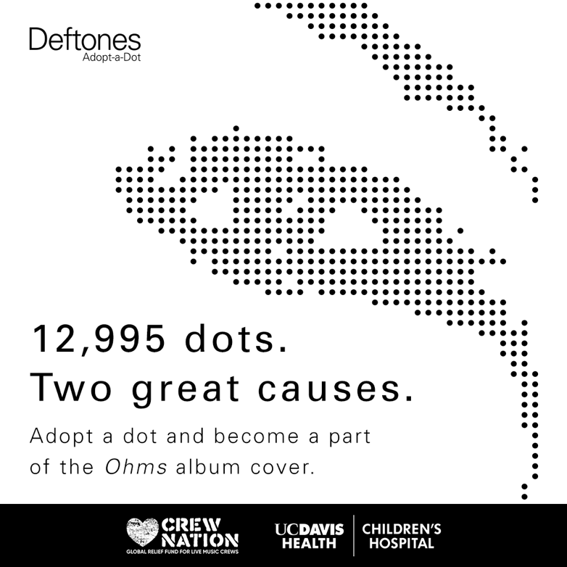

September 22, 2020 (Los Angeles, CA) - Grammy Award-winning band Deftones have launched a philanthropic campaign called ‘Adopt-a-Dot’ where fans can make a charitable donation for one, or multiple dots from the thousands of pixelated dots that comprise the cover-art created by Frank Maddocks of their forthcoming album Ohms. All proceeds to benefit the UC Davis Children’s Hospital and Live Nation’s ‘Crew Nation,’ a global relief fund for live music crews who have been impacted by COVID19. Donations can be made at Deftones.com/Adopt. There are 12,995 dots available, once a donator adopts their dot(s), they have the ability to upload their photo to the site and be a part of the album cover for these two special causes. Ohms is set for release this coming Friday, September 25th via Warner Records / Reprise.

Adopt a Dot comes on the heels of Deftones’ recently released song and video last week Friday “Genesis” and follows the previous video for the title track to the forthcoming album “Ohms.”

ABOUT THE ART:
"’Ohms’ album art is an iconic rendering of a suspended, chance moment in time. As with Deftones music and lyrics, the definitive meaning of the imagery invites and relies on interpretation from the viewer. From a dreamy gaze above, to sadness, hope, despair, optimism and a longing for connection, the emotions conveyed are endless and infinitely evolving." - Frank Maddocks Creative Director, Deftones

ABOUT UC DAVIS CHILDREN'S HOSPITAL:
UC Davis Children’s Hospital is the Sacramento region’s only nationally ranked, comprehensive hospital for children, offering children and their families the highest level of care for virtually every pediatric condition.

ABOUT CREW NATION:
Live music inspires millions around the world, but the concerts we all enjoy wouldn’t be possible without the countless crew members working behind the scenes. As COVID-19 puts concerts on pause, we want to extend a helping hand to the touring and venue crews who depend on shows to make a living.

DOWNLOAD HI RES ARTWORK HERE

﻿Follow Deftones:
Official | Instagram | Twitter | YouTube | Press Materials

For more information, please contact:
Yash Zadeh | Warner Records
Yashar.Zadeh@warnerrecords.com

