DAVID GUETTA & MORTEN SERVE UP
POWERFUL NEW CLUB TRACK “DETROIT 3AM”

LISTEN HERE

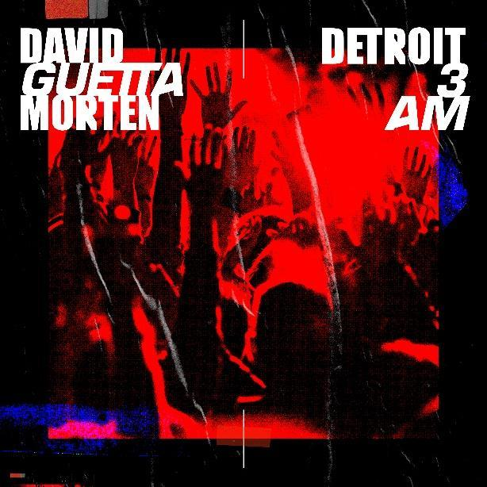

March 6, 2020 (Los Angeles, CA) – Grammy-Award winning superstar DJ, David Guetta unveils a stunning new melodic tech-house record, “Detroit 3AM” with Danish DJ/producer MORTEN. The new record is the latest in a long line of successful collaborations from David Guetta and MORTEN which count over 60 million combined streams.

Following the innovative sounds of their “Make It To Heaven with Raye,” “Never Be Alone feat. Aloe Blacc” and tribute remix of Avicii’s “Heaven,” the talented twosome show yet another side to their music with “Detroit 3AM.” The new track is an electronic ode to the birth town of techno and its legendary DJ’s: Juan Atkins, Derrick May, Kevin Saunderson and Jeff Mills. Packed with futuristic synths, distorted kicks and formidable energy, “Detroit 3AM” is another cutting-edge production from the pair.

David Guetta and MORTEN remain a driving force in today’s ever-evolving electronic dance music scene with their unique sound. David Guetta counted over 3 billion global streams in 2019 and amassed more than 4.5 billion cumulative views. Guetta begins his U.S. residency with Wynn Nightlife at Encore Beach Club and XS Night Club on March 28th. He’ll return on May 15th to headline Brooklyn Mirage with Martin Solveig followed by Electric Daisy Carnival on May 17th before heading back to Ibiza for his two summer residencies at Ushuaïa and Hi Ibïza.

Follow David Guetta:
Official | Twitter | Instagram | Facebook | Press Materials

Follow MORTEN:
Official | Twitter | Instagram | Facebook

