DAVID GUETTA TO HOST NEW YORK'S LARGEST AT HOME DANCE PARTY WITH THE SECOND "UNITED AT HOME" CHARITY LIVESTREAM EVENT ON MAY 30TH

RAISING MONEY FOR THE MAYOR’S FUND TO ADVANCE NEW YORK CITY, FEEDING AMERICA, THE WORLD HEALTH ORGANIZATION, AND FONDATION HÔPITAUX DE PARIS - HÔPITAUX DE FRANCE

UNITED AT HOME
New York, Saturday, May 30th
7pm New York/ 4pm LA/ 12am London/ 1am Paris/ 3am Dubai/ 8am Tokyo

#unitedathomeNYC #NYCdanceathome

Watch Teaser Here

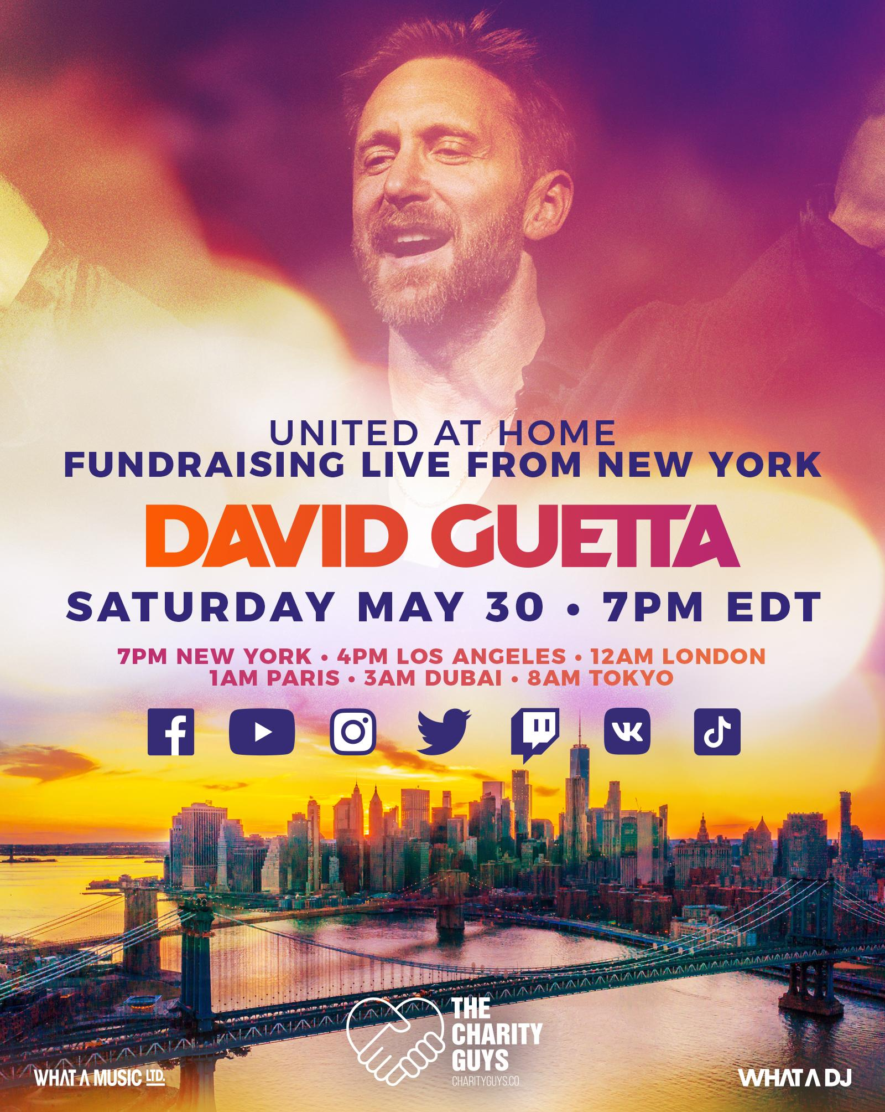

May 21, 2020 (Los Angeles, CA) - After the smashing success of United At Home in Miami, which raised more than $750,000 for COVID-19 relief charities and drew more than 25 million viewers, David Guetta will host a live stream performance in New York on May 30th to raise spirits and money for the Mayor’s Fund to Advance New York City, Feeding America, the World Health Organization, and Fondation Hôpitaux de Paris - Hôpitaux de France.

Guetta's performance will take place at one of New York City's most iconic locations, to be revealed during his set. United At Home, conceived and co-produced by the Charity Guys, aims to put a smile on the faces of New York and the rest of the world through the power of music.

Guetta’s performance will begin after New York’s “daily clap” for frontline and healthcare workers at 7:00 pm (EST), and can be viewed live on social media through the DJ’s Facebook, Instagram, YouTube, Twitter, Twitch, VK and TikTok channels. The stream will feature guest appearances from City First Responders along with other special surprise guests. New Yorkers are encouraged to join Guetta’s global audience and watch this performance safely from home. Moreover, the set can only be enjoyed online; it will not be amplified.

‘I’m excited to announce I will host another live stream to raise money for charity and help battle the virus’, says David Guetta. ‘New York is one of my favorite cities and it’s an honor to be able to do something to help the city during this difficult time. We’re planning something special that can be enjoyed from homes around the world. As a DJ, the crowd is the most important part of any show and even though we can’t be together in a club or at a festival, we can use this time to come together in new ways and help those who need it most’.

“Our city’s healthcare workers are first responders in the fight against coronavirus. As New Yorkers have stepped back and stayed home, our doctors, nurses and hospital staff have stepped forward to work around the clock to save lives,” said First Lady Chirlane McCray. “I thank David Guetta for his partnership to help the city continue to raise funds for PPE and other critical supplies to protect our healthcare heroes during this public health crisis.”

Funds raised by the performance will be donated to the following organizations:

- The Mayor’s Fund to Advance New York City, chaired by First Lady Chirlane McCray, is NYC’s official fundraising arm for COVID-19 relief and is working every day to support vulnerable populations including frontline health care workers and essential staff, immigrant communities, domestic violence survivors, and others. Guetta’s United At Home initiative will also continue to benefit
- Feeding America, the nation’s largest hunger-relief organization;
- Fondation Hôpitaux de Paris - Hôpitaux de France, whose mission is to improve the conditions of healthcare works and patients in hospitals across France; and
- The World Health Organization’s COVID-19 Solidarity Response Fund, which is ensuring frontline workers are equipped with essential protective wear, patients are receiving proper care, and efforts to develop vaccines, tests, and treatments are accelerated.

On April 18th, David Guetta lit up the blue-turquoise waters of Biscayne Bay of Downtown Miami, playing for 8000 thousand locals who danced on from their balconies. In front of a 205-feet pool at the Icon Brickell in Downtown Miami, the iconic French artist played a 1.5 hours set packed with feel-good music which has now been viewed more than 25 million times (watch, here) and has raised over $750,000 including a $300,000 personal contribution from the DJ. The donation channels remain open for Feeding South Florida, Feeding America, World Health Organization and Fondation Hôpitaux de Paris - Hôpitaux de France and donations are still welcome via davidguetta.com/donate.

The second edition of United At Home will no doubt be another roaring success as Guetta unties the world through music yet again.

Tune in via David Guetta’s socials. Kicking off at 7pm EST

#unitedathomeNYC #NYCdanceathome

https://facebook.com/davidguetta
https://youtube.com/davidguetta
https://instagram.com/davidguetta
https://twitter.com/davidguetta
https://www.twitch.tv/davidguetta
https://vk.com/davidguetta
https://www.tiktok.com/@davidguetta

To donate, please head to davidguetta.com/donate

For inquiries regarding corporate donations and partnership opportunities including exposure on the official website and live stream (Facebook, Instagram, YouTube, Twitter, Twitch, VK and TikTok), please contact Michael Wiesenfeld at michael@davidguetta.com.

About David Guetta
There are artists and entertainers who achieve stardom and popularity, but few have the influence and endurance to redraw borders between genres and reshape the industry’s dynamics. “When Love Takes Over,” the first single of his 2009 album ‘One Love’, hit #1 in the UK, the Guetta- produced Black Eyed Peas song “I Gotta Feeling” became a worldwide hit, topping the charts in 17 countries. Over the decade since, Guetta’s success has been off the charts. Globally, he’s racked up over 50 million record sales, whereas his total number of streams is over 10 billion. He has received numerous Platinum and Gold certifications, was named ‘EDM Power Player’ by Billboard, and won two Grammy Awards out of six nominations. Besides his hard-won DJ skills, he is prolific in the studio, working with artists like Madonna, Rihanna, Lady Gaga, Snoop Dogg, Martin Garrix, Usher, Sia, John Legend, Nicki Minaj, Sean Paul, Kelly Rowland, Showtek, Avicii, Ne-Yo, and Akon, for starters. His seventh studio album titled ‘7’, included huge electronic pop tracks like “2U” with Justin Bieber, “Flames” with Sia, “Don’t Leave Me Alone” with Anne-Marie, “Goodbye” with Jason Derulo, Nicki Minaj and Willy William and “Say My Name” with J Balvin and Bebe Rexha plus a second disc of underground dance tracks, recorded under Guetta’s Jack Back alias. With his wide-reaching and game-changing approach, he is more than just a DJ and producer: he’s made dance music reach the mainstream, fused urban, electronic and pop music into new popular genres, and managed to stay on top of the game for decades. David Guetta is surely not done with showing the world his incredible sound and it is safe to say that at this stage in his career, David knows exactly where to take it next.

The Charity Guys is in out-of-the-box consulting agency specialized in setting up highly creative fundraising campaigns for Celebrities and high-profile individuals.
www.charityguys.co

The Mayor’s Fund to Advance New York City works in partnership with the business and philanthropic communities to advance initiatives that improve the lives of residents in all five boroughs. It seeks to seed promising, evidence-based models; evaluate the efficacy of new public programs and policies; bring innovative solutions to scale; and respond to the emerging needs of the city by building public-private partnerships. First Lady of New York City Chirlane McCray is chair of the Mayor’s Fund Board of Directors. In addition, the Mayor's Fund has an Advisory Board of prominent civic and business leaders to advise and assist the Board of Directors.
nyc.gov/fund

The World Health Organization works worldwide to promote health, keep the world safe, and serve the vulnerable. The WHO goal is to ensure that a billion more people have universal health coverage, to protect a billion more people from health emergencies, and provide a further billion people with better health and well-being.
www.who.int

Feeding America is the largest hunger-relief organization in the United States. Its mission is to feed America’s hungry through a nationwide network of member food banks and engage our country in the fight to end hunger.
www.feedingamerica.org

Fondation Hôpitaux de Paris - Hôpitaux de France's mission is to improve conditions of health workers and patients within hospitals throughout France.
www.fondationhopitaux.fr

For all media inquiries, please contact:
Darren Baber / Warner Records – darren.baber@warnerrecords.com

