DAVID GUETTA’s NYC “UNITED AT HOME” PERFORMANCE FROM ICONIC TOP OF THE ROCK GARNERED OVER 24 MILLION VIEWS AND RAISED MORE THAN $500,000 FOR COVID-19 RELIEF

MAJOR LEAGUE SOCCER AND HEINEKEN JOINED FORCES TO SPONSOR SATURDAY’s EVENT
*****
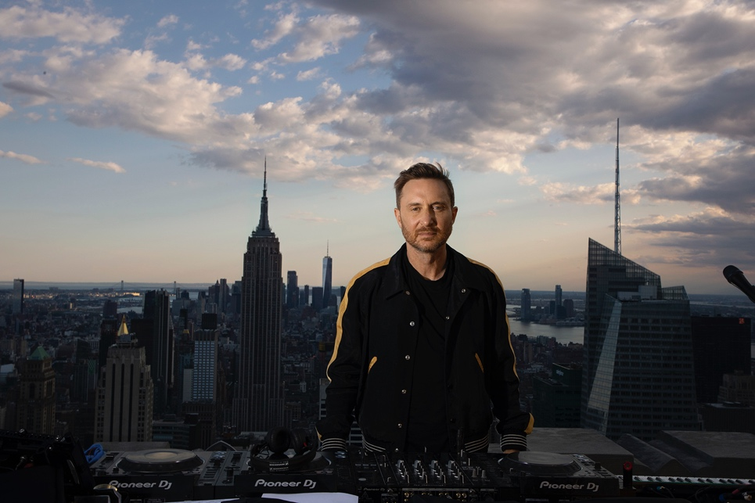

May 31, 2020 (Los Angeles, CA) - Global superstar DJ/producer David Guetta performed at New York City’s Top of the Rock Observation Deck at Rockefeller Center to a virtual crowd of over 24 million to benefit Covid-19 relief efforts. The event, titled Major League Soccer and Heineken presents United At Home raised half a million dollars for Mayor’s Fund to Advance New York City, Feeding America, World Health Organization and Fondation Hôpitaux de Paris - Hôpitaux de France. The live performance took place outdoors on the 70thfloor of the Top of the Rock observation deck and started just after 7:00 p.m. EST to coincide with New York’s “daily clap” for healthcare workers. Guetta played to a digital screen displaying fans from all over the world who joined the party via online rooms. NYC’s frontline workers appeared on screen, as well as celebrity guests.
Yesterday’s performance is the second edition of “United At Home,” following Guetta’s first fundraiser in Miami which raised more than $750,000 for global charities and drew more than 25 million online views since it’s release on April 18th.

“Thank you to everyone who joined the stream last night from homes around the world, you made this event so special”, says David Guetta. “Although we can’t dance together in real life just yet, I loved to see you online and it was amazing to connect again through music. To those who donated, thank you for your generosity, and a huge thank you to our presenting sponsors Major Soccer League and Heineken for making this event possible.”

The event, conceived and produced by The Charity Guys, was streamed on Guetta’s Facebook, Instagram, YouTube, Twitter, Twitch, VK and TikTok channels. To maintain social distancing and not attract crowds to the area, the performance was exclusively enjoyed online, sound was not amplified.

Funds raised will go directly to The Mayor’s Fund to Advance New York City, chaired by First Lady Chirlane McCray, which is New York City’s official fundraising arm for Covid-19 relief and works each day to support vulnerable populations including frontline health care workers and essential staff, immigrant communities, domestic violence survivors, and others.

“‘United At Home’ was an unforgettable event that leveraged music and soccer to connect people in an extraordinary way, we are thankful for our dedicated partner Heineken and global star David Guetta for making this a reality,” said David Bruce, MLS SVP of Brand and Integrated Marketing. “Seeing people around the world enjoying this performance, celebrating the culture of music and soccer, and positively impacting our communities was amazing.”

The event also benefited Feeding America, the nation’s largest hunger-relief organization; Fondation Hôpitaux de Paris - Hôpitaux de France, whose mission is to improve the conditions of healthcare workers and patients in hospitals across France; and The World Health Organization’s COVID-19 Solidarity Response Fund, which is ensuring frontline workers are equipped with essential protective wear, patients are receiving proper care, and efforts to develop vaccines, tests, and treatments are accelerated.

“We were honored to co-present David Guetta’s United at Home this weekend, alongside our long-standing partners at MLS,” said Borja Manso Salinas, VP Brand Marketing, Heineken. “As people need to remain connected now more than ever, we’re pleased to see over 24 million fans come together digitally this weekend to unite through the power of music and soccer.”

Signed collector items from the event will be available for auction on Guetta's social media.

Donations are still welcome via davidguetta.com/donate

#unitedathomeNYC #NYCdanceathome
https://facebook.com/davidguetta
https://youtube.com/davidguetta
https://instagram.com/davidguetta
https://twitter.com/davidguetta
https://www.twitch.tv/davidguetta
https://vk.com/davidguetta
https://www.tiktok.com/@davidguetta

###

For all media inquiries, please contact:
Darren Baber / Warner Records – darren.baber@warnerrecords.com

