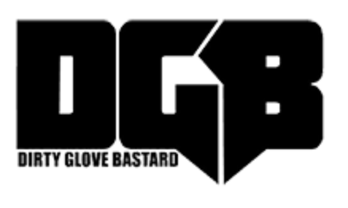

January 6, 2021

https://www.dirty-glove.net/exclusive-lil-zay-osama-talks-positive-side-of-chicago-navigating-as-an-artist-in-the-pandemic-more/

