DISTURBED CONFIRM RESCHEDULED 2021 DATES FOR THE SICKNESS 20TH ANNIVERSARY AMPHITHEATER TOUR WITH VERY SPECIAL GUEST STAIND AND BAD WOLVES
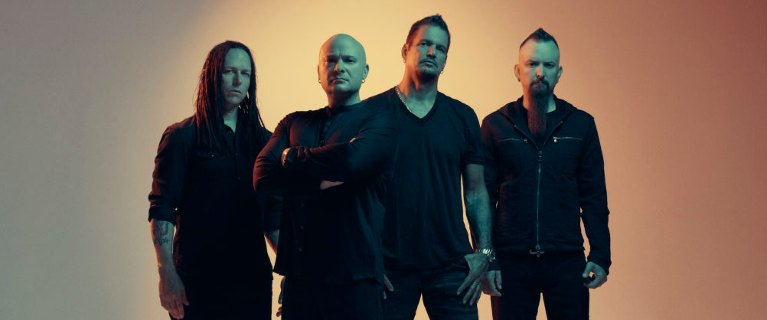
This morning, two-time Grammy nominated and multi-platinum band, Disturbed confirm the rescheduled 2021 dates for their The Sickness 20th Anniversary Tour, co-produced by Frank Productions and Live Nation. The amphitheater tour, with very special guest Staind and Bad Wolves, will begin on July 7th, 2021 at iTHINK Financial Amphitheatre (full dates below) and all previously purchased tickets will be honored for their rescheduled dates. The Sickness 20th Anniversary Tour celebrates the two-decade anniversary of the band’s seminal album, The Sickness. On this tour, the band will perform songs off the album, as well as tracks from their most recent studio release, Evolution, and their extensive catalog. Tickets for all shows are available here.
All dates on this tour have been rescheduled with the exception of the Chula Vista, CA show, for which tickets will automatically be refunded. If ticket holders cannot attend the new rescheduled date or would prefer a refund, they will receive an email directly allowing them to request one. For any further ticketing inquiries, please visit livenation.com/refund or reach out to your point of purchase.
Disturbed have continued their record-breaking streak at rock radio, claiming the title of “2019’s Most Played Artists” in the Active Rock format. The band earned their seventh consecutive #1 on the Mediabase Active Rock Chart and Billboard’s Mainstream Rock Songs Chart with their latest single “No More,” an achievement unmatched by any artist in history. Disturbed have earned ten #1 singles on the chart, including “A Reason To Fight,” the track that initially broke the record earlier this year. “No More” is the third top-charting single from the band’s #1 album, Evolution (Reprise Records).

About Disturbed:
Simply put, DISTURBED are one of the most successful rock bands in modern history. The multiplatinum-selling quartet accomplished the rare feat of achieving five consecutive number one debuts on the Billboard Top 200. That accolade historically elevated them to rarified air alongside Metallica, the only other hard rock group to do so in the history of the chart. Immortalized (2015) received a platinum certification and spawned the triple-platinum crossover smash “The Sound of Silence,” which garnered a nomination at the 2017 GRAMMY® Awards in the category of “Best Rock Performance.” Since their formation in 1996, the band has sold 16 million albums globally and scored twelve No. 1 singles at Active Rock Radio. Their quadruple-platinum 2000 debut, The Sickness, formally announced their arrival as hard rock leaders, with that status solidified by subsequent GRAMMY® Award nominations as well as gold-, platinum- and double platinum-certified records, as well as countless sold-out shows around the globe. Named “Best Rock Artist” during the 2017 iHeartRadioMusic Awards, Disturbed continue to boldly forge ahead with the release of their aptly titled seventh offering, Evolution.
About STAIND:
Aaron Lewis, Mike Mushok, Johnny April and Jon Wysocki formed Staind in 1995,in their hometown of Springfield, Massachusetts. Over the course of their career, the band released seven studio albums and eight Top 10 singles, selling over 15 million albums worldwide. Break The Cycle, released in 2001 and RIAA certified 5x platinum, featured the smash single, “It’s Been A While,” one of the most played songs in modern rock radio history, spending 20 weeks at Number 1. Staind is currently comprised of lead vocalist and rhythm guitarist Aaron Lewis, lead guitarist Mike Mushok, bassist and backing vocalist Johnny April, and drummer Sal Giancarelli. This year STAIND reunited for a few select dates, after a five-year hiatus.
www.staind.com

About Bad Wolves:
Bad Wolves consists of vocalist Tommy Vext (ex-Divine Heresy), drummer John Boecklin (ex-Devil Driver), guitarist Doc Coyle (Vagus Nerve, ex-God Forbid), guitarist Chris Cain (Bury Your Dead) and bassist Kyle Konkiel (ex-In This Moment). They released their debut album, Disobey (May 2018), via Better Noise Music, which reached #22 on the Billboard Top 200, #2 on the Hard Rock Chart, #4 on Rock, and #8 on the Top Current Albums Chart. Their global breakout single, “Zombie,” is certified Platinum in the U.S. and Sweden, double Platinum in Canada, Gold in Australia and IMPALA Diamond in Europe. The track has topped-charts worldwide, including the U.S. iTunes Overall and Rock charts, Billboard’s Mainstream Rock Songs chart, Spotify’s Global Viral 50 chart, while also reigning atop the Active Rock radio chart for three straight weeks. The album yielded the follow-up tracks “Hear Me Now,” featuring Diamante, and the soaring ballad “Remember When,” which both reached #1 at Active Rock Radio. The official music video for “Zombie,” a tribute to the late singer Dolores O’Riordan of The Cranberries and an homage to the original, has garnered over 255 million views across platforms. On June 19th, 2018, Bad Wolves presented a $250,000 check to Dolores O’Riordan’s four children, with a continued promise to donate all of their royalties from the song to them. In 2019, they continued that momentum with their sophomore album, N.A.T.I.O.N. which came in at #1 upon its release on the Top Hard Rock, Current Hard Rock and Billboard Hard Rock charts. The single “Killing Me Slowly” recently hit #1 to make it 4 consecutive #1 songs for the band at Active Rock Radio.
RESCHEDULED DATES: DISTURBED THE SICKNESS 20TH ANNIVERSARY TOUR - 2021
Wed July 7 – West Palm Beach, FL at iTHINK Financial Amphitheatre
Thu July 8 – Tampa, FL at MIDFLORIDA Credit Union Amphitheatre
Sat July 10 – Alpharetta, GA at Ameris Bank Amphitheatre
Mon July 12 – Cincinnati, OH at Riverbend Music Center
Tue July 13 – Cuyahoga Falls, OH at Blossom Music Center
Sun July 18 – Clarkston, MI at DTE Energy Music Theatre
Tue July 20 – Toronto, ON at Budweiser Stage
Wed July 21 – Darien Center, NY at Darien Lake Amphitheater
Fri July 23 – Mansfield, MA at Xfinity Center
Sat July 24 – Hartford, CT at XFINITY Theatre
Mon July 26 – Syracuse, NY at St. Joseph’s Health Amphitheater at Lakeview
Wed July 28 – Holmdel, NJ at PNC Bank Arts Center
Thu July 29 – Wantagh, NY at Northwell Health at Jones Beach Theatre
Sat July 31 – Bristow, VA at Jiffy Lube Live
Sun Aug 1 – Saratoga Springs, NY at Saratoga Performing Arts Center
Wed Aug 4 – Burgettstown, PA at S&T Bank Music Park
Fri Aug 6 – Hershey, PA at Hersheypark Stadium
Sun Aug 8 – Tinley Park, IL at Hollywood Casino Amphitheatre – Chicago, IL
Fri Aug 13 – Maryland Heights, MO at Hollywood Casino Amphitheatre – St. Louis, MO
Sat Aug 14 – Noblesville, IN at Ruoff Music Center
Mon Aug 16 – Rogers, AR at Walmart AMP
Wed Aug 18 – The Woodlands, TX at The Cynthia Woods Mitchell Pavilion
Fri Aug 20 – Albuquerque, NM at Isleta Amphitheater
Sat Aug 21 – Phoenix, AZ at Ak-Chin Pavilion
Mon Aug 23 – Irvine, CA at FivePoint Amphitheatre
Tue Aug 24 – Mountain View, CA at Shoreline Amphitheatre
Thu Aug 26 – Ridgefield, WA at Sunlight Supply Amphitheater
Fri Aug 27 – Auburn, WA at White River Amphitheatre
Sun Aug 29 – Wheatland, CA at Toyota Amphitheatre
Tue Aug 31 – West Valley City, UT at USANA Amphitheatre

For more information, please contact Mary Moyer (mary@qprime.com) and Emilio Herce (emilio@qprime.com) at Q Prime 212.302.9790 or Patrice Compere (Patrice.Compere@warnerrecords.com - 212-707-3450) at Warner Records.

About Live Nation Entertainment
Live Nation Entertainment is the world's leading live entertainment company comprised of global market leaders: Ticketmaster, Live Nation Concerts, and Live Nation Sponsorship. For additional information, visit www.livenationentertainment.com.

About Frank Productions
Frank Productions (FPC Live) is a full-service concert promotion company involved in every facet of live events including production, logistics, ticketing, marketing, sponsorships, food and beverage, operations, and merchandising. Frank Productions produces and promotes live entertainment events in arenas, amphitheaters, performing arts centers, clubs, and other venues across the country. For additional information, visit www.FPC-Live.com.

