DISTURBED SHARE NEW SINGLE & VIDEO “HEY YOU”
LISTEN HERE – WATCH HERE
NEW ALBUM COMING LATER THIS YEAR
EARN SEVEN NEW MULTI-PLATINUM CERTIFICATIONS BY RIAA
CURRENTLY ON TOUR
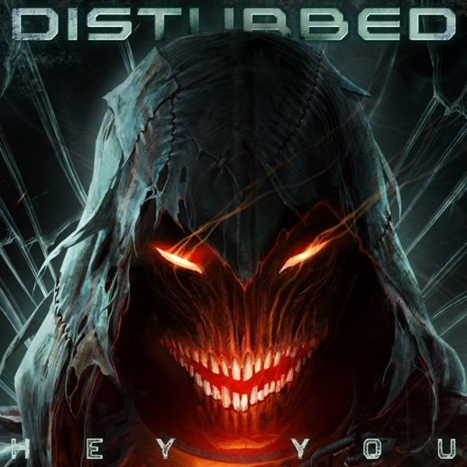
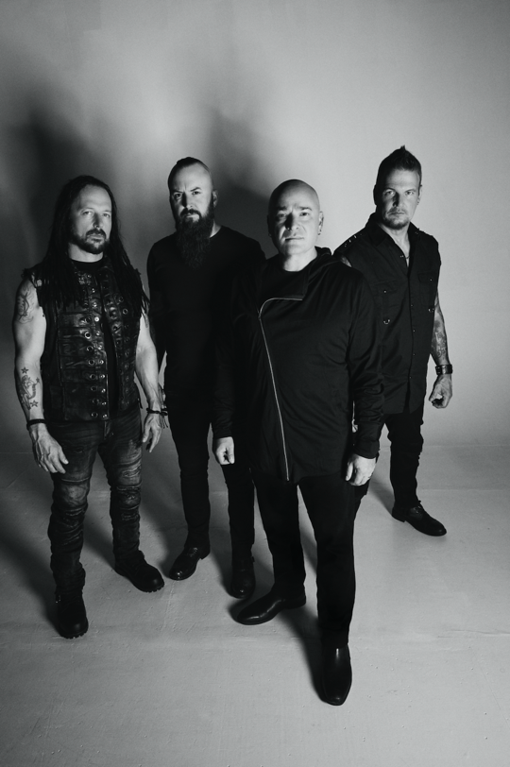
July 14, 2022 (Los Angeles, CA) – Today, Disturbed, share their new single “Hey You” via Reprise Records alongside the official video, directed by Josiahx. “Hey You” is the multi-platinum selling band’s first new music since their chart-topping 2018 album Evolution, and David Draiman of the band shares, “it’s a wake up call. We’ve become our own worst enemies. Civil discourse has become the exception instead of the norm. People have lost themselves in outrage addiction.” Listen to Disturbed’s new single “Hey You” here and watch the video here. The band have also revealed that they have a new album coming later this year.
Continuing on their monumental career, the band’s 2008 album Indestructible was just certified 2X Multi-Platinum by The Recording Industry Association of America (RIAA). Several songs in the band’s catalog were also recently certified, including “Down With The Sickness” (6X Multi-Platinum Digital Single) “The Sound of Silence” (7X Multi-Platinum Digital Single), “Stupify” (Gold & Platinum Digital Single), “Stricken” (2X Platinum & Multi-Platinum Digital Single), “Inside The Fire” (Platinum) and “Land of Confusion” (Gold & Platinum Digital Single).
The band are performing at several upcoming festivals throughout the year (full dates below). Tickets for all dates are available here.
DISTURBED, the multiplatinum-selling quartet, accomplished the rare feat of achieving five consecutive number one debuts on the Billboard Top 200. That accolade historically elevated them to rarified air alongside Metallica, the only other hard rock group to do so in the history of the chart. Immortalized (2015) received a platinum certification and spawned the 7X platinum crossover smash “The Sound of Silence,” which garnered a nomination at the 2017 GRAMMY® Awards in the category of “Best Rock Performance.” Since their formation in 1996, the band has sold 16 million albums globally and scored twelve No. 1 singles at Active Rock Radio. Their 5X platinum 2000 debut, The Sickness, formally announced their arrival as hard rock leaders, with that status solidified by subsequent GRAMMY® Award nominations as well as gold-, platinum- and double platinum-certified records, as well as countless sold-out shows around the globe. Named “Best Rock Artist” during the 2017 iHeartRadioMusic Awards, Disturbed continue to boldly forge ahead and are currently working on the follow up to their aptly titled seventh offering, Evolution.
Photo Credit: Travis Shinn
Disturbed Upcoming Tour Dates
July 16 - Upheaval Festival - Grand Rapids, MI
July 17 - Inkcarceration Festival - Mansfield, OH
August 10 - Musikfest - Bethlehem, PA
August 19 - Iowa State Fair - Des Moines, IA
August 20 - Illinois State Fair - Springfield, IL
September 11 - Blue Ridge Rock Festival - Alton, VA
September 15 - OC Bikefest - Ocean City, MD
September 22 - 99.7 The Blitz's Great Summer Smokeout - Columbus, OH
September 24 - 101.1 WRIF's Riff Fest - Detroit, MI

For more information, please contact Mary Moyer (mary@qprime.com) and Emilio Herce (emilio@qprime.com) at Q Prime or Patrice Compere at Warner Records (patrice.compere@warnerrecords.com).

