DISTURBED SHARES MUSIC VIDEO FOR THEIR NEW COVER OF
STING’S “IF I EVER LOSE MY FAITH IN YOU”
THE SICKNESS (20TH ANNIVERSARY DELUXE EDITION) OUT NOW
THE SICKNESS 20TH ANNIVERSARY AMPHITHEATER TOUR WITH VERY SPECIAL GUEST STAIND AND BAD WOLVES SCHEDULED FOR 2021
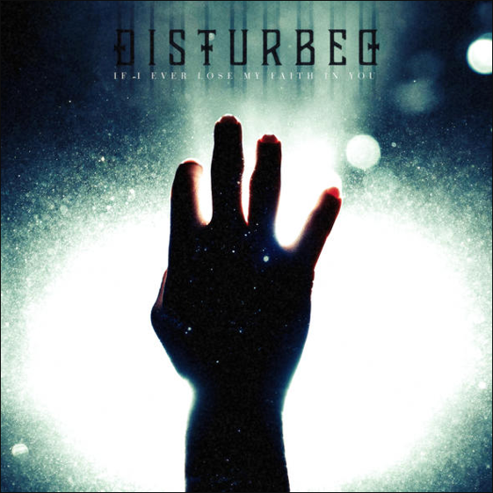
Today, Disturbed, the two-time Grammy nominated and multi-platinum band, share their cover of Sting’s hit single “If I Ever Lose My Faith In You.” Said the band about the new cover, “We have loved this song for a long time, and even though it was released in 1993, it seems strangely applicable to today’s world. The song is about losing faith, and might initially sound pessimistic, but it’s about the importance and power of personal relationships, and how they can save you and provide solace in an increasingly confusing world.” The band today also share a new music video for the song, directed by Matt Mahurin, watch it here.
Disturbed’s The Sickness (20th Anniversary Deluxe Edition) is out now in both vinyl and digital editions. The vinyl version is pressed on Limited Edition Black Clouds Colored Vinyl and the digital deluxe edition includes seven additional live tracks, including “Down With The Sickness,” “Voices,” and “Shout 2000” (full track listing Below). The Sickness (20th Anniversary Deluxe Edition) is available on both formats here.
Disturbed recently confirmed the 2021 dates for their The Sickness 20th Anniversary Tour, co-produced by Frank Productions and Live Nation. The amphitheater tour, with very special guest Staind and Bad Wolves, will begin on July 7th, 2021 at iTHINK Financial Amphitheatre (full dates below) and all previously purchased tickets will be honored for their rescheduled dates. The Sickness 20th Anniversary Tour celebrates the two-decade anniversary of the band’s The Sickness. On this tour, the band will perform songs off the album, as well as tracks from their most recent studio release, Evolution, and their extensive catalog. Tickets for all shows are available here.
Hi-Res Single Art and Press Photo Here
Today, Disturbed also announce their Songkick Live From the Vault session which will be released on September 17th, and features performances from their 2018 Austin City Limits set. Songkick’s Live From the Vault series taps into an archive of incredible live performances from music’s most epic festivals, bringing fans live performance experiences that have never been available on-demand before. Pre-save Disturbed’s Songkick session here.
Disturbed have continued their record-breaking streak at rock radio, claiming the title of “2019’s Most Played Artists” in the Active Rock format. The band earned their seventh consecutive #1 on the Mediabase Active Rock Chart and Billboard’s Mainstream Rock Songs Chart with their latest single “No More,” an achievement unmatched by any artist in history. Disturbed have earned ten #1 singles on the chart, including “A Reason To Fight,” the track that initially broke the record earlier this year. “No More” is the third top-charting single from the band’s #1 album, Evolution (Reprise Records).

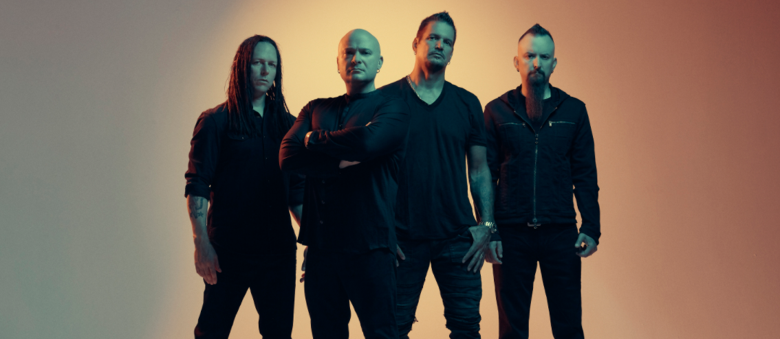

About Disturbed:
Simply put, DISTURBED are one of the most successful rock bands in modern history. The multiplatinum-selling quartet accomplished the rare feat of achieving five consecutive number one debuts on the Billboard Top 200. That accolade historically elevated them to rarified air alongside Metallica, the only other hard rock group to do so in the history of the chart. Immortalized (2015) received a platinum certification and spawned the triple-platinum crossover smash “The Sound of Silence,” which garnered a nomination at the 2017 GRAMMY® Awards in the category of “Best Rock Performance.” Since their formation in 1996, the band has sold 16 million albums globally and scored twelve No. 1 singles at Active Rock Radio. Their quadruple-platinum 2000 debut, The Sickness, formally announced their arrival as hard rock leaders, with that status solidified by subsequent GRAMMY® Award nominations as well as gold-, platinum- and double platinum-certified records, as well as countless sold-out shows around the globe. Named “Best Rock Artist” during the 2017 iHeartRadioMusic Awards, Disturbed continue to boldly forge ahead with the release of their aptly titled seventh offering, Evolution.
DISTURBED THE SICKNESS 20TH ANNIVERSARY TOUR - 2021
Wed July 7 – West Palm Beach, FL at iTHINK Financial Amphitheatre
Thu July 8 – Tampa, FL at MIDFLORIDA Credit Union Amphitheatre
Sat July 10 – Alpharetta, GA at Ameris Bank Amphitheatre
Mon July 12 – Cincinnati, OH at Riverbend Music Center
Tue July 13 – Cuyahoga Falls, OH at Blossom Music Center
Sun July 18 – Clarkston, MI at DTE Energy Music Theatre
Tue July 20 – Toronto, ON at Budweiser Stage
Wed July 21 – Darien Center, NY at Darien Lake Amphitheater
Fri July 23 – Mansfield, MA at Xfinity Center
Sat July 24 – Hartford, CT at XFINITY Theatre
Mon July 26 – Syracuse, NY at St. Joseph’s Health Amphitheater at Lakeview
Wed July 28 – Holmdel, NJ at PNC Bank Arts Center
Thu July 29 – Wantagh, NY at Northwell Health at Jones Beach Theatre
Sat July 31 – Bristow, VA at Jiffy Lube Live
Sun Aug 1 – Saratoga Springs, NY at Saratoga Performing Arts Center
Wed Aug 4 – Burgettstown, PA at S&T Bank Music Park
Fri Aug 6 – Hershey, PA at Hersheypark Stadium
Sun Aug 8 – Tinley Park, IL at Hollywood Casino Amphitheatre – Chicago, IL
Fri Aug 13 – Maryland Heights, MO at Hollywood Casino Amphitheatre – St. Louis, MO
Sat Aug 14 – Noblesville, IN at Ruoff Music Center
Mon Aug 16 – Rogers, AR at Walmart AMP
Wed Aug 18 – The Woodlands, TX at The Cynthia Woods Mitchell Pavilion
Fri Aug 20 – Albuquerque, NM at Isleta Amphitheater
Sat Aug 21 – Phoenix, AZ at Ak-Chin Pavilion
Mon Aug 23 – Irvine, CA at FivePoint Amphitheatre
Tue Aug 24 – Mountain View, CA at Shoreline Amphitheatre
Thu Aug 26 – Ridgefield, WA at Sunlight Supply Amphitheater
Fri Aug 27 – Auburn, WA at White River Amphitheatre
Sun Aug 29 – Wheatland, CA at Toyota Amphitheatre
Tue Aug 31 – West Valley City, UT at USANA Amphitheatre

For more information, please contact Mary Moyer (mary@qprime.com) and Emilio Herce (emilio@qprime.com) at Q Prime 212.302.9790 or Patrice Compere (Patrice.Compere@warnerrecords.com - 212-707-3450) at Warner Records.

