DISTURBED’S THE SICKNESS (20TH ANNIVERSARY DELUXE EDITION) AVAILABLE NOW ON LIMITED EDITION BLACK CLOUDS COLORED VINYL AND DIGITALLY
THE SICKNESS 20TH ANNIVERSARY AMPHITHEATER TOUR WITH VERY SPECIAL GUEST STAIND AND BAD WOLVES RESCHEDULED FOR 2021
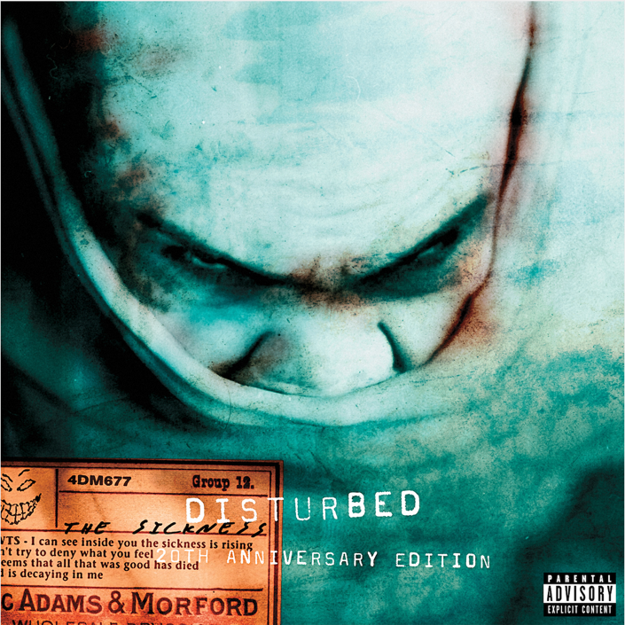
Today, Disturbed, the two-time Grammy nominated and multi-platinum band, release The Sickness (20th Anniversary Deluxe Edition) in both vinyl and digital editions. The vinyl version is pressed on Limited Edition Black Clouds Colored Vinyl and the digital deluxe edition includes seven additional live tracks, including “Down With The Sickness,” “Voices,” and “Shout 2000” (full track listing Below). The Sickness (20th Anniversary Deluxe Edition) is available on both formats here.
Disturbed recently confirmed the rescheduled 2021 dates for their The Sickness 20th Anniversary Tour, co-produced by Frank Productions and Live Nation. The amphitheater tour, with very special guest Staind and Bad Wolves, will begin on July 7th, 2021 at iTHINK Financial Amphitheatre (full dates below) and all previously purchased tickets will be honored for their rescheduled dates. The Sickness 20th Anniversary Tour celebrates the two-decade anniversary of the band’s The Sickness. On this tour, the band will perform songs off the album, as well as tracks from their most recent studio release, Evolution, and their extensive catalog. Tickets for all shows are available here.
All dates on this tour have been rescheduled with the exception of the Chula Vista, CA show, for which tickets will automatically be refunded. If ticket holders cannot attend the new rescheduled date or would prefer a refund, they will receive an email directly allowing them to request one. For any further ticketing inquiries, please visit livenation.com/refund or reach out to your point of purchase.
Disturbed have continued their record-breaking streak at rock radio, claiming the title of “2019’s Most Played Artists” in the Active Rock format. The band earned their seventh consecutive #1 on the Mediabase Active Rock Chart and Billboard’s Mainstream Rock Songs Chart with their latest single “No More,” an achievement unmatched by any artist in history. Disturbed have earned ten #1 singles on the chart, including “A Reason To Fight,” the track that initially broke the record earlier this year. “No More” is the third top-charting single from the band’s #1 album, Evolution (Reprise Records).

About Disturbed:
Simply put, DISTURBED are one of the most successful rock bands in modern history. The multiplatinum-selling quartet accomplished the rare feat of achieving five consecutive number one debuts on the Billboard Top 200. That accolade historically elevated them to rarified air alongside Metallica, the only other hard rock group to do so in the history of the chart. Immortalized (2015) received a platinum certification and spawned the triple-platinum crossover smash “The Sound of Silence,” which garnered a nomination at the 2017 GRAMMY® Awards in the category of “Best Rock Performance.” Since their formation in 1996, the band has sold 16 million albums globally and scored twelve No. 1 singles at Active Rock Radio. Their quadruple-platinum 2000 debut, The Sickness, formally announced their arrival as hard rock leaders, with that status solidified by subsequent GRAMMY® Award nominations as well as gold-, platinum- and double platinum-certified records, as well as countless sold-out shows around the globe. Named “Best Rock Artist” during the 2017 iHeartRadioMusic Awards, Disturbed continue to boldly forge ahead with the release of their aptly titled seventh offering, Evolution.
Disturbed- The Sickness (20th Anniversary Deluxe Edition) Track Listing
1. Voices
2. The Game
3. Stupify
4. Down with the Sickness
5. Violence Fetish
6. Fear
7. Numb
8. Want
9. Conflict
10. Shout 2000
11. Droppin Plates
12. Meaning of Life
13. God of the Mind- Digital Only
14. A Welcome Burden- Digital Only
15. The Game (Live)- Digital Only
16. Down with the Sickness (Live)- Digital Only
17. Voices (Live) - Digital Only
18. Fear (Live) - Digital Only
19. Conflict (Live) - Digital Only
20. Droppin Plates (Live) - Digital Only
21. Shout 2000 (Live) - Digital Only
RESCHEDULED DATES: DISTURBED THE SICKNESS 20TH ANNIVERSARY TOUR - 2021
Wed July 7 – West Palm Beach, FL at iTHINK Financial Amphitheatre
Thu July 8 – Tampa, FL at MIDFLORIDA Credit Union Amphitheatre
Sat July 10 – Alpharetta, GA at Ameris Bank Amphitheatre
Mon July 12 – Cincinnati, OH at Riverbend Music Center
Tue July 13 – Cuyahoga Falls, OH at Blossom Music Center
Sun July 18 – Clarkston, MI at DTE Energy Music Theatre
Tue July 20 – Toronto, ON at Budweiser Stage
Wed July 21 – Darien Center, NY at Darien Lake Amphitheater
Fri July 23 – Mansfield, MA at Xfinity Center
Sat July 24 – Hartford, CT at XFINITY Theatre
Mon July 26 – Syracuse, NY at St. Joseph’s Health Amphitheater at Lakeview
Wed July 28 – Holmdel, NJ at PNC Bank Arts Center
Thu July 29 – Wantagh, NY at Northwell Health at Jones Beach Theatre
Sat July 31 – Bristow, VA at Jiffy Lube Live
Sun Aug 1 – Saratoga Springs, NY at Saratoga Performing Arts Center
Wed Aug 4 – Burgettstown, PA at S&T Bank Music Park
Fri Aug 6 – Hershey, PA at Hersheypark Stadium
Sun Aug 8 – Tinley Park, IL at Hollywood Casino Amphitheatre – Chicago, IL
Fri Aug 13 – Maryland Heights, MO at Hollywood Casino Amphitheatre – St. Louis, MO
Sat Aug 14 – Noblesville, IN at Ruoff Music Center
Mon Aug 16 – Rogers, AR at Walmart AMP
Wed Aug 18 – The Woodlands, TX at The Cynthia Woods Mitchell Pavilion
Fri Aug 20 – Albuquerque, NM at Isleta Amphitheater
Sat Aug 21 – Phoenix, AZ at Ak-Chin Pavilion
Mon Aug 23 – Irvine, CA at FivePoint Amphitheatre
Tue Aug 24 – Mountain View, CA at Shoreline Amphitheatre
Thu Aug 26 – Ridgefield, WA at Sunlight Supply Amphitheater
Fri Aug 27 – Auburn, WA at White River Amphitheatre
Sun Aug 29 – Wheatland, CA at Toyota Amphitheatre
Tue Aug 31 – West Valley City, UT at USANA Amphitheatre

For more information, please contact Mary Moyer (mary@qprime.com) and Emilio Herce (emilio@qprime.com) at Q Prime 212.302.9790 or Patrice Compere (Patrice.Compere@warnerrecords.com - 212-707-3450) at Warner Records.

