For Immediate Release August 1, 2019
FOALS CONFIRM EVERYTHING NOT SAVED WILL BE LOST – PART 2 TO BE RELEASED VIA WARNER RECORDS ON OCTOBER 18TH
DEBUT MUSIC VIDEO FOR “BLACK BULL,” FIRST TRACK FROM ALBUM
EVERYTHING NOT SAVED WILL BE LOST – PART 1 SHORTLISTED FOR THE MERCURY PRIZE
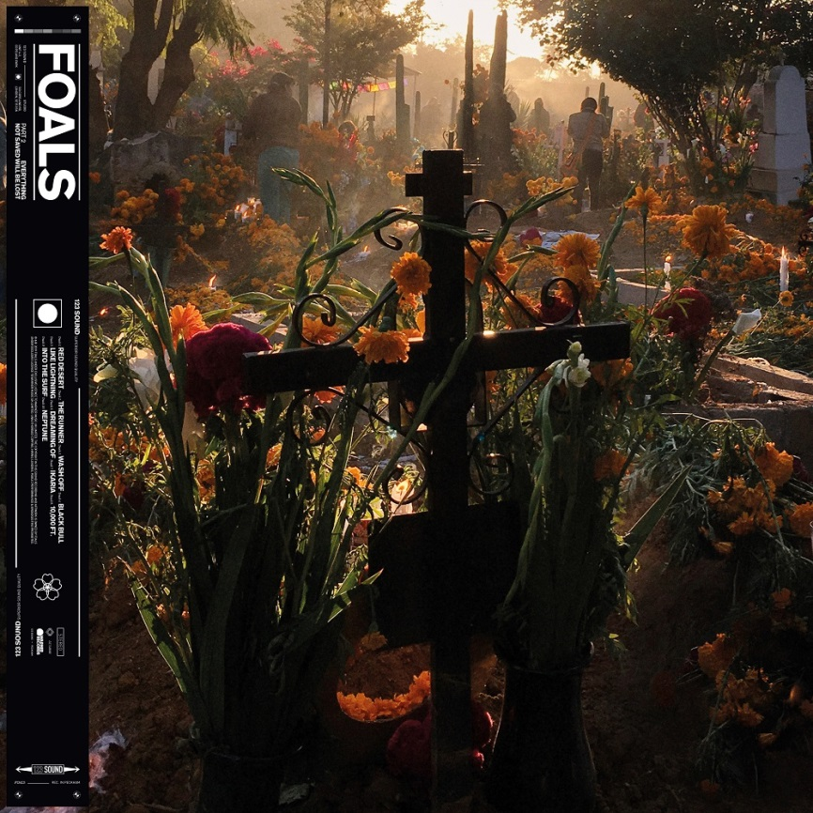
Critical Praise For Everything Not Saved Will Be Lost – Part 1
“big and adventurous... vibrant and versatile…”
-NPR Music

“…feels like the band taking stock of what works and amplifying each element — embossing their sound and creating something more themselves than ever before.”
-The FADER

“post-punk thrust, math-rock patterns and splintered lyrics mirror the daily dystopian media barrage.”
-The New York Times

“This year we are promised not just one Foals album, but two. And after listening to the first, we’re very, very lucky indeed.”
-Associated Press

Today, Foals confirm the release of Everything Not Saved Will Be Lost – Part 2 via Warner Records on October 18th. The release completes the artistic statement and striking state-of-the-world-address of Everything Not Saved Will Be Lost – Part 1, a record which is shortlisted for the prestigious, 2019 Mercury Prize. “Part two is a heavier listen, the guitars are more emphasized and there’s some big riffs on it,” explained lead singer and guitarist Yannis Philippakis in an interview with NME. “It’s a rock record and it definitely carries on the narrative from part one. Part one ended with a lot of fire and destructive imagery, part two is trying to respond to that: how you can continue in the wreckage and through the scorched earth? We’re just excited for people to hear it because it completes the journey of what we’ve made over the last year-and-a-half.”
The band today also share the music video for “Black Bull,” the first song off Everything Not Saved Will Be Lost – Part 2, and a bruising expression of conflicted masculinity & delusions of grandeur. The video for “Black Bull’ was directed by Niall O'Brien and can be watched here.

Everything Not Saved Will Be Lost – Part 2 will be released on CD, digital and vinyl formats. Special editions include orange vinyl that will be available exclusively through indie stores and a picture disc which is designed to be added to the Everything Not Saved Will Be Lost Collector’s Edition boxset. The album is now available to pre-order here, with “Black Bull” included as an instant download.
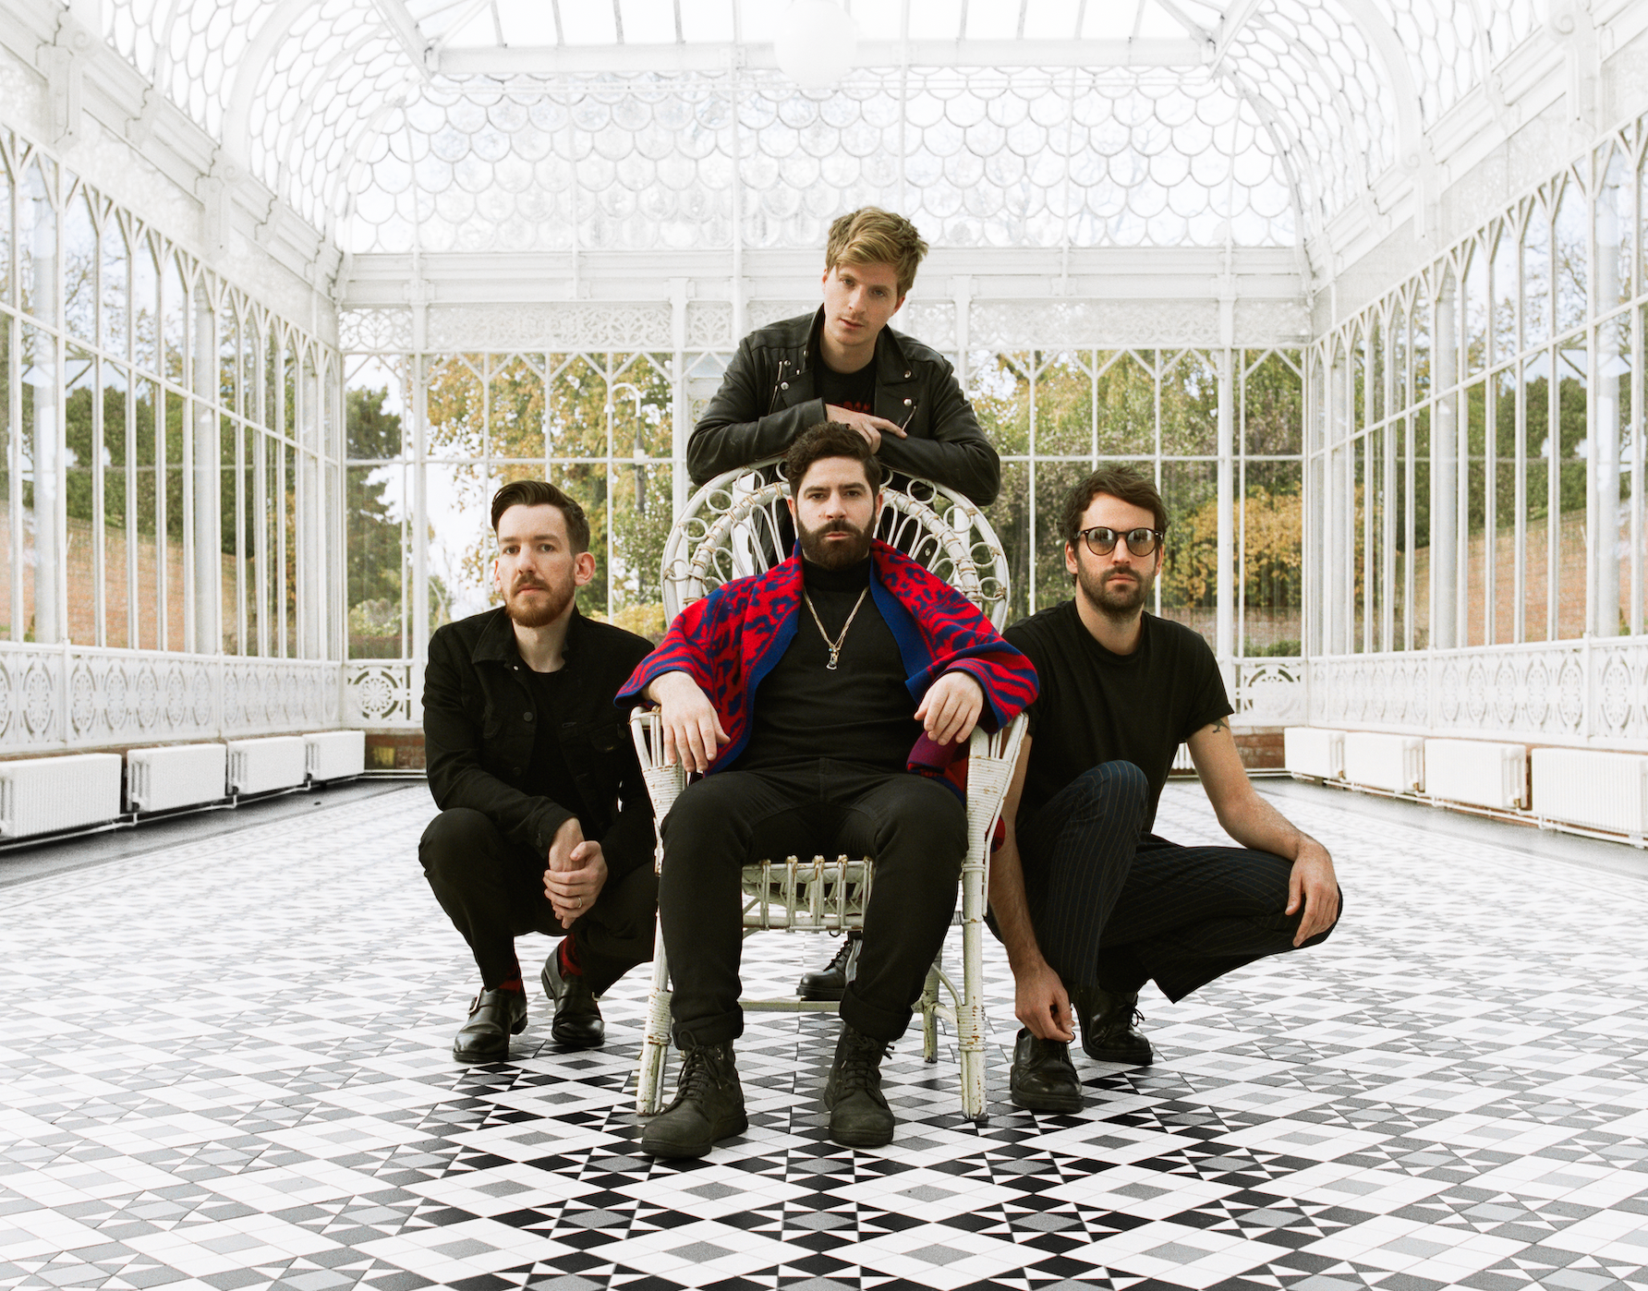
Part 2, like Part 1, was produced by Foals themselves: Yannis Philippakis (vocals/guitar), Jimmy Smith (guitar), Jack Bevan (drums) and Edwin Congreave (keys), with Philippakis and Congreave contributing bass too. The album simmers with the pure visceral intensity which has long been emblematic of the band— “The Runner” and “Black Bull” are streamlined attacks, and this approach also informs “10,000 Feet”— while retaining the opening chapter’s eclectic nature. “Wash Off” marries manic world music-tinged grooves with a punk-like intensity and the cinematic instrumentals “Red Desert” and “Ikaria” underline that Everything Not Saved Will Be Lost is a journey rather than a mere collection of songs.

The album also extends its predecessor’s exploration of contemporary concerns – conflicted masculinity & delusions of grandeur in ‘Black Bull’ , humanity’s dependency on tech in ‘Wash Off’ –the overall tone is set by ‘The Runner’, which hones in on the importance of fighting back against the odds. That defiance detours into tenderly romantic territory with “Into The Surf” before the 10-minute “Neptune’”– somehow feeling like both a requiem and an elegy – brings proceedings to a close in exploratory yet emotive style.
Collectively, Every Not Saved Will Be Lost is symbolic of Foals’ trajectory so far. From playing chaotic house parties in their home city of Oxford to becoming major festival headliners across Europe, they’ve earned critical acclaim (NME and Q Award wins, plus Mercury Prize, Ivor Novello and BRIT Award nominations) and fan devotion (1.7 million album sales, plus over half a billion streams at Spotify since 2015) in equal measure.

Foals followed the release of Part 1 by completing an extended tour of the US and Europe. Foals also played triumphant sets at Glastonbury and Radio 1’s Big Weekend before headlining the Truck and Y Not Festivals. Foals will continue to tour extensively in the lead-up to the release of Part 2 by headlining Boardmasters and playing international shows as far afield as Japan, Thailand and Russia. Please see http://www.foals.co.uk/tour for a full list of dates and ticket information.

Everything Not Saved Will Be Lost – Part 2 tracklist:
1. “Red Desert”
2. “The Runner”
3. “Wash Off”
4. “Black Bull”
5. “Like Lightning”
6. “Dreaming Of”
7. “Ikaria”
8. “10,000 Feet”
9. “Into the Surf”
10. “Neptune”

Official site
Spotify
Facebook
Instagram
YouTube
Twitter

For more information, please contact Mary Moyer (mary@qprime.com) or Emilio Herce (emilio@qprime.com) at Q Prime 212.302.9790.

