For Immediate Release January 21, 2019

FOALS LAUNCH DUAL ALBUM PROJECT WITH MARCH 8TH RELEASE OF EVERYTHING NOT SAVED WILL BE LOST – PART 1
PART 2 TO FOLLOW IN AUTUMN

WATCH THE MUSIC VIDEO FOR LEAD TRACK “EXITS”
CONFIRM NORTH AMERICAN & EUROPEAN HEADLINING TOURS

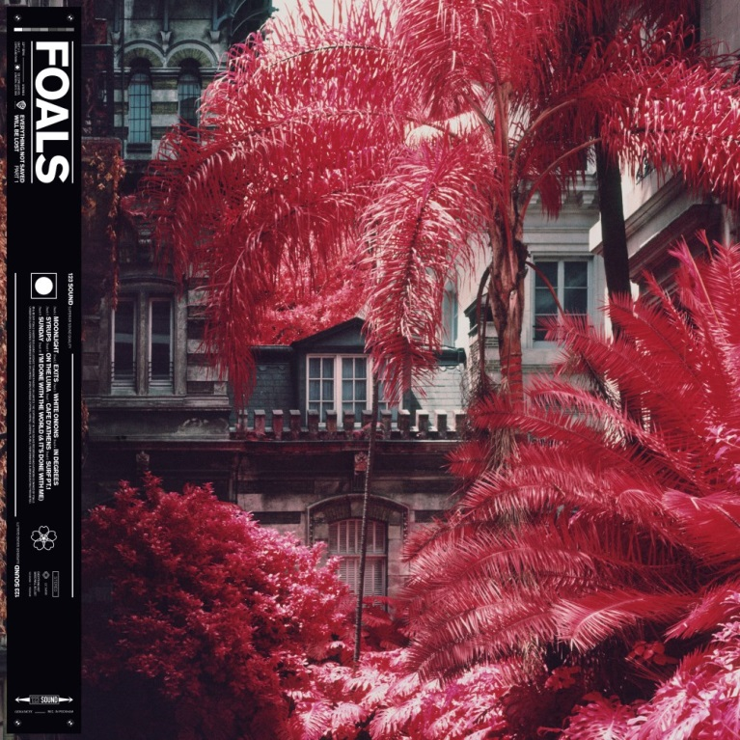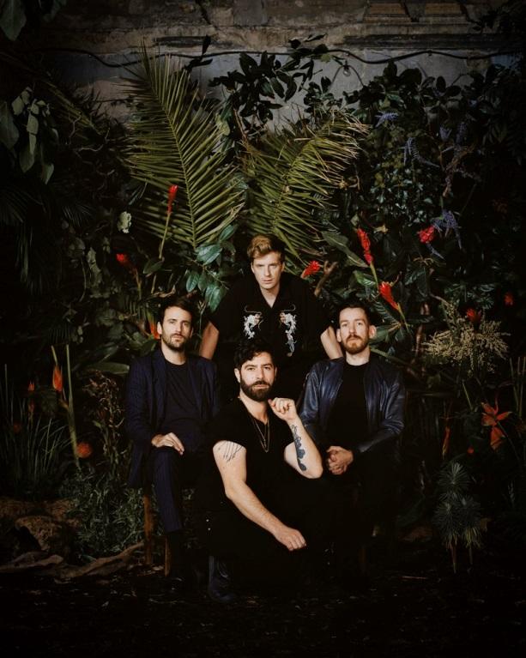
(Foals portrait by Alex Knowles. Download high res images here.)

Today, Foals announce that they will return with two new albums in 2019: Everything Not Saved Will Be Lost – Part 1 & 2, a pair of releases, separate but related, they share a title, themes and artwork. ‘Part 1’ will be released on March 8th, with ‘Part 2’ following in the Autumn. From playing chaotic house parties in their home city of Oxford to becoming major festival headliners across Europe, Foals’ trajectory has been remarkable. They’ve earned critical acclaim (NME and Q Award wins, plus Mercury Prize, Ivor Novello and BRIT Award nominations) and fan devotion (1.7 million sales of their four Gold-certified albums, plus over half a billion streams at Spotify since 2015) in equal measure. Everything Not Saved Will Be Lost – Part 1 is now available to pre-order here, with lead single, “Exits,” provided as an instant download.
The band today shares the music video for Everything Not Saved Will Be Lost – Part 1’s lead track, “Exits,” which was directed by Albert Moya, features actors Isaac Hempstead-Wright and Christa Théret, and was produced by CANADA. Watch it here.
This morning, Foals also confirm a 17-date North American headlining tour, which will kick off in Vancouver, BC on March 18th, with additional stops in Brooklyn, Seattle, Los Angeles, Philadelphia, Boston, and Chicago (full dates below) Tickets for these dates will be available here on Friday, January 25th at 10AM local time (with the exception of the April 16th Washington, D.C. show, which will be on sale Thursday, Jan. 24 at 10AM ET). The band will also perform a headline tour throughout the UK and Europe, in cities including London, Paris, Amsterdam, Berlin, and Glasgow (full dates below). Tickets for all European dates will be available here on Friday, Feb. 1 at 9AM local time. Twickets is the official ticket resale partner of the tour. To combat touts, resale is restricted to no more than face value. Buying or selling tickets on any other resale platform is strictly prohibited. Learn more here. The band has previously confirmed festival dates throughout North America including Mexico’s Vive Latino 2019 and Atlanta’s Shaky Knees Festival.

Profoundly tethered but possessing their own personalities, the two forthcoming albums capture the most compelling, ambitious and cohesive creations that Foals – completed by Jimmy Smith (guitar), Jack Bevan (drums) and Edwin Congreave (keys) – have ever produced. “They’re two halves of the same locket,” frontman Yannis Philippakis explains. “They can be listened to and appreciated individually, but fundamentally, they are companion pieces.”
Eager to break the traditional pop song structure which they felt they were becoming increasingly tapered to, the 20 tracks defy expectation. There are exploratory, progressive-tinged tracks which occasionally break the 10-minute mark alongside atmospheric segues which make the music an experience rather than a mere collection of songs. Yet the band’s renowned ability to wield relentless grooves with striking power also reaches new heights.

The albums’ lead single “Exits” is a case in point, featuring Philippakis conjuring the image of a disorienting world via a contagious vocal melody. It’s a fresh anthem for Foals’ formidable arsenal, but also an ominous forecast.

“There's a definite idea about the world being no longer habitable in the way that it was,” says Yannis. “A kind of perilousness lack of predictability and a feeling of being overwhelmed by the magnitudes of the problems we face. What's the response? And what’s the purpose of any response that one individual can have?”

“Exits” signposts what to expect thematically from Everything Not Saved Will Be Lost. The title is a warning that anything – from the tiniest fleeting moment of inspiration through to the planet’s own biological diversity – can be under threat of being irrevocably erased.

It’s a theme that permeates throughout the albums’ material, as Foals mirror the public neuroses that have been provoked by our current cultural climate. Paranoia of state surveillance? Fear of environmental collapse? An overwhelming feeling of anxiety? It’s all there in these apocalyptic songs.

It’s particularly evident in the euphoric “In Degrees” which imagines a future where your ability to talk to each other has been reduced to nothing. This approach is perhaps most vividly captured on ‘Syrups’, and the devastating closing pair of songs on Part 1, “Sunday” and “I’m Done With The World (& It’s Done With Me)”.

“Lyrically, there are resonances with what's going on in the world at the moment,” summarises Yannis. “I just feel like, what’s the utility of being a musician these days, if you can’t engage with at least some of this stuff? These songs are white flags, or they’re SOSs, or they’re cries for help… each in a different way.”

The new albums’ journeys began as the What Went Down era ended. Founding bassist Walter Gervers departed on amicable terms after playing the Festival Paredes de Coura in Portugal in August 2017. Foals felt that he couldn’t be replaced – a decision that ushered in a period of recalibration, reorganisation and, ultimately, rejuvenation.

After taking a little time out, Foals reconvened with Yannis on production duties, who, together with Edwin, also covered the bass parts. They began by writing in a rehearsal space before exporting those sketches into the recording phase at 123 Studios, Peckham, London with the assistance of engineer Brett Shaw. They’d repeat the cycle between the two spaces, effectively creating an ongoing feedback loop as they sought to push every new idea to the finish line.

Everything Not Saved Will Be Lost – Part 1 tracklisting:

1. Moonlight
2. Exits
3. White Onions
4. In Degrees
5. Syrups
6. On The Luna
7. Cafe D'Athens
8. Surf Pt.1
9. Sunday
10. I'm Done With The World (& It’s Done With Me)

FOALS TOUR DATES
March 16 /// Mexico City, Mexico /// Vive Latino 2019*
March 18 /// Vancouver, BC /// Orpheum Theater
March 19 /// Portland, OR /// Roseland Theater
March 20 /// Seattle, WA /// Paramount Theatre
March 22 /// Oakland, CA /// Fox Theater
March 23 /// San Diego, CA /// The Observatory North Park
March 24 /// Los Angeles, CA /// Shrine Auditorium
March 27 /// Las Vegas, NV /// Brooklyn Bowl
March 30 /// Buenos Aires, Argentina /// Lollapalooza 2019*
March 31 /// Santiago, Chile /// Lollapalooza 2019*
April 2 /// Santiago, Chile /// Lollapalooza Sideshow @ Teatro La Cúpula*
April 5 /// Sao Paulo, Brazil /// Lollapalooza 2019*
April 13 /// Brooklyn, NY /// Brooklyn Steel
April 16 /// Washington, D.C. /// 9:30 Club
April 19 /// Boston, MA /// House of Blues
April 20 /// Philadelphia, PA /// The Fillmore
April 22 /// Toronto, ON /// Rebel
April 24 /// St. Louis, MO /// The Pageant
April 26 /// Detroit, MI /// Saint Andrews Hall
April 27 /// Chicago, IL /// Riviera Theatre
April 28 /// Milwaukee, WI /// The Rave
April 30 /// Minneapolis, MN /// First Avenue
May 3 - May 5 /// Atlanta, GA /// Shaky Knees Festival 2019*
May 12 /// Brussels, Belgium /// Ancienne Belgique
May 13 /// Paris, France /// Bataclan
May 15 /// Lausanne, Switzerland /// Les Docks
May 16 /// Milan, Italy /// Fabrique
May 17 /// Luxembourg, Luxembourg /// Den Atelier
May 19 /// Amsterdam, Netherlands /// Paradiso
May 20 /// Berlin, Germany /// Huxleys
May 24 /// Newcastle, United Kingdom /// This Is Tomorrow 2019*
June 5 /// Hamburg, Germany /// Grosse Freiheit
June 6 /// Aaarhus, Denmark /// Northside Festival*
June 7 - June 9 /// Nürburg, Germany /// Rock Am Ring 2019*
June 11 /// Manchester, United Kingdom /// O2 Victoria Warehouse
June 14 /// Tunbridge Wells, United Kingdom /// Bedgebury Pinetum
June 15 /// Birmingham, United Kingdom /// Digbeth Arena
June 18 /// Glasgow, United Kingdom /// SWG3 Galvanizers Yard
June 20 /// Thetford, United Kingdom /// Thetford Forest
June 21 /// London, United Kingdom /// Alexandra Palace
June 24 - June 26 /// Zagreb, Croatia /// Inmusic Festival*
June 26 /// Bournemouth, United Kingdom /// International Centre
July 2 /// Dublin, Ireland /// Trinity College
July 5 /// Barcelona, Spain /// Festival Cruïlla 2019*
July 5- Jul 7 /// Ewijk, Netherlands /// Down The Rabbit Hole*
July 26 - Jul 28 /// Benidorm, Spain /// Low Festival 2019*
August 1 - Aug 3 /// Lustenau, Austria /// Szene Open Air*
*Festival Date

Official site
Spotify
Facebook
Instagram
YouTube
Twitter
For more information, please contact Mary Moyer (mary@qprime.com) or Emilio Herce (emilio@qprime.com) at Q Prime 212.302.9790.

