BREAKOUT SINGER/SONGWRITER PATRICK DRONEY ANNOUNCES DEBUT STUDIO ALBUM STATE OF THE HEART VIA WARNER RECORDS - OUT MAY 21

RAZOR SHARP TITLE TRACK AND ACCOMPANYING MUSIC VIDEO STARRING LUCY HALE AVAILABLE NOW FOLLOWING ENTERTAINMENT TONIGHT’S FIRST LOOK – LISTEN/WATCH HERE

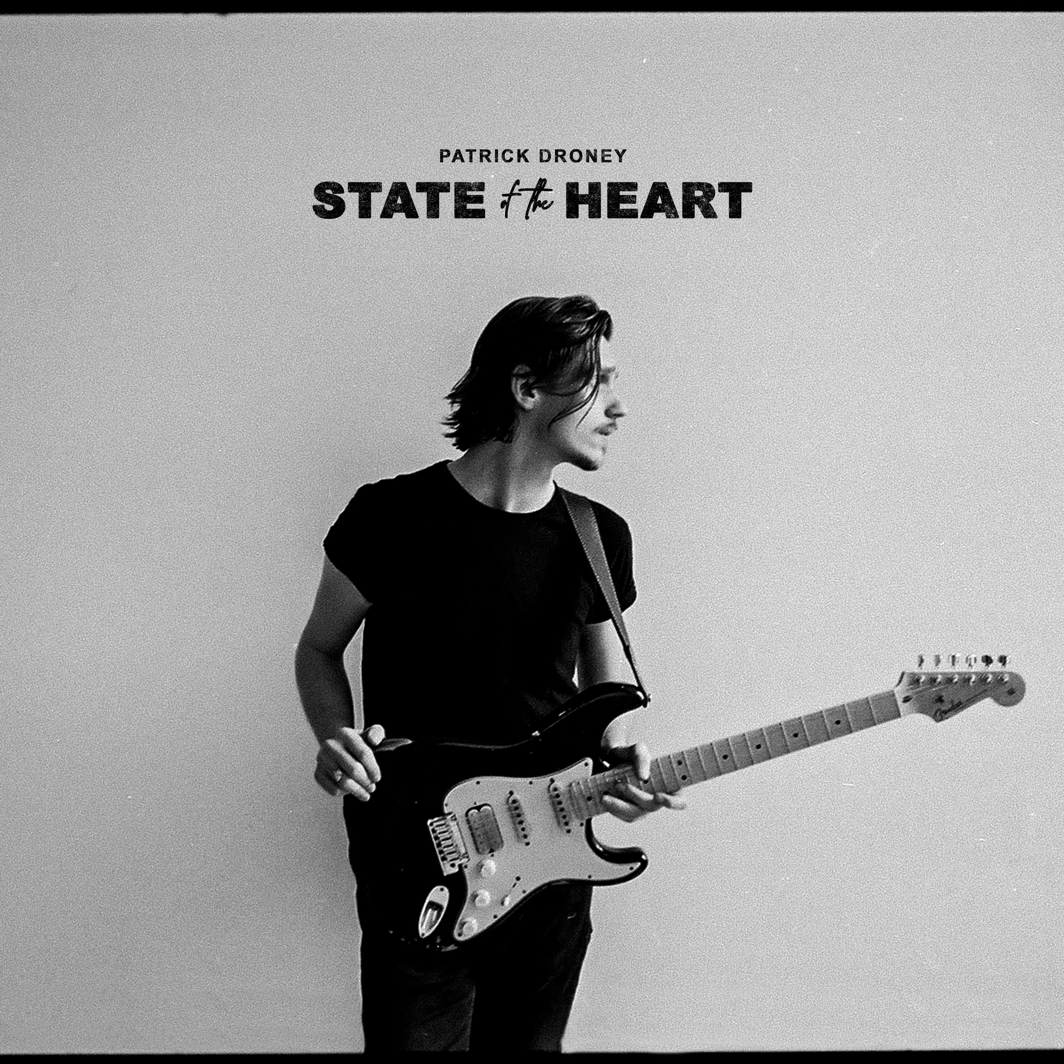

Nashville, TN - March 26, 2021 - Singer, songwriter and celebrated guitarist Patrick Droney announces plans today for his upcoming debut full-length studio album STATE OF THE HEART via Warner Records, available May 21. Building on the success of a “momentous 2020” (American Songwriter), and continuing to stretch into themes dripping throughout his acclaimed EP of the same title - the meaning of loss, reconciling what’s behind you and the pursuit of self - STATE OF THE HEART boasts 15 tracks entirely co-produced and co-written by Droney. The pulsating title track is out today, while the album is available for pre-save.

Contributing multiple instrumental credits including signature electric guitar, keys, bass and drums, Droney prominently mines inspiration and confessional details from multiple coming-of-age seasons crafting his debut album across New York City, Los Angeles and Nashville, weaving listeners through the heartbeat of three cities for some of his most intimate storytelling. Moments like the groove-tinged “River” explores the essence of time, bolstered by red-hot electric guitar riffs, while “Talk About That” is a masterful offering finding Droney searching deeper about the human condition. The solo-penned “On Your Way Home” put Droney’s textured vocals on the forefront and “When The Lights Go Out” is an infectious jolt of energy paired over a sprawling melody.

"It’s been a true journey to the state of the heart,” Droney shared. "This album is both an accumulation of where I’ve been these last ten years as well as a real starting point towards where I’m going. I hope this collection of songs serves as a friend on the long, but worthy, pursuit of trying to find ourselves."

Continuing the momentum today, the singer/songwriter released the music video for title track “State of the Heart,” starring Lucy Hale, available to watch HERE. Directed by Gus Black and previewed yesterday by Entertainment Tonight, the cinematic video finds a strongly bonded young couple as they struggle against what they can’t ignore, “fighting with time so we take shots in the dark.” The video is punctuated with scorching guitar solos, set across iconic locations in Los Angeles.

STATE OF THE HEART Track List

1. State of the Heart
2. Talk About That
3. When the Lights Go Out
4. Yours in the Morning
5. River
6. Little by Little
7. The Wire
8. Nowhere Town
9. Guess That's Why I'm Calling
10. Where You Are
11. Glitter
12. Right With You
13. Chasing You
14. Passerby
15. On Your Way Home

Blessed with a gift for soulful, 21st-century pop melodies and armed with guitar skills that nod to past masters, Pennsylvania-born Patrick Droney creates songs that feel timeless and new all at once. He picked up a six-string before he started grade school and received the Robert Johnson Foundation's Next Generation Award by the tender age of 12, securing cosigns from legends like James Brown and B.B. King. After following music from the Clive Davis Institute at NYU to sunny L.A. to Nashville, Droney dropped a self-titled debut EP in 2018, establishing himself as a master of both incendiary R&B grooves ("Stand and Deliver") and dreamy pop songs ("High Hope") that soar with transcendent guitar, landing him performances at a sold-out Barclays Center for Tidal X and on Late Night with Seth Meyers, plus a deal as a Fender ambassador. Now signed to Warner Records with more than 50 million streams to date, he most recently unveiled the State of the Heart EP, which earned acclaim from the likes of American Songwriter, SPIN, Ones To Watch, and more.

###

