For Immediate Release October 18, 2019

FOALS’S EVERYTHING NOT SAVED WILL BE LOST – PART 2 OUT NOW VIA WARNER RECORDS

EVERYTHING NOT SAVED WILL BE LOST – PART 1 WINS “BEST ALBUM” OF 2019 AT
UK Q AWARDS

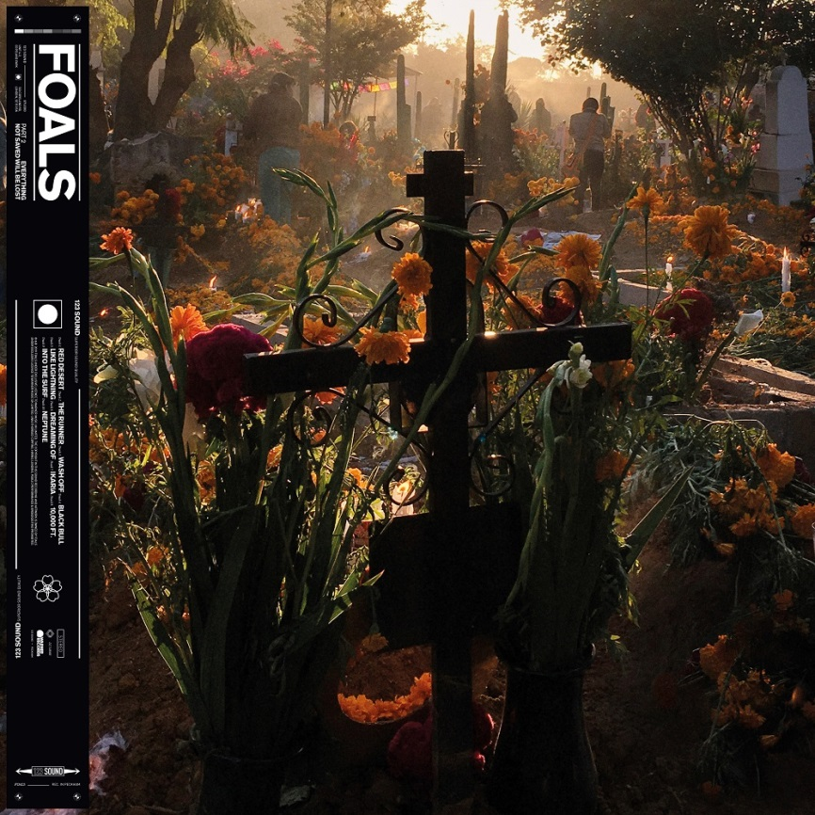
Critical Praise For Everything Not Saved Will Be Lost – Part 2

“…a grander, more bombastic collection of songs”
-NPR Music

“The post-punk band Foals are doing their best to bring back spine-tingling, sweaty live club shows. “Everything Not Saved Will be Lost — Part 2,” the sequel to a raging record from March, is the conclusion of a song cycle about destruction and survival of all kinds.”
-The New York Times

“…these batch of songs prove Foals to be at the top of their game, making complex, brilliant music.”
-Associated Press

“….this follow-up is indisputable proof of their greatness’
- NME 5/5

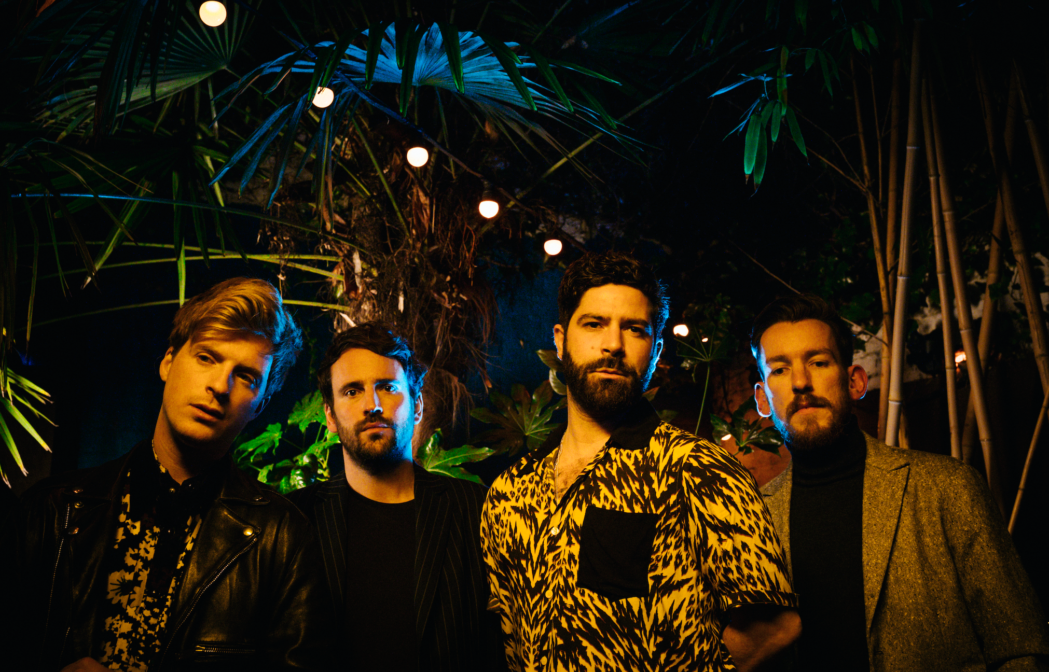
Today, Foals release Everything Not Saved Will Be Lost – Part 2 via Warner Records. The album completes the artistic statement and striking state-of-the-world-address of Everything Not Saved Will Be Lost – Part 1, and the Associated Press says “these batch of songs prove Foals to be at the top of their game, making complex, brilliant music.”
The album is available on CD, digital and vinyl formats here. Special editions include orange vinyl available exclusively through indie stores and a picture disc which is designed to be added to the Everything Not Saved Will Be Lost Collector’s Edition boxset.

On Wednesday, Foals took home the “Best Album” award at 2019’s UK Q Awards for Everything Not Saved Will Be Lost – Part 1. Since their start in 1990, The Q Awards, run by the music magazine Q, have become one of Britain's most pretegiouis music awards.

Recently, Foals debuted their animated music video for “Into The Surf.” The video explores the story of two people who are irresistibly drawn together, set against a backdrop of Greek scenery – mountainous coastlines and clear blue water – as they seek to reconnect. Fate has other ideas though, and their goal falls agonisingly short at the last moment. The song and video were inspired by frontman Yannis Philippakis’ Greek family background and reflect themes that are prevalent in Greek folk music, such as dying in a foreign land far away from your family. Watch the video for “Into The Surf” here.
Collectively, Every Not Saved Will Be Lost is symbolic of Foals’ trajectory so far. From playing chaotic house parties in their home city of Oxford to becoming major festival headliners across Europe, they’ve earned critical acclaim (NME and Q Award wins, plus Mercury Prize, Ivor Novello and BRIT Award nominations) and fan devotion (1.7 million album sales, plus over half a billion streams at Spotify since 2015) in equal measure.

Foals followed the release of Part 1 by completing an extended tour of the US and Europe, and have just added dates throughout the UK in 2020. Please see http://www.foals.co.uk/tour for a full list of dates and ticket information.

Everything Not Saved Will Be Lost – Part 2 tracklist:
1. “Red Desert”
2. “The Runner”
3. “Wash Off”
4. “Black Bull”
5. “Like Lightning”
6. “Dreaming Of”
7. “Ikaria”
8. “10,000 Feet”
9. “Into the Surf”
10. “Neptune”

Official site
Spotify
Facebook
Instagram
YouTube
Twitter

For more information, please contact Mary Moyer (mary@qprime.com) or Emilio Herce (emilio@qprime.com) at Q Prime 212.302.9790.

