SHARES NEW VIDEO FOR “I’VE ALL I NEED”
FROM HIS DEBUT ALBUM AS YOU WERE

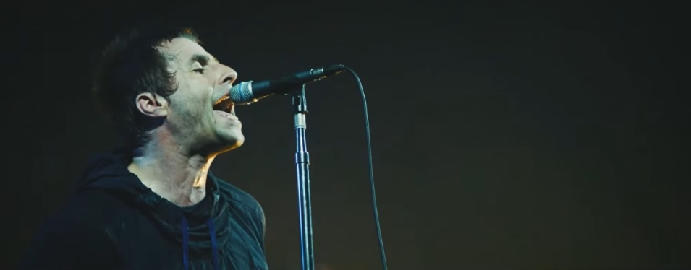

May 25, 2018 (Los Angeles, CA) Liam Gallagher completes the comeback of the decade with his critically acclaimed debut album AS YOU WERE. Gallagher has recently completed a sold-out tour of the U.S. and is about to begin the summer season of massive outdoor shows and festivals. To celebrate, Gallagher shares a brand-new video for the track “I’ve All I Need,” from his internationally acclaimed
solo debut.

Directed by Charlie Lightening, the video presents a snapshot of some of Gallagher’s highlights throughout the course of the past year. Opening with footage of him putting the finishing touches to As You Were, the video finds Gallagher inspiring chaotic crowd reactions from Glastonbury Festival, Manchester, Japan and beyond. There’s also a wealth of intimate behind-the-scenes clips which includes some famous faces in the shape of David Beckham, Stormzy, and Foo Fighters duo Dave Grohl and Taylor Hawkins.

Click here to view and share “I’ve All I Need”

“I’ve All I Need” will also be released on limited edition 7” vinyl today, with the song’s lyrics etched onto the b-side. Click here for further information.

Released in October, As You Were shot straight to #1 in the U.K. with over 100,000 sales. It maintained a Top 10 chart position for five weeks, remained in the Top 40 for over six months, and was certified Platinum for 300,000 domestic sales back in February.

Having just played a stadium show as special guest to The Rolling Stones, Gallagher’s summer touring schedule features the following U.K. and Ireland dates. Click here for tour and ticket details.

Meanwhile, the press on both sides of the Atlantic continue to respond in kind:

“Gallagher’s lyrics are frank and honest with a touch of self-deprecation.” – Rolling Stone

“As You Were stands as proof that rock’s most charismatic general is back on active service and spoiling for trouble. How we’ve missed him.” **** – Q Magazine

“Like a boxing champ making his way to the ring, Gallagher entered the stage. It was a moment that best encapsulated the show: no flashy gimmicks, all about the music.” -- Mxdwn

“It’s by some stretch the best Liam-fronted outing in two decades… a genuinely iconic voice amid strong material.” **** -- Mojo

# # #

For further information, contact Rick Gershon at Warner Bros. Records:
818-953-3473 / rick.gershon@wbr.com
Digital Assets:
Listen to As You Were here.
Follow Liam Gallagher:
Twitter
Spotify
Facebook
Instagram
liamgallagher.com

Press materials:
http://press.wbr.com/liamgallagher

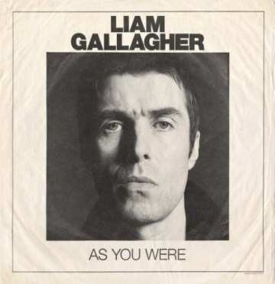
(hi-res image)

