GARY CLARK JR. COLLABORATES ON NEW TRACK
“VALLEY OF LAST RESORT” WITH GUSTAVO SANTAOLALLA AND
PAUL WILLIAMS

SONG FEATURED IN HUNTER S. THOMPSON DOCUMENTARY FREAK POWER: THE BALLOT OR THE BOMB ON AMAZON AND APPLETV

LISTEN HERE
WATCH HERE

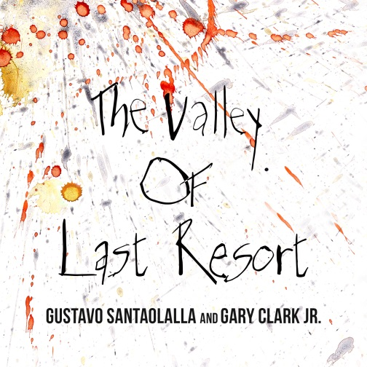

October 30, 2020 (Los Angeles, CA) – Four time Grammy Award-winner Gary Clark Jr. has collaborated on a new track written by and produced by multiple Grammy and two time Oscar-winning composer Gustavo Santaolalla (“Brokeback Mountain,” “Babel”) and co-written by Clark with lyrics by legendary songwriter Paul Williams titled, “Valley Of Last Resort.” The track is featured in Hunter S. Thompson documentary, Freak Power: The Ballot Or The Bomb, released on Amazon and AppleTV. Clark contributes some stunning vocals and electrifying guitar with Santaollala on vocals and playing multiple instruments including his trademark ronroco, which is available today via all DSP’s. Click here to stream “Valley Of Last Resort,” and here to view and share the visual.

The documentary captures Thompson’s searing and impactful 1970 campaign for Sheriff of Pitkin County, Colorado. FREAK POWER: The Ballot or the Bomb is co-directed by Daniel Joseph Watkins and Ajax Phillips, and produced by Mimi Polk Gitlin (“Thelma and Louise,” “The Breadwinner”) and Angus Wall (editor, “The Girl With the Dragon Tattoo,” “The Social Network”). Click here for further information.

“Valley of Last Resort” was inspired by the fact that 50 years later we are unfortunately confronted by similar issues as the civil unrest and protests in our country have been on the rise. This song is a delicately arranged testament to Clark’s ability to fluidly interpret diverse musical styles and textures working alongside Santaolalla and Williams. Clark and Santaolalla first met at Eric Clapton’s 2019 Crossroads Guitar Festival in September 2019, and this is another stunning collaboration after GCJ’s critically acclaimed triple-Grammy winning album, THIS LAND. His follow-up to THIS LAND is expected in 2021.

For further information, contact Rick Gershon at Warner Records:
Rick.Gershon@warnerrecords.com

FOLLOW GARY CLARK JR:
Official | Facebook | Twitter | Instagram | YouTube | Spotify | Publicity Materials

