GRAMMY AWARD-WINNER GARY CLARK JR. EXTENDS TOUR
READY TO LIGHT UP NORTH AMERICA THIS SUMMER

Tickets On Sale July 23 At 10:00AM Local Time

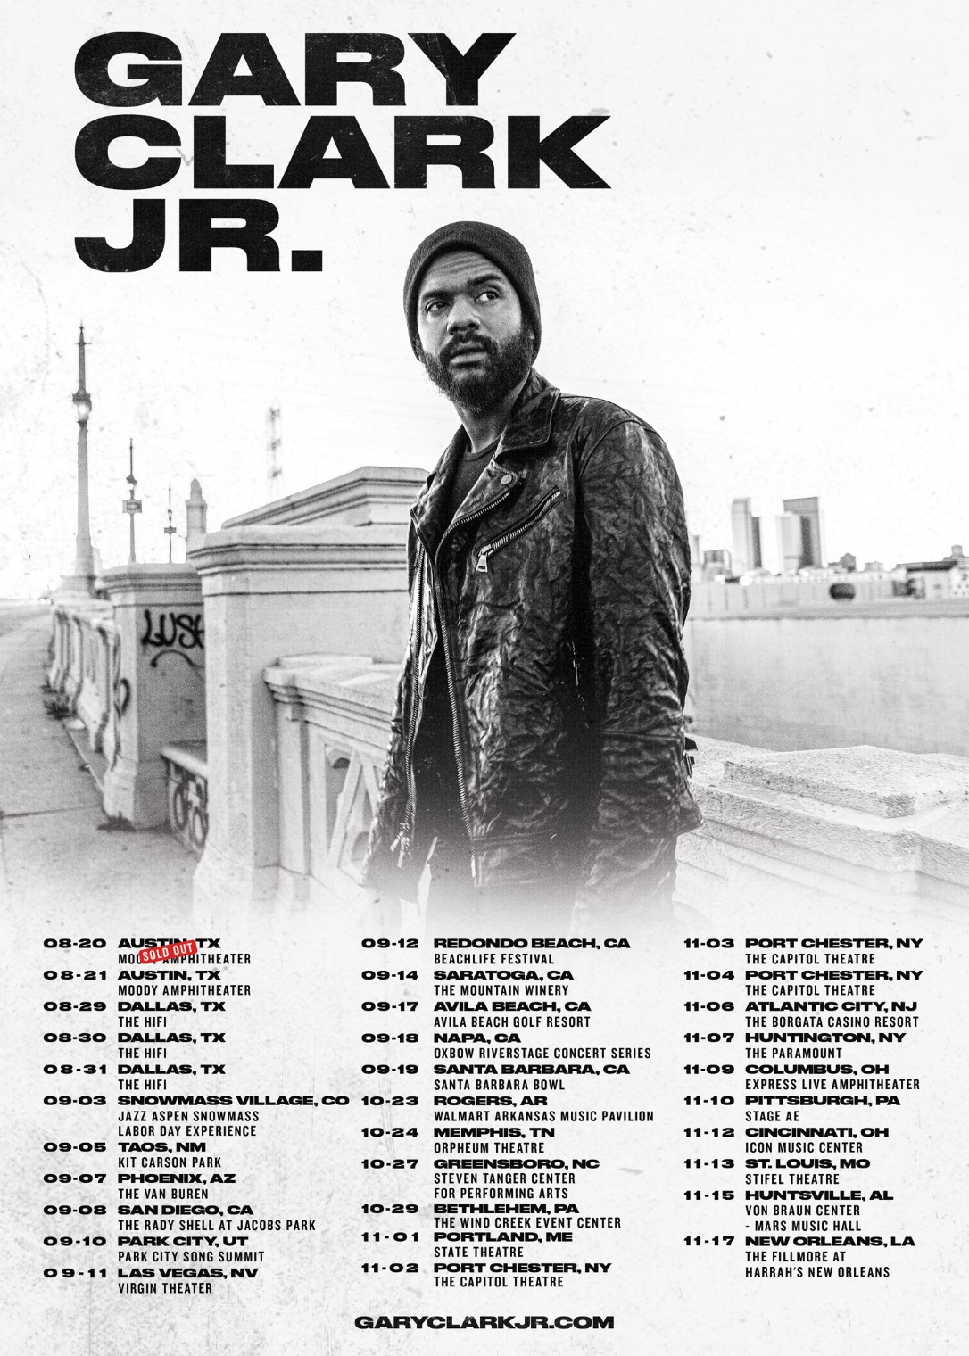

July 20, 2021 (Los Angeles, CA) – Due to popular demand, Grammy Award-winner Gary Clark Jr. has extended his US tour into Fall 2021. The tour marks Clark’s return to the concert stage for the first time in 18 months. Tickets for the new dates go on sale Friday, July 23, at 10:00AM local time. Click here for further details.

At present, the Austin-born artist and producer is working on new material for his next full-length album. Details to follow.

# Indicates newly confirmed show

US TOUR DATES 2021:
Aug 20 Austin, TX Moody Theater (SOLD OUT)
#Aug 21 Austin, TX Moody Theater (2nd show added)
Aug 29 Dallas, TX The HiFi
Aug 30 Dallas, TX The HiFi
Aug 31 Dallas, TX The HiFi
Sep 03 Snowmass Village, CO Jazz Aspen Snowmass Labor Day Experience
#Sep 05 Taos, NM Kit Carson Park
Sep 07 Phoenix, AZ The Van Buren
Sep 08 San Diego, CA The Shell
Sep 10 Park City, UT Park City Song Summit
Sep 11 Las Vegas, NV Virgin Theater (on sale now)
Sep 12 Redondo Beach, CA BeachLife Festival
Sep 14 Saratoga, CA The Mountain Winery (on sale now)
Sep 17 Avila Beach, CA Avila Beach Golf Resort
Sep 18 Napa, CA Oxbow RiverStage Concert Series
Sep 19 Santa Barbara, CA Santa Barbara Bowl
#Oct 23 Rogers, AR Walmart Amphitheater
#Oct 24 Memphis, TN Orpheum
#Oct 27 Greensboro, NC Steven Tanger Center For The Performing Arts
#Oct 29 Bethlehem, PA The Wind Creek Events Center
#Nov 01 Portland, ME State Theatre
#Nov 02 Post Chester, NY The Capitol Theatre
#Nov 03 Post Chester, NY The Capitol Theatre
#Nov 04 Post Chester, NY The Capitol Theatre
#Nov 06 Atlantic City, NJ The Borgata Casino Resort
#Nov 07 Huntington, NY Paramount
#Nov 09 Columbus, OH Express Live
#Nov 10 Pittsburgh, PA Stage AE
#Nov 12 Cincinnati, OH Icon Music Center
#Nov 13 St. Louis, MO Stifel Theatre
#Nov 15 Huntsville, Al Mars Music Center
#Nov 17 New Orleans, LA Fillmore

Europe 2022:
Jun 04 Lisboa, Portugal Passeio Maritimo
Jun 07 Seville, Spain Benito Villamerin Stadium
Jun 15 Rogaland, Norway Forus Travbane (Forus Racecourse)
Jun 18 Prague, Czech Republic Letnany Airport
Jun 20 Warsaw, Poland PGE Narodowy
Jun 23 Groningen, Netherlands Stadspark Groningen
Jun 28 Dublin, Ireland Marlay Park
July 01 London, UK Tottenham Hotspur Stadium
July 02 London, UK Tottenham Hotspur Stadium
July 05 Glasgow, UK TRNSMT Festival (Glasgow Green)
July 08 Munich, Germany Munich Olympic Stadium
July 10 Milan, Italy San Siro Stadium
July 13 Vienna, Austria Ernst Happel Stadion Wien

About Gary Clark Jr.:
Clark achieved global impact following his first Grammy Award® in 2014 winning Best Traditional R&B Performance for the track “Please Come Home” from his Warner Records debut album Blak And Blu, and seemingly never left the road. 2015’s The Story Of Sonny Boy Slim wrought hard- won international acclaim as a critical force to be reckoned with. Throughout 2019 Clark ascended to greater heights with the release of THIS LAND – his third full-length studio album which bowed at #6 on the Billboard Top 200, marking his third consecutive Top 10 debut. The album and single of the same name attracted acclaim from the likes of The New York Times, The Washington Post, The Los Angeles Times, Rolling Stone, Pitchfork and more. He has performed on Saturday Night Live, The Late Show with Stephen Colbert, The Ellen DeGeneres Show, The Tonight Show Starring Jimmy Fallon, The Late Late Show with James Corden, Jimmy Kimmel Live!, Good Morning America, CBS News Sunday, CBS This Morning, The Today Show, Late Night with Seth Meyers, The Daily Show with Trevor Noah, The Howard Stern Show, WTF with Marc Maron and more. Clark’s domestic tours became instant sell outs and his international profile found him topping bills at legendary festivals around the world and venues including the Hollywood Bowl, along with multiple appearances in stadiums supporting and sharing the stage with The Rolling Stones. Most recently, Clark won three more Grammy Awards including Best Rock Performance “This Land,” Best Rock Song “This Land,” and Best Contemporary Blues Album THIS LAND. Clark also performed his award-winning single “This Land,” backed by The Roots at last year’s Grammy Award® ceremony and released their version of the track. Countless collaborations have been recorded with Stevie Wonder, Andra Day, John Legend, Alecia Keys, Foo Fighters, Nas, Sheryl Crow, Brandi Carlile, Eric Clapton, Gustavo Santaolalla, Booker T. Jones, and many more. To date, Clark has been nominated for six GRAMMY Awards® and won four. Clark is currently working on his follow-up to THIS LAND.

For further information, contact Rick Gershon at Warner Records:
Rick.Gershon@warnerrecords.com

FOLLOW GARY CLARK JR.:
Official | Facebook | Twitter | Instagram | YouTube | Spotify | Publicity Materials

