Gerard Way Releases New Track
“Here Comes The End” Featuring Judith Hill

Track Is Released in Celebration of the Second Season of Netflix Show, Umbrella Academy

Photo credit: Lindsey Ballato

The clock is moving
Hands to midnight
Can we get through this?
While the walls come down we all pretend
Here comes the end

July 8, 2020 (Los Angeles, CA) – After releasing a few Quarantine tracks to his personal SoundCloud account only, My Chemical Romance front man, Gerard Way, is back with his first properly released song of 2020. “Here Comes The End” features stunner, Judith Hill, and was recorded for Netflix’s hit series, Umbrella Academy. Gerard explains of the song “I was originally inspired to write this track when series one of Umbrella Academy was being shot, by the time I finished it 2020 was in full swing, the world had taken a profound turn and the song was finished in a surreal new reality.”
The track feels simultaneously inspired by current events, early 90’s Primal Scream and The Rolling Stones. The song is released today with the trailer for the second season of Umbrella Academy, which will be available on July 31.

Listen to “Here Comes The End” HERE.
Watch the trailer HERE.

Umbrella Academy is based on the popular Eisner award-winning comics and graphic novels created by Gerard Way and Gabriel Ba and published by Dark Horse Comics.

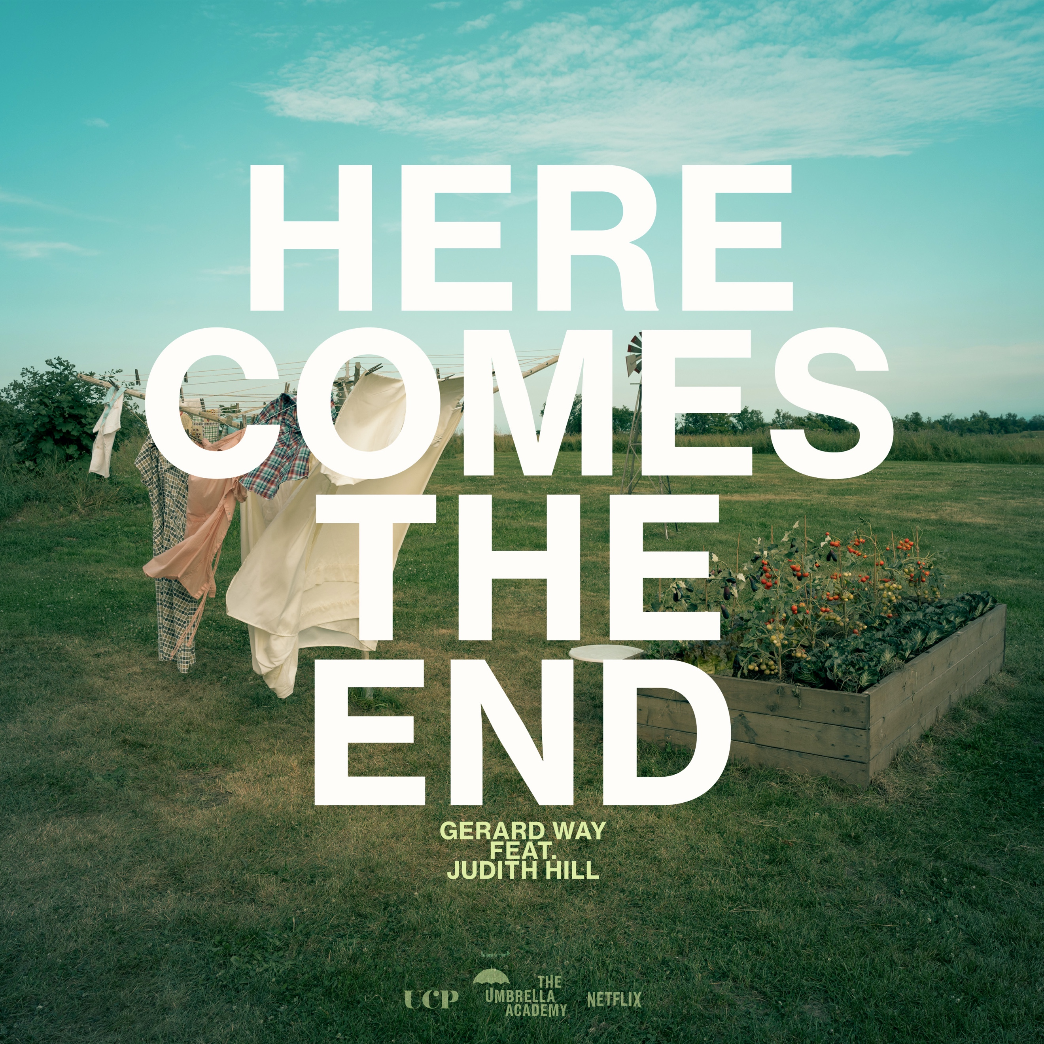

###

For more information, contact:

Bobbie Gale at MixedMediaWorks
bobbie@mixedmediaworks.com

Darren Baber at Warner Records
Darren.baber@warnerrecords.com

