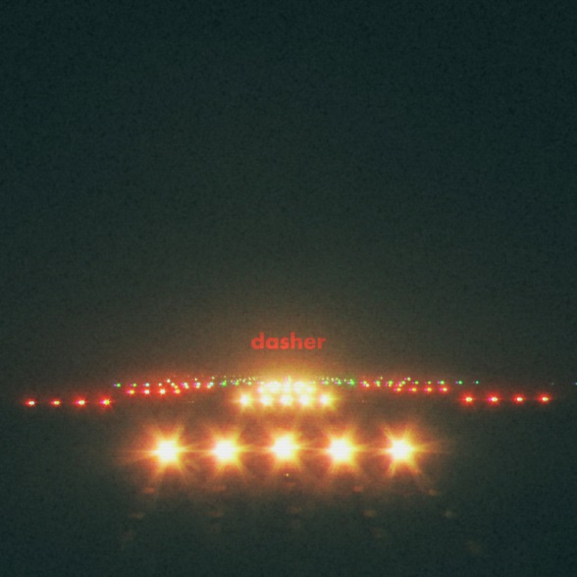
December 14, 2018 (Los Angeles, CA) – Gerard Way releases new single today via Reprise Records. Gerard has been playing/working in the studio lately – so we are being blessed with a third track in two months.
‘Tis the season for Christmas releases….so we present to you Gerard’s version of a Christmas song – “Dasher.”

On this new track, Gerard says, “‘Dasher’ is about a girl who falls in love with a reindeer. The reindeer thinks she’s pretty great too. They have adventures, they talk about life. The song is also about the magic sometimes hidden in the mundane.”
Click HERE to listen
Click HERE to watch lyric video
In other Gerard news, Netflix has just shared a trailer for The Umbrella Academy, Gerard’s comic book series, which the media company has produced into a show coming in 2019. Click HERE
###

Press Contacts:
Bobbie Gale / Warner Bros. Records
(818) 953-3692 / Bobbie.Gale@wbr.com

