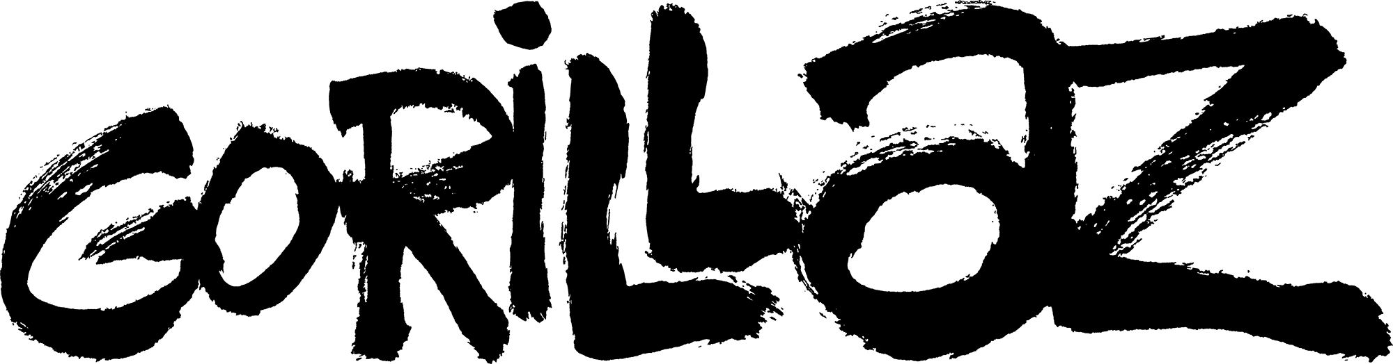

Song Machine strikes again!

Elton John & 6LACK join Gorillaz for

‘THE PINK PHANTOM’

WATCH NOW!

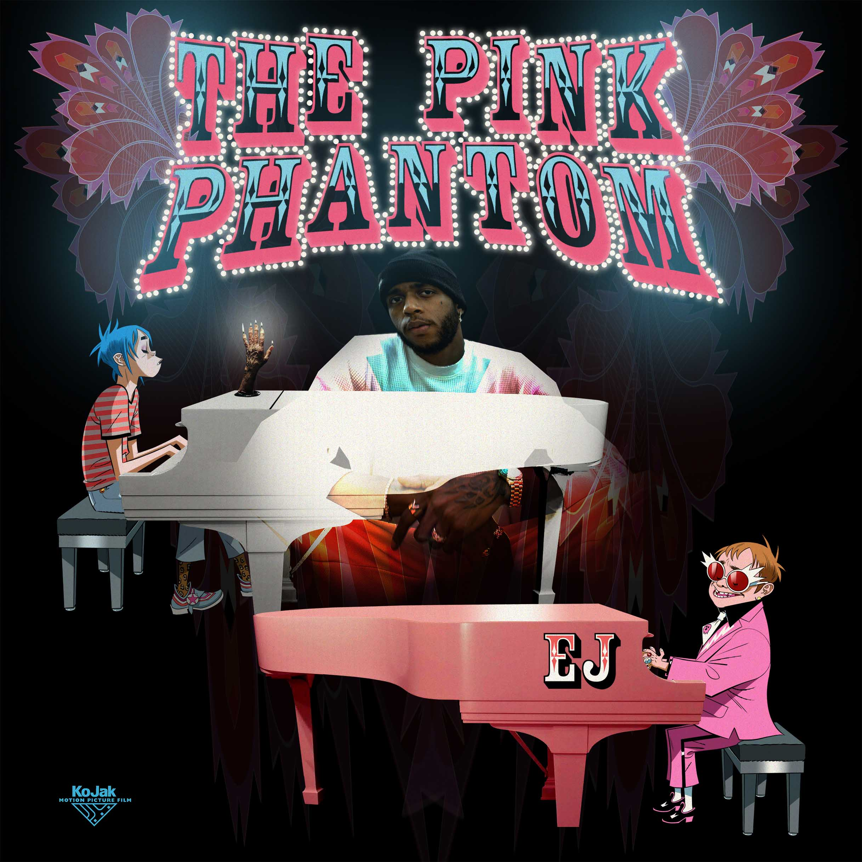

FOLLOW SONG MACHINE HERE

‘The Pink Phantom’ featuring Elton John & 6LACK is the latest episode of Song Machine and sees Gorillaz joined by a unique combination of talent in the one and only Elton John – as you have never seen him before! - and GRAMMY-nominated Atlanta rapper 6LACK. Watch the video here.
Elton John said of the collaboration: “Damon reached out and asked me to do something and the way the song has turned out is just great. I was in the studio in London and he was at the other end in Devon, but even remotely it was such an engaging and creative process. I’ve always loved Damon because he encompasses so many different sorts of music. He has his fingers in so many pies and although he's achieved so much, he never sits still creatively. He's constantly pushing forward and embracing the new, which is admirable and rare. He’s always working - he’s always doing something. He’s done so much to promote music from around the world, from Africa, from China, that people hadn't previously heard and I really admire that. I’ve always been a Gorillaz fan anyway, so when he asked me to do a Gorillaz track - it was a no brainer. I’m so very, very happy that that’s come about.”

Gorillaz frontman 2D added: INSERT 2D QUOTE

The full collection of Song Machine: Season One is out on 23rd October, complete details here.

And coming on 12th & 13th December is SONG MACHINE LIVE, a global live stream which will be Gorillaz only live performance this year. For more information visit LIVENow.

Download high res press shot here: insert link

For press enquiries, please call RMP/Good Machine on 0208 749 7999
Brídín Murphy Mitchell: bridin@rmplondon.co.uk
Chris Cuff: chris.cuff@goodmachinepr.com

1st October 2020

Further Information:

Watch Episode 1 - Momentary Bliss ft. slowthai and Slaves - here.
Watch Episode 2 - Désolé ft Fatoumata Diawara – here.
Watch Episode 3 – Aries ft Peter Hook and Georgia – here.
Watch Episode 4 – Friday 13th ft Octavian – here
Watch Episode 5 – Pac-Man ft ScHoolboy Q - here
Watch Episode 6 – Strange Timez ft Robert Smith – here

www.gorillaz.com
Gorillaz are once again disrupting the paradigm and breaking convention in their round the back door fashion with Song Machine, the newest concept from one of the most inventive bands around. Song Machine will see Gorillaz joined by an exciting and ever-evolving roster of as yet unannounced collaborators captured live in Kong Studios alongside the world’s most successful virtual band*. The cameras are rolling 24/7, the fourth wall is broken, the kettle is on, the chaos is real, the door is open… What’s coming next? Stay tuned.

Song Machine: Season One - Strange Timez is out on 23rd October 2020 with physical releases on standard CD, vinyl and cassette; plus the 17-track Deluxe and Super Deluxe box sets. Not forgetting the bulging full-colour, one-of-a-kind 210-page Almanac, the very first annual from Gorillaz.
Virtual band Gorillaz is singer 2D, bassist Murdoc Niccals, guitarist Noodle and drummer Russel Hobbs. Created by Damon Albarn and Jamie Hewlett, their acclaimed eponymous debut album was released in 2001. The BRIT and Grammy Award winning band’s subsequent albums are Demon Days (2005), Plastic Beach (2010), The Fall (2011), Humanz (2017) and The Now Now (2018). A truly global phenomenon, Gorillaz have achieved success in entirely ground-breaking ways, touring the world from San Diego to Syria, winning numerous awards including the coveted Jim Henson Creativity Honor.
* The band are recognised by The Guinness Book Of World Records as the planet’s Most Successful Virtual Act.

About 6LACK:
Pronounced “Black”, the alternative R&B and three-time GRAMMY-nominated rapper/singer/songwriter 6LACK is the #2 most streamed R&B artist behind Frank Ocean. His debut project FREE 6LACK recently went platinum, and his sophomore album released East Atlanta Love Letter (now certified GOLD) to critical acclaim and peaked at #3 on the Billboard 200 and #1 on the Top R&B Albums. 6LACK has been the most featured artist of 2019-2020 with over 30 features, and hasn't missed a beat releasing his latest project 6 PC HOT EP, which went top 5 on the R&B Charts, in addition to its R&B debut, 6pc opened at No. 11 on Top R&B/Hip-Hop Albums and at No. 15 on the all-genre Billboard 200.

