UK ARTIST GRIFF REVEALS NEW TRACK
“DIDN’T BREAK IT ENOUGH”

WATCH THE VIDEO NOW
DEBUT EP COMING SOON

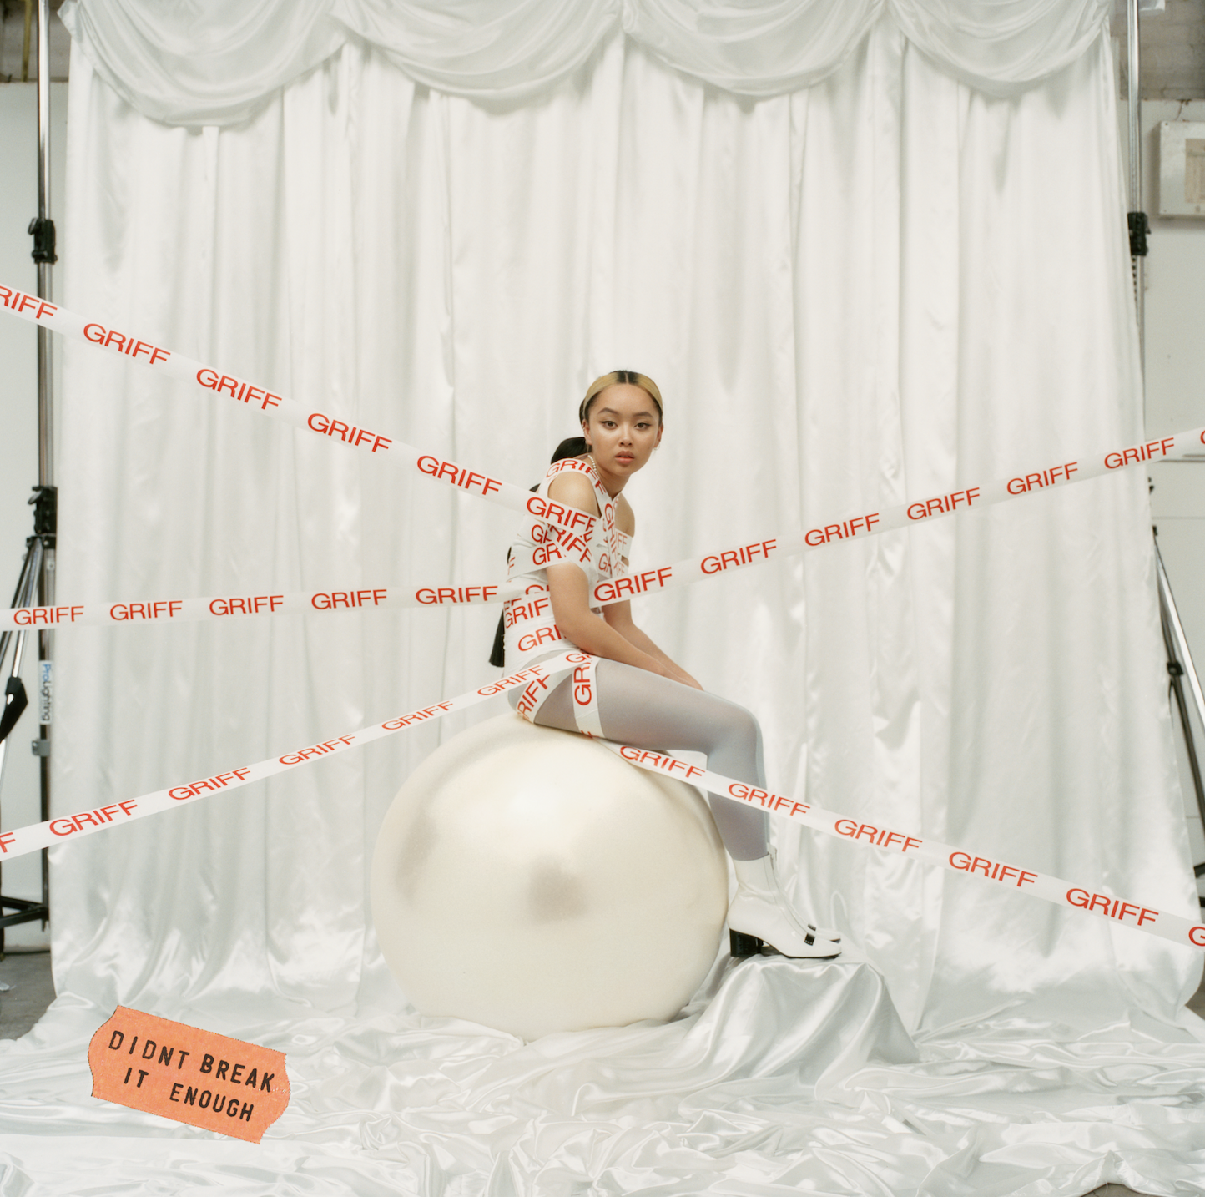

"Griff looks every bit like pop’s bright new star...it is, quite frankly, all rather brilliant" - i-D
"Startlingly good...her alt-R&B smarts come through" - Sunday Times
"A no-nonsense debut…Griff cuts a strong, empowering female voice: she knows the
weight of her strength as well as her flaws" - The Line of Best Fit
“Bedroom pop at its finest…electric” - Nylon

LISTEN TO TRACK HERE
WATCH VIDEO HERE

August 30, 2019 (Los Angeles, CA) - At just 18-years-old, Griff made an immediate impact earlier this summer with her empowered but affecting debut single, “Mirror Talk,” via Warner Records. Having received its first play as Annie Mac’s ‘New Name’ on BBC’s Radio 1 shortly after completing her final exams – and gone on to receive widespread plaudits – “Mirror Talk” introduced Griff’s pop-powerhouse potential in effortless fashion. It’s this confidence – and vulnerability – that shines through again on second track, “Didn’t Break It Enough,” which strips back influences of electronic music, soul and R&B to their rawest essentials.

“I was trying say that when things are broken they’re not supposed to work,” comments Griff. “If a light bulb is broken it’s not gonna light up, but when the heart’s broken it can still love the same way and sometimes more than it did before it broke. This track is all me, I wrote and produced it alone sooo I do hope you like.”

Born to Chinese and Jamaican parents- alongside two brothers and the family's foster children - Griff grew up knowing that she stood out. She first became exposed to music through church, and then by borrowing her brother's Logic, when she started to write and record her own songs. Over the last few years, all Griff’s spare time outside the punishing schedule of completing school has been spent buried in her room, creating sounds in secret from her classmates (many of whom only found out what she’d been up to after her first track was released).

Having now finished school, Griff’s candid way with the thrilling highs and occasionally-melodramatic lows of modern teenage life will be brought together in her debut EP due later this year.
###
Press Contact:
Bobbie Gale / Warner Records
(818) 953-3692 / Bobbie.Gale@warnerrecords.com

