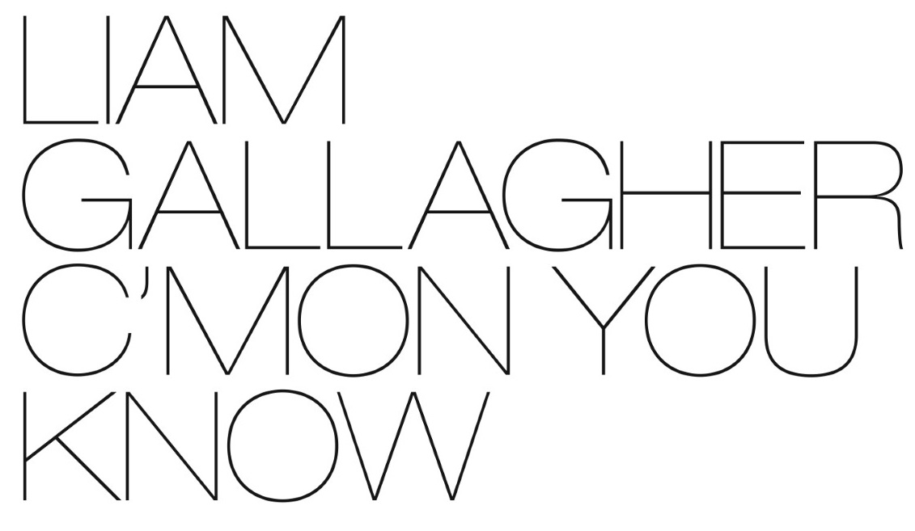

NEW STUDIO ALBUM C’MON YOU KNOW TO BE RELEASED ON MAY 27, 2022

ANNOUNCES BIGGEST SOLO SHOW TO DATE AT KNEBWORTH PARK ON JUNE 4TH

JOINED BY VERY SPECIAL GUEST MICHAEL KIWANUKA
+ KASABIAN, FAT WHITE FAMILY, AND GOAT GIRL

WATCH THE EVENT TRAILER HERE

Tickets go on sale Friday, October 8th at 2am PT/5am ET on LiveNation.co.uk / www.ticketmaster.co.uk/LGKnebworth

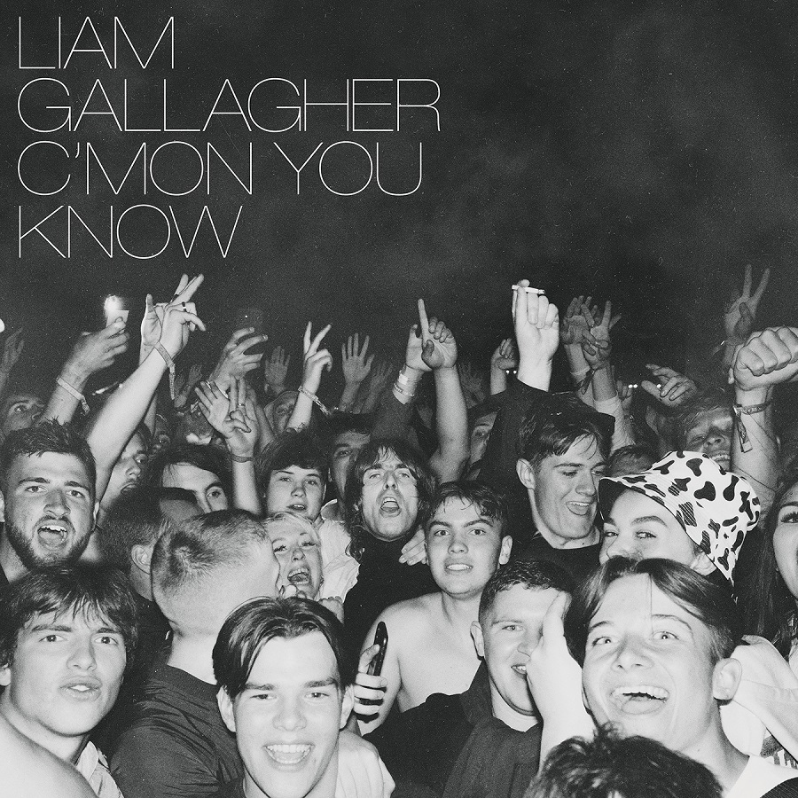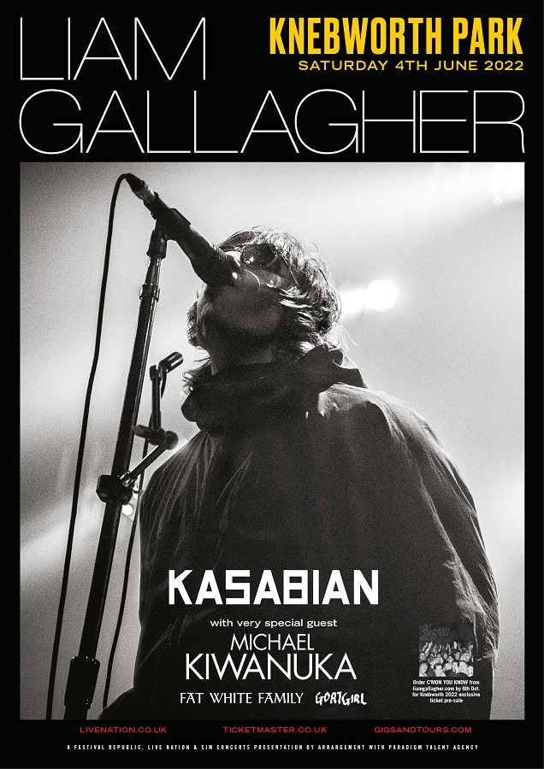
(download album packshot and event poster here)
October 1, 2021 (Los Angeles, CA) – We’ve come to expect big things from Liam Gallagher, but today he reveals plans for 2022 that are biblical even by his colossal standards. He is set to release his new album C’MON YOU KNOW on May 27th as he looks to score a fourth consecutive #1 UK album. He also celebrates the 25th anniversary of Oasis’ era-defining gigs at Knebworth Park with the news that he’ll return there to play the biggest show of his solo career to date on June 4, 2022. Tickets go on sale 2am PT/5am ET next Friday, October 8th at LiveNation.co.uk and ticketmaster.co.uk/LGKnebworth.

C’MON YOU KNOW follows the huge success of Liam’s previous studio albums As You Were (2017) and Why Me? Why Not. (2019), which established his iconic status for a whole new generation. Between his triumphs as a solo artist and his phenomenal success with Oasis, Liam has spent a combined total of almost six months at #1 across eleven chart-topping albums. More details regarding C’MON YOU KNOW will follow.

The Knebworth Park show will see Liam return to the site where Oasis famously played two unforgettable nights there in 1996. The 25th anniversary of the shows was marked with the release of the feature-length documentary Oasis Knebworth 1996, which NME described as “an era-defining gig that will live forever.” The Knebworth Park gig will be the biggest show of Liam’s solo career to date, following his triumphant return to touring this summer with headline sets at Reading, Leeds and TRNSMT alongside a free gig for NHS staff at The O2. Opening the iconic Knebworth Park stage on June 4th will be very special guest Michael Kiwanuka, Goat Girl, Fat White Family, and Kasabian.

Liam says, "I'm absolutely buzzing to announce that on 4th June 2022 I'll be playing Knebworth Park. It's gonna be biblical. C'mon You Know. LG x"

Fans who pre-order C’MON YOU KNOW here by 7am PT/10am ET on Wednesday, October 6th will receive access to a pre-sale for Knebworth Park tickets that opens at 2am PT/5am ET on Thursday, October 7th. Remaining tickets will then go on general sale on Friday, October 8th at LiveNation.co.uk and www.ticketmaster.co.uk/LGKnebworth.

Liam Gallagher at Knebworth Park is a Festival Republic, Live Nation and SJM Concerts presentation.

***

About Live Nation Entertainment
Live Nation Entertainment (NYSE: LYV) is the world’s leading live entertainment company comprised of global market leaders: Ticketmaster, Live Nation Concerts, and Live Nation Media & Sponsorship. For additional information, visit www.livenationentertainment.com

About Knebworth Park
The home of British rock music. Over 100 major artists have played Knebworth Park festivals since their inception in 1974, including The Rolling Stones, Pink Floyd, Led Zeppelin, Queen, Elton John, Paul McCartney, Oasis, Robbie Williams, and the Red Hot Chili Peppers.

Live Nation Media Contact

Mohammad Qazalbash Mohammad.Qazalbash@LiveNation.co.uk

Molly Hemsley Molly.Hemsley@LiveNation.co.uk

Liam Gallagher Media Contact:

Ceri Roberts ceri.roberts@warnerrecords.com

