NEW SINGLE “ONE OF US” OUT NOW
LISTEN TO THE TEASER HERE

NEW ALBUM WHY ME? WHY NOT FOLLOWS ON SEPTEMBER 20TH
PRE-ORDER HERE

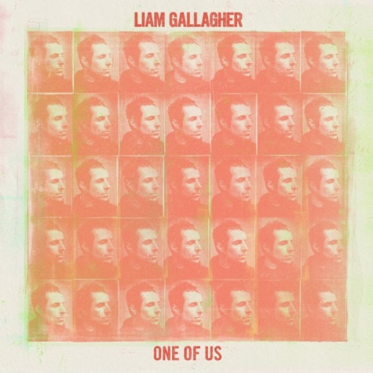
(Promo photo credit: Tom Beard – Click here for hi-res)

August 16, 2019 (Los Angeles, CA) - "Shockwave," "The River" and "Once": Three melodically potent tracks have previewed Liam Gallagher’s forthcoming second solo album Why Me? Why Not., suggesting that the highly anticipated album will be something special. His charisma and impassioned vocal power are constant throughout songs which range from reflections on the past to righteous anger at the direction that we’re collectively heading in.

That rush of remarkable form continues with the new single “One Of Us,” released today. Sweeping strings and gospel-tinged backing vocals heighten the emotional impact of the song which expresses hope that a fractured relationship can be salvaged in the future.

"‘One of Us’ is about family, friendship and a sense of belonging,” says Gallagher. “I love the groove and the gospel outro. It reminds me of The Sweet Inspirations."

Gallagher co-wrote “One Of Us” along with Andrew Wyatt. His youngest son Gene contributed bongos, accompanied by Nick Zinner of Yeah Yeah Yeahs on guitar.

Upon release, Gallagher’s tracks continue to garner critical praise leading up to the release of Why Me? Why Not.

It’s an emotional song with a lot of resonance and Gallagher knows it.” – Rolling Stone
“Liken it to Oasis glory days.” – Billboard
“Liam Gallagher’s gnarly attitude is clearly intact, as the voice and vigor of legends Oasis… Gallagher in all of his glory.” – FLOOD

“One Of Us” is now available to order on vinyl as is Why Me? Why Not. Click here to order both.
Formats include a collectible D2C package which compiles a deluxe CD, a sun yellow vinyl album and a one-sided etched 12” which features three deluxe bonus tracks along with a demo recording that’s exclusive to this format – all packaged in a hardcover book with two art prints and a poster.
Liam Gallagher, as previously announced, will perform alongside The Who on select dates of their North American Moving On! tour this October. Click here for tickets and show details. Gallagher’s entire European tour in support of Why Me? Why Not., is now completely sold out.
U.S. - Liam Gallagher on tour with The Who: https://liamgallagher.com/tour
Wed Oct 09 Chase Center San Francisco, CA
Fri Oct 11 Hollywood Bowl Hollywood, CA
Sun Oct 13 Hollywood Bowl Hollywood, CA
Wed Oct 16 Viejas Arena at Aztec Bowl/ UCSD San Diego, CA
Sat Oct 19 T-Mobile Park Seattle, WA
Mon Oct 21 Rogers Arena Vancouver, BC
Thur Oct 24 Hollywood Bowl Hollywood, CA

U.K. / Ireland:
Mon Nov 11 Cardiff, Wales Motorpoint Arena
Tue Nov 12 Birmingham, UK Birmingham Arena
Thur Nov 14 Aberdeen, Scotland P&J Live
Fri Nov 15 Glasgow Scotland, The SSE Hydro
Sun Nov 17 Newcastle, UK Utilita Arena
Mon Nov 18 Sheffield, UK Fly DSA Arena
Wed Nov 20 Manchester, UK MEN Arena
Thur Nov 21 Liverpool, UK M&S Bank Arena
Sat Nov 23 Dublin, Ireland 3 Arena
Sun Nov 24 Dublin, Ireland 3 Arena
Tue Nov 26 Nottingham, UK Motorpoint Arena
Thur Nov 28 London, UK O2 Arena
Fri Nov 29 London, UK O2 Arena

# # #

For further information contact:
Rick Gershon 818-953-3473 / rick.gershon@warnerrecords.com
Ceri Roberts 212-707-2259 / ceri.roberts@warnerrecords.com

Follow Liam Gallagher:
Twitter
Spotify
Facebook
Instagram
liamgallagher.com

Press materials:
http://press.warnerrecords.com/liamgallagher

