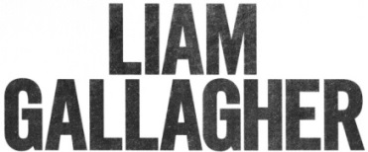

UNVEILS BRAND NEW TRACK “THE RIVER”

HIGHLY ANTICIPATED ALBUM WHY ME? WHY NOT. OUT SEPTEMBER 20
ON WARNER RECORDS
NORTH AMERICAN TOUR WITH THE WHO CONFIRMED FOR THIS FALL
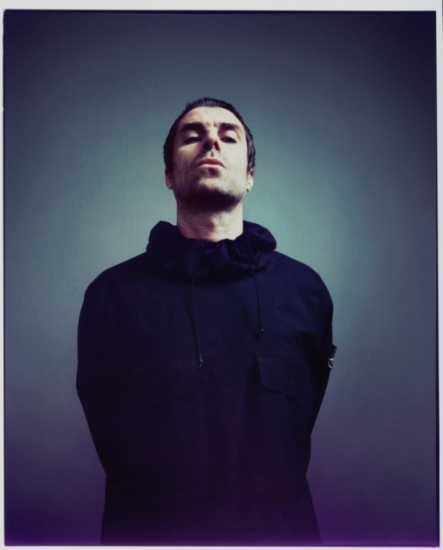
(Photo credit: Tom Beard – Click here for hi-res)

June 27, 2019 (Los Angeles, CA) – Today, Liam Gallagher releases “The River,” the second track from his highly anticipated album Why Me? Why Not., set for release on September 20 via Warner Records. “The River” follows Gallagher’s recently released single “Shockwave” from the forthcoming album.

LISTEN/SHARE “THE RIVER” HERE

“It looks like Gallagher is back to the business of making music! Big riffs and the swagger that Liam brought to Oasis in the first place. Gallagher’s confidence comes through. ” – Stereogum

“’Shockwave’ conjures up a bit of the scrappy feel of early, blown-out Oasis circa Definitely Maybe.” – Spin

Powered by deeply-rooted emotions, “The River” offers a rallying call for the current generation to fight for change. The track was co-written by Gallagher along with songwriter/producer Andrew Wyatt, who was a key collaborator on his first solo album, As You Were.

“The River” lives up to Gallagher’s vision for Why Me? Why Not. As he stated, “I want the second album to be a step-up because the hardest thing to do is to make something the same, only better. So that’s what we’ve done. It’s a better record than As You Were. Which is saying something, as that was epic, wasn’t it?”

Both “The River” and “Shockwave” are available as instant downloads for fans who pre-order Why Me? Why Not. HERE.

Today, Gallagher also reveals the official Why Me? Why Not. album cover artwork, featuring a photo by Tom Beard.

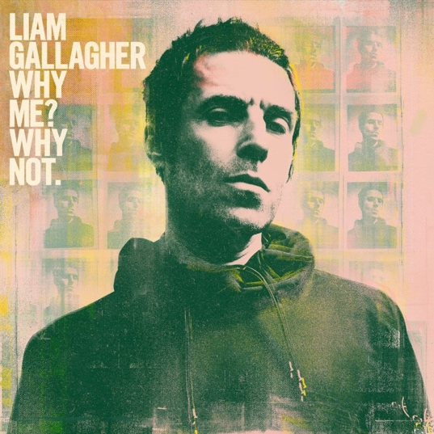
(Photo credit: Tom Beard – Click here for hi-res)
As previously announced, Liam Gallagher has been tapped by The Who to perform on select dates of their North American Moving On! tour this fall. Tickets are on sale now, click here.
Liam Gallagher on tour with The Who:
# = newly confirmed date

Wed Oct 09 Chase Center San Francisco, CA
#Fri Oct 11 Hollywood Bowl Hollywood, CA
#Sun Oct 13 Hollywood Bowl Hollywood, CA
Wed Oct 16 Viejas Arena at Aztec Bowl/ UCSD San Diego, CA
Sat Oct 19 T-Mobile Park Seattle, WA
Mon Oct 21 Rogers Arena Vancouver, BC
Thur Oct 24 Hollywood Bowl Hollywood, CA

# # #

For further information contact:
Rick Gershon 818-953-3473 / rick.gershon@warnerrecords.com
Ceri Roberts 212-707-2259 / ceri.roberts@warnerrecords.com

Follow Liam Gallagher:
Twitter
Spotify
Facebook
Instagram
liamgallagher.com

Press materials:
http://press.warnerrecords.com/liamgallagher

