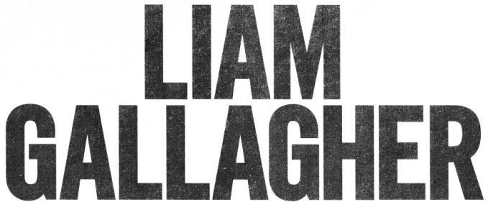

LIAM GALLAGHER’S NEW MTV UNPLUGGED ALBUM OUT NOW
LISTEN HERE

JOIN LIAM FOR TWITTER LISTENING PARTY TODAY AT 2PM ET/11AM PT

“Live record offers warmth, hope and a sense of unity.” **** - NME

“Liam shines in an acoustic setting.” **** - Q

“Astonishing, accomplished, as close to real as it gets, it’s a triumph to be revered.” 8/10 - Clash

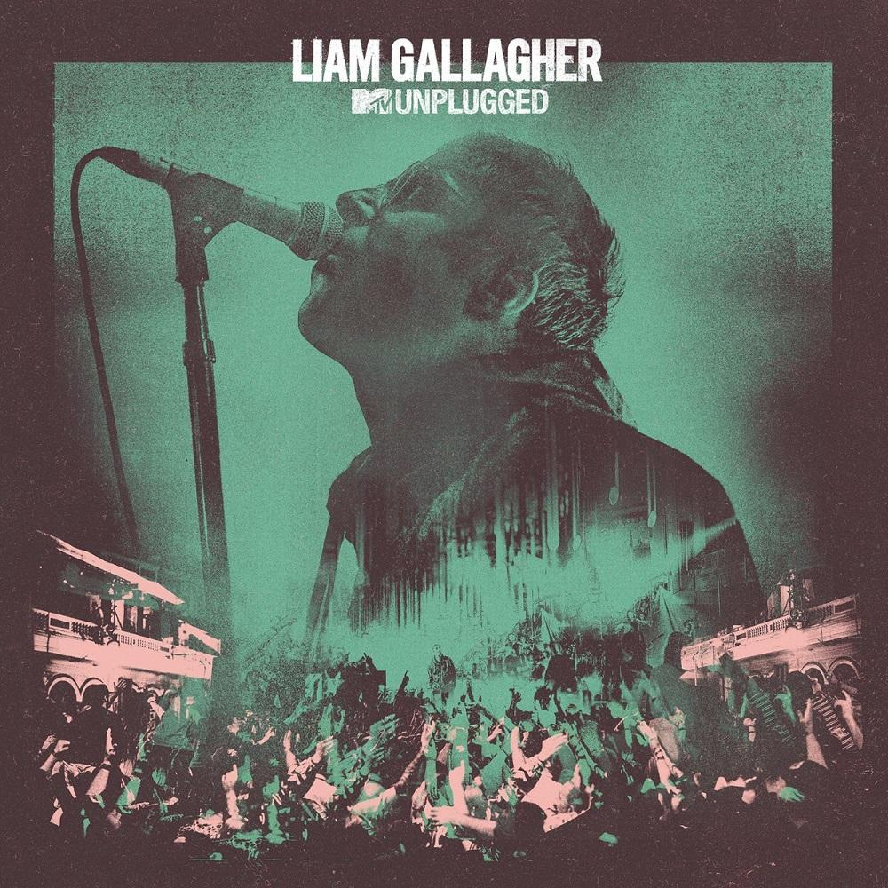

June 12, 2020 (Los Angeles, CA) – Liam Gallagher’s eagerly anticipated MTV Unplugged album is out today on Warner Records. Recorded at Hull’s City Hall last summer, the show saw Liam join the list of all-time greats (Paul McCartney, Nirvana and many more) who have filmed a prestigious MTV Unplugged session. Liam and Oasis guitarist Bonehead will join fans today at 2pm ET/11am PT, as part of Tim Burgess’s Listening Party (#TimsTwitterListeningParty) to share their thoughts about the album and answer questions throughout.

Liam commented, “I was honoured to perform at the legendary showcase that is ‘MTV Unplugged’. It was a lovely experience and the people of Hull were biblical and sounded fantastic. I hope you enjoy the record. LG x”

The show’s electrifying atmosphere is palpable from the very beginning with a phenomenal reaction as Liam takes to the stage with “Wall of Glass.” Material from Liam’s solo career such as his personal favorite “Once” and the joyous “Now That I’ve Found You” resonates in this stripped-back format, with his vocal shining alongside a trio of backing singers and string arrangements performed by the 24-piece Urban Soul Orchestra. Stripped of the force of its studio recording, “Gone” is a standout as it reveals new-found bombastic dynamics and an evocative cinematic atmosphere.

Oasis guitarist Bonehead features on performances of “Some Might Say,” “Stand By Me,” “Cast No Shadow” and Liam’s first ever live vocal performance of the Definitely Maybe bonus track “Sad Song.” The show concludes on a crowd-pleasing high with an emotive take on the classic “Champagne Supernova.”

MTV Unplugged Tracklist:
1. “Wall Of Glass”
2. “Some Might Say”
3. “Now That I Found You”
4. “One of Us”
5. “Stand By Me”
6. “Sad Song”
7. “Cast No Shadow”
8. “Once”
9. “Gone”
10. “Champagne Supernova”

###

For further information contact:
Ceri Roberts / ceri.roberts@warnerrecords.com

Follow Liam Gallagher:
Website | Twitter | Facebook | Instagram | Spotify | Press Site

