MASTODON RELEASE VINYL EDITION OF MEDIUM RARITIES TODAY
FEATURING NEW SONG “FALLEN TORCHES”

LISTEN HERE AND WATCH HERE

Mastodon Confirmed To Perform On Adult Swim’s Virtual Festival 2020
November 13th/14th Exclusively on YouTube

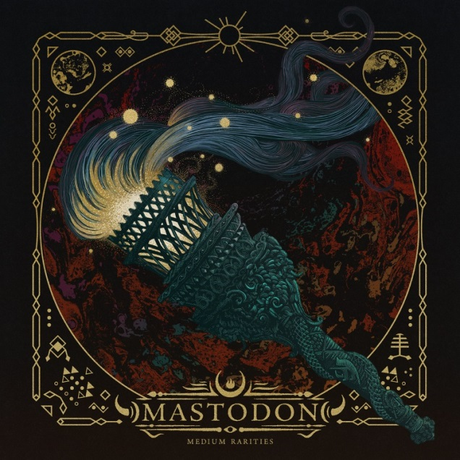
(Click here for hi-res artwork)

October 30th, 2020 (Los Angeles, CA) – Mastodon celebrate their 20th anniversary as a band by releasing a limited edition pink vinyl pressing of MEDIUM RARITIES today, via Reprise Records. The GRAMMY®-winning hard rock quartet have gathered up a treasure trove of hard-to-find audio treasures including a new song “Fallen Torches,” along with stunning video directed by Hey Beautiful Jerk and Machina-Infinitum. Click here to view/share “Fallen Torches.” Click here to order the limited-edition pink vinyl edition.

“Fallen Torches” is written by Mastodon and features guest vocals by longtime friend and collaborator Scott Kelly from the band Neurosis.” As the band explains, “the track was delayed so the band could focus on the release of Stairway to Nick John, a tribute to their late, long time manager Nick John, with proceeds going to the Hirshberg Foundation for Pancreatic Cancer Research in his honor.”
As previously announced, yet another new Mastodon track “Rufus Lives” from the Orion Pictures film and soundtrack of Bill & Ted Face The Music, out now on 10K Projects. Click here to stream
Bill & Ted Face The Music, The Original Motion Picture Soundtrack.

Mastodon will be one of the featured performers on this year’s Adult Swim Festival which will be presented exclusively on You Tube November 13th & 14^{th.} Click here for complete details.

Medium Rarities Tracklisting:
- Fallen Torches (Previously Unreleased)
- A Commotion (Feist Cover)
- Asleep in the Deep (Instrumental version)
- Capillarian Crest (Live)
- A Spoonful Weighs A Ton (The Flaming Lips Cover)
- Toe To Toes (Instrumental version)
- Circle of Cysquatch (Live)
- Atlanta (Feat. Gibby Haynes)
- Jaguar God (Instrumental)
- Cut You Up With A Linoleum Life (Aqua Teen Hunger Force)
- Blood & Thunder (Live)
- White Walker (Game of Thrones)
- Halloween (Instrumental version)
- Crystal Skull (Live)
- Orion (Metallica Cover)
- Iron Tusk (Live)

Mastodon are currently working on their anxiously awaited ninth full-length and first record since the GRAMMY® Award-winning Emperor of Sand in 2017.

# # #

Contact:
Rick Gershon at Warner Records / Reprise Records
rick.gershon@warnerrecords.com

Follow Mastodon:
Website | Facebook | YouTube | Twitter | Instagram | Spotify

Press materials:
https://press.warnerrecords.com/mastodon/

