GRAMMY AWARD-WINNING ROCK BAND MASTODON TEAM UP WITH DREAMSTAGE TO PRESENT A UNIQUE LIVE PERFORMANCE EXPERIENCE

CAPTURED LIVE AT GEORGIA AQUARIUM FIRST EVER ACOUSTIC PERFORMANCE SET FOR JULY 15

TICKETS AVAILABLE NOW

WATCH HERE

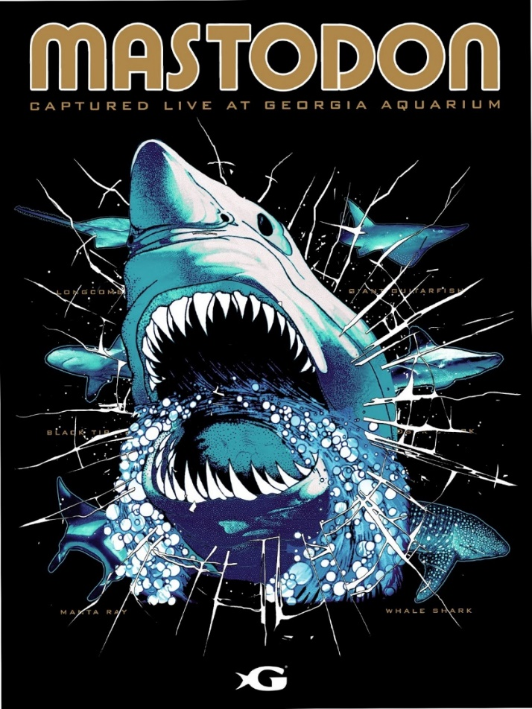
(Click here for hi-res poster image)

June 17, 2021 (Los Angeles, CA.) -- Mastodon team up with DREAMSTAGE to present a completely unprecedented live performance set for July 15, at 9PM EDT. The GRAMMY® award-winning rock band along with the pioneering HD live streaming platform DREAMSTAGE, is thrilled to announce Captured Live At Georgia Aquarium, a unique live Mastodon experience in a rare, intimate setting from their hometown of Atlanta, Georgia like you’ve never heard them before. In addition, the program will include exclusive commentary from the band offering an inside view into their creative process. Click here for tickets and further information. Click here to view and share the trailer.

Now in their 21st year the hard rock quartet are one of the most legendary active live acts around. Captured Live At Georgia Aquarium will bring that passion and power pouring out of your home speakers, as the band performs acoustic for the first... and perhaps last time, from the Georgia Aquarium in their hometown. Tickets on sale now. Along with bundle merch packages, with $1 from each T-shirt bundle package going to support the Georgia Aquarium.

Fresh off the release of their Medium Rarities collection, along with “Rufus Lives” off the Bill & Ted Face The Music (Original Motion Picture Soundtrack) last autumn, plus the hard-hitting “Forged By Neron” - the lead single for DARK KNIGHTS: DEATH METAL Soundtrack (DC Comics) - out tomorrow, Mastodon provide a career-spanning special performance event.

DREAMSTAGE was launched last August by CEO Thomas Hesse (former President of Sony Music for Global Digital Business and U.S. Sales/Distribution), CTO Scott Chasin (serial entrepreneur with a track record of successfully founding and growing startups, including ProtectWise and MX Logic), and Artistic Director Jan Vogler (internationally known cellist and director of the Dresden Music Festival).

Last month DREAMSTAGE announced a strategic investment from global streaming service Deezer [press release here], while hosting incredible performances from Yo-Yo Ma (co-sponsored by Audible), Sean Paul, Live from Jamaica, Rodrigo y Gabriela and slenderbodies, Rodney Atkins and Jeris Johnson. Their successful series, Broadway Stories & Songs hosted by renowned musical director Ted Sperling, wrapped last weekend, with upcoming performances from Train on June 25, along with the inaugural DREAMSTAGE Virtual PRIDE, June 25-26, featuring Big Freedia, LP, Trixie Mattel, Dawn Richards, Dorian Electra & more.

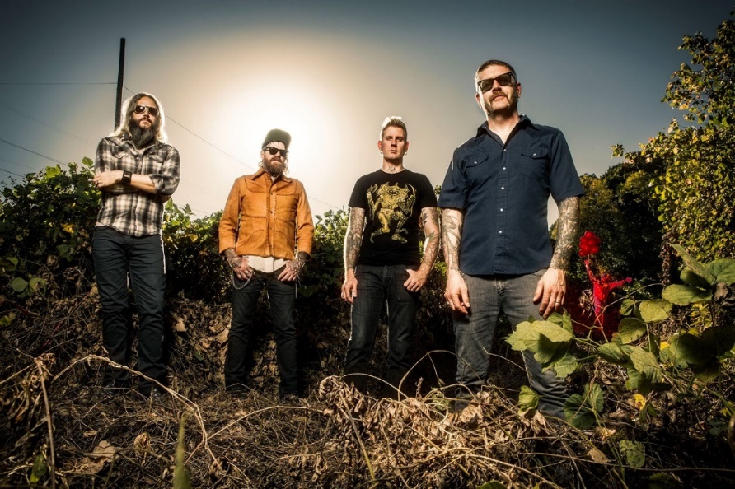
(Click here for hi-res image by Jimmy Hubbard )

About Mastodon:
GRAMMY® Award-winning band Mastodon continue to chart their own course through their highly successful music career. Founded in Atlanta, GA during 2000 by Troy Sanders (bass/vocals), Brent Hinds (guitar/vocals), Bill Kelliher (guitar) and Brann Dailor (drums/vocals), the group have unleashed a series of influential albums. Rolling Stone notably cited 2004’s Leviathan on its coveted The 100 Greatest Metal Albums of All Time. Meanwhile, Crack The Skye closed out 2009 on year-end lists by everyone from TIME to SPIN. They delivered three consecutive Top 10 debuts on the Billboard Top 200 with The Hunter [2011], Once More ‘Round the Sun [2014], and Emperor of Sand [2017]. “Sultan’s Curse” notably garnered their first GRAMMY® Award in the category of Best Metal Performance. The group commemorated their late manager Nick John with their 2019 take on “Stairway To Heaven,” affectionately entitled “Stairway To Nick John.” Initially released for Record Store Day, all proceeds benefit the Hirschberg Foundation For Pancreatic Cancer Research. Their evolution continues later this year, with their eighth full-length offering for Reprise Records produced by David Bottrill [Tool, Rush].

About DREAMSTAGE
DREAMSTAGE launched in August 2020 and has already delivered over 50 live streaming concerts. Led by its three co-founders: CEO Thomas Hesse (former President of Sony Music for Global Digital Business and U.S. Sales/Distribution), CTO Scott Chasin (serial entrepreneur with a track record of successfully founding and growing startups, including ProtectWise and MX Logic) and Artistic Director Jan Vogler (internationally known cellist and director of the Dresden Music Festival), the company covers the entire virtual concert value chain - from ticket sales to the delivery of a pristine live audio/video signal to all screens and devices.

In May 2021, DREAMSTAGE announced a strategic partnership with the global streaming service Deezer. While its revenues today come from ticket sales and brand sponsorships, DREAMSTAGE also plans to offer live gig subscriptions in the future. The company’s roadmap includes an ever-increasing array of interactive fan experiences, partnerships with live venues, and manifold opportunities to expand into other live entertainment formats beyond music.

Contacts:
Mastodon: Rick Gershon at Warner Records / Reprise Records
rick.gershon@warnerrecords.com

DREAMSTAGE: Brendan Bourke at The Syndicate brendan@thesyn.com
Jeff Kilgour at The Syndicate jeff@thesyn.com

Follow Mastodon:
Website | Facebook | Twitter | Spotify | YouTube | Tik Tok | Press Materials

