MY CHEMICAL ROMANCE ANNOUNCES THEIR FIRST U.S. TOUR IN NINE YEARS

FOLLOWS THE BAND’S TRIUMPHANT REUNION SHOW
IN LOS ANGELES

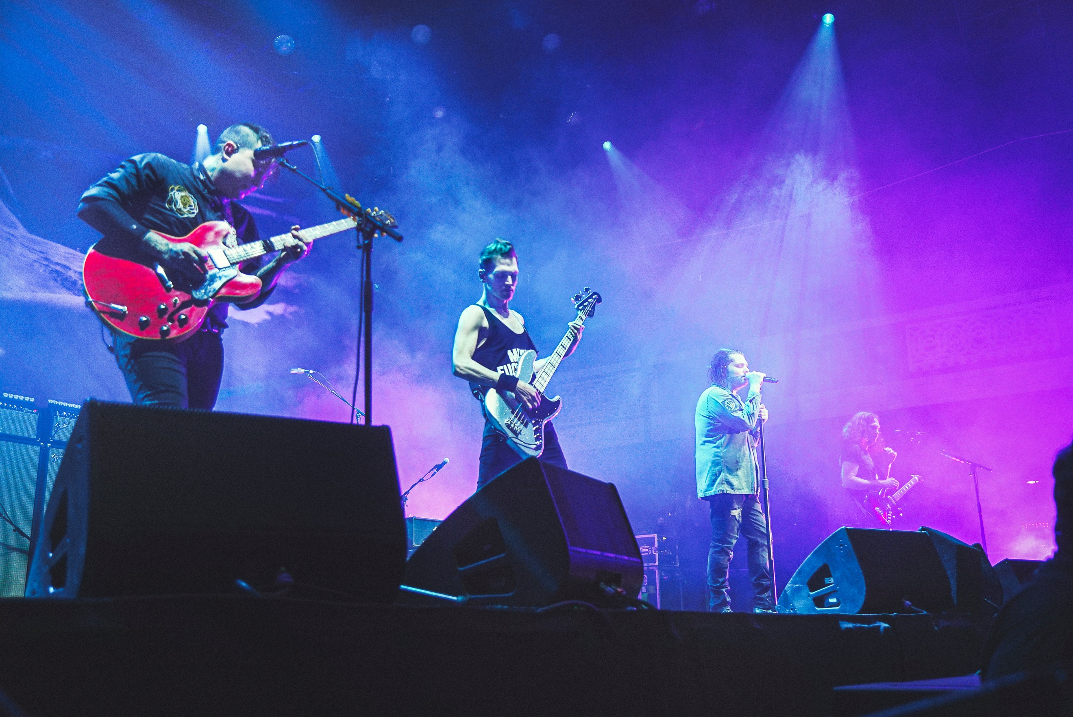
Credit: Claire Marie Vogel / @oclaire

“It’s with this landmark concert that MCR ceases to be a nostalgic act, and proves its mettle as a timeless, rock & roll band for the ages.” - Rolling Stone

“It was physically impossible to stand in that room and not understand to the core of your being why this band means so much to so many people.” - NME

January 29, 2020 (Los Angeles, CA) - After performing a sold-out show at the landmark Shrine Auditorium in Los Angeles on December 20, 2019, My Chemical Romance has announced a full U.S. tour beginning on September 9th in Detroit, MI and finishing on October 11th in Las Vegas, NV. The uncompromising rock group previously announced multiple overseas performances for March, including shows in Milton Keynes, England two of which sold out (130,000 tickets) in under an hour. Their U.S.-based fans, dubbed Killjoys, have been left anxiously waiting - wait no more….

View Band’s Special Video Announcement of Tour HERE.

Tickets will go live Friday, January 31st at 12 PM local time – get them HERE.

Formed in Newark, NJ, My Chemical Romance made its debut in 2002 with the independently released album I Brought You My Bullets, You Brought Me Your Love. The band signed to Reprise Records the following year and made its major label debut with 2004’s Three Cheers for Sweet Revenge, now 3x certified Platinum. The album contained the Platinum hit "I'm Not Okay (I Promise)," the Gold-certified "Helena," and "The Ghost of You." Rolling Stone hailed their third studio album, The Black Parade (3x Platinum) as one of the top albums of 2006. Lead single “Welcome to the Black Parade” topped both Billboard’s Alternative Songs chart and the UK’s Official Singles chart and is now 3x Platinum. The band toured extensively behind the album – appearing as characters from The Black Parade – and released the live album The Black Parade is Dead! in 2008. Danger Days: The True Lives of the Fabulous Killjoys was released in 2010 and topped Billboard’s Alternative Albums and Top Rock Albums charts. It was followed by a series of singles which as a whole made up the Conventional Weapons release in 2013. My Chemical Romance’s songs continue to rack up half a billion global streams each year.

TOUR DATES:
Sep 9th - Detroit, MI - Little Caesars Arena
Sep 11th - St Paul, MN - Xcel Energy Center
Sep 12th - Chicago, IL – RIOT FEST
Sep 14th - Toronto, ON - Scotiabank Arena
Sep 15th - Boston, MA - TD Garden
Sep 17th - Brooklyn, NY – Barclays Center
Sep 18th - Philadelphia, PA - Wells Fargo Center
Sep 20th - Atlanta, GA – MUSIC MIDTOWN – PIEDMONT PARK
Sep 22nd - Newark, NJ - Prudential Center
Sep 26th - Sunrise, FL - BB&T Center
Sep 29th - Houston, TX - Toyota Center
Sep 30th - Dallas, TX - American Airlines Center
Oct 2nd - Denver, CO - Pepsi Center
Oct 4th - Tacoma, WA - Tacoma Dome
Oct 6th - Oakland, CA - Oakland Arena
Oct 8th - Los Angeles, CA - The Forum
Oct 10th - Sacramento, CA - AFTERSHOCK
Oct 11th - Las Vegas, NV - T-Mobile Arena

For ALL My Chemical Romance tour dates, click HERE.

For more information, please contact:
Bobbie@mixedmediaworks.com
Laura.Swanson@warnerrecords.com

