MOTHER MOTHER RELEASE HIGHLY ANTICIPATED NEW ALBUM INSIDE
OUT NOW

World Tour Nearly Sold Out Seven Months in Advance

LISTEN HERE / WATCH HERE

(Click here for INSIDE album cover art)

June 25, 2021 (Los Angeles, CA.) – Today, Canadian Alt-rockers Mother Mother release their internationally anticipated new album INSIDE, the band’s eighth career album and first for Warner Records. The 14-track song cycle was written and recorded during lockdown and speaks to the isolation of the times and yet each of the songs shine with an infectious optimism.
Vocalist, guitarist, songwriter and producer Ryan Guldemond explains, “It’s always a bit surreal and a little scary putting songs out into the world after the long and hidden process of making an album. Inside was written in the time of Covid, a unique time for us all, and directly embodies themes surrounding isolation and hope. As we start to emerge out the other side of this thing, it feels cathartic to share this particular body of work with the world. We hope that our fans find the same peace, healing and joy in listening to these songs as we did while creating them." INSIDE is available now. Click here to stream.
To celebrate the release, the band joined fans last night to premiere the video for their new single “Sick of the Silence,” which can be seen here. This follows up on their stunning debut of that song on The Late Late Show with James Corden. Click here to view and share.
With the release of INSIDE, Mother Mother have also announced their return to the world stage in 2021 and 2022. Shows on multiple continents have sold out or upgraded into larger venues due to demand for tickets over seven months prior to launch including Los Angeles, Chicago, London and an impressive 5-night run in their hometown of Vancouver, BC.
INSIDE was heralded by the infectious, instantly hummable lead single “I Got Love,” which quickly climbed to the #1 spot on the Canadian radio charts where it remained for a combined six weeks, while garnering over 6 million streams to date. The band quickly followed with “Stay Behind,” “Forgotten Souls” and “Pure Love,” which have cumulatively eclipsed 12 million streams in the leadup to the album’s arrival.

INSIDE Track list:
- Seven
- Two
- Sick of the Silence
- Forgotten Souls
- Pure Love
- Weep
- I Got Love
- Stay Behind
- The Knack
- Girl Alone
- Like a Child
- Breathe
- Until it Doesn’t Hurt
- Inside

# indicates newly added date:

2021 Tour Dates:
# Sep 17 Summerfest /Warehouse Stage Milwaukee, WI
Sept 19 Riot Fest Chicago, IL
Oct 03 Austin City Limits Music Festival Austin, TX
Dec 02 The Commodore Ballroom Vancouver, BC
Dec 03 The Commodore Ballroom Vancouver, BC
Dec 04 The Commodore Ballroom Vancouver, BC (early show, all ages)
Dec 04 The Commodore Ballroom Vancouver, BC (late show)
Dec 05 The Commodore Ballroom Vancouver, BC

2022 Tour Dates:
Jan 07 White Oak Music Hall Houston, TX
Jan 08 Scoot Inn Austin, TX – SOLD OUT
Jan 09 The HiFi Dallas, TX- SOLD OUT
Jan 11 The Van Buren Phoenix, AZ – SOLD OUT
Jan 12 Music Box San Diego, CA – SOLD OUT
Jan 13 Regent Theater Los Angeles, CA - SOLD OUT
Jan 15 The Fillmore San Francisco, CA - SOLD OUT
Jan 17 Wonder Ballroom Portland, OR - SOLD OUT
Jan 18 Neptune Theatre Seattle, WA - SOLD OUT
Jan 21 Summit Denver, CO - VENUE UPGRADED
Jan 23 Metro Chicago, IL- SOLD OUT
Jan 25 Saint Andrew’s Hall Detroit, MI- SOLD OUT
Jan 26 Beachland Ballroom Cleveland, OH - SOLD OUT
Jan 28 Town Ballroom Buffalo, NY
Jan 30 Paradise Rock Club Boston, MA - SOLD OUT
Feb 01 The Foundry Philadelphia, PA (early show) - SOLD OUT
Feb 01 The Foundry Philadelphia, PA (late show) – SOLD OUT
Feb 02 Irving Plaza New York City, NY
Feb 04 9:30 Club Washington, DC – SOLD OUT
Feb 05 The Underground Charlotte, NC - SOLD OUT
Feb 06 The Masquerade (Heaven) Atlanta, GA - VENUE UPGRADED
Feb 22 Tavastia Helsinki, Finland - SOLD OUT
Feb 24 Tyrol Stockholm, Sweden - VENUE UPGRADED-SOLD OUT
Feb 26 Parkteatret Oslo, Norway - SOLD OUT
Feb 27 VEGA Small Hall Copenhagen, Denmark - SOLD OUT
Mar 01 Fabrik Hamburg, Germany –VENUE UPGRADED
Mar 02 Kesselhaus Berlin, Germany – VENUE UPGRADED
Mar 04 Paradiso Noord Amsterdam, Netherlands (early show) – SOLD OUT
Mar 04 Paradiso Noord Amsterdam, Netherlands (late show) – SOLD OUT
Mar 05 Rotonde Brussels, Belgium - SOLD OUT
Mar 06 Kantine Cologne, Germany – VENUE UPGRADED
Mar 08 Freiheitshalle Munich, Germany – VENUE UPGRADED
Mar 09 Santeria Toscana 31 Milan, Italy
Mar 11 Razzmatazz 2 Barcelona, Spain- SOLD OUT
Mar 12 Sala Moby Dick Madrid, Spain - SOLD OUT
Mar 14 Les Etoiles Paris, France - SOLD OUT
Mar 16 Heaven London, UK - SOLD OUT
Mar 17 Garage Glasgow, Scotland - SOLD OUT
Mar 20 Olympia Dublin, Ireland - SOLD OUT
Mar 22 The O2 Forum London, UK - ADDED SHOW
# Mar 25 Glavclub Moscow, Russia
# Mar 26 Morze St. Petersburg, Russia
# Apr 29 Royal Theatre Victoria, BC
# Apr 30 Royal Theatre Victoria, BC
# May 02 Northern Alberta Jubilee Audit. Edmonton, AB
# May 03 Jack Singer Concert Hall Calgary, AB
# May 04 Jack Singer Concert Hall Calgary, AB
# May 05 Conexus AC Convention Hall Regina, AB
# May 07 Centennial Concert Hall Winnipeg, MB
# May 08 Thunder Bay Community Audit. Thunder Bay, ON
# May 10 Centre In The Square Kitchener, ON
# May 11 The Corona Theatre Montreal, QC
# May 13 The Music Hall Oshawa, ON
# May 14 London Music Hall London, ON
# May 16 The Grand Theatre Kingston, ON
# May 17 First Ontario PAC Hamilton, ON
# May 19 Massey Hall Toronto, ON
# May 20 National Arts Centre Ottawa, ON

For additional details, go to: https://www.mothermothersite.com/

About MOTHER MOTHER:
Comprised of Ryan Guldemond, Molly Guldemond, Jasmin Parkin, Ali Siadat and Mike Young, MOTHER MOTHER has had a whirlwind decade; over 1.3 billion streams and views, more than 15 million monthly listeners and counting on digital platforms and 3.1 million Shazam searches. The band had a recent feature in Rolling Stone, and made several appearances of late in Billboard’s Emerging Artist Chart, as well as topping Lyric Find’s global and US lyric search charts. In their native Canada, MOTHER MOTHER has had many top 10 singles on the alternative radio charts, including #1’s for weeks on end and the crown of most airplay for any alternative act at radio for multiple years running. Globally, the band’s avid fanbase continues to grow exponentially, as their presence on TikTok organically exploded during the fall of 2020 during lockdown. A variety of songs from O My Heart and Touch Up were used virally on the platform over 325 million times, resulting in millions of streams and new followers on streaming platforms and socials.

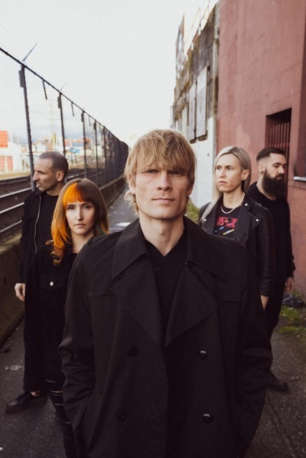
(Click here for Hi-res)

For further information, contact Rick Gershon at Warner Records:
Rick.Gershon@warnerrecords.com

Follow MOTHER MOTHER
Official Site | Facebook | Twitter | Instagram | Tik Tok | YouTube | Spotify | Press Materials

