MARÍA ISABEL RELEASES NEW EP
I HOPE YOU'RE VERY UNHAPPY WITHOUT ME
LISTEN HERE

LAUNCHES HEADLINING NORTH AMERICAN TOUR NEXT WEEK

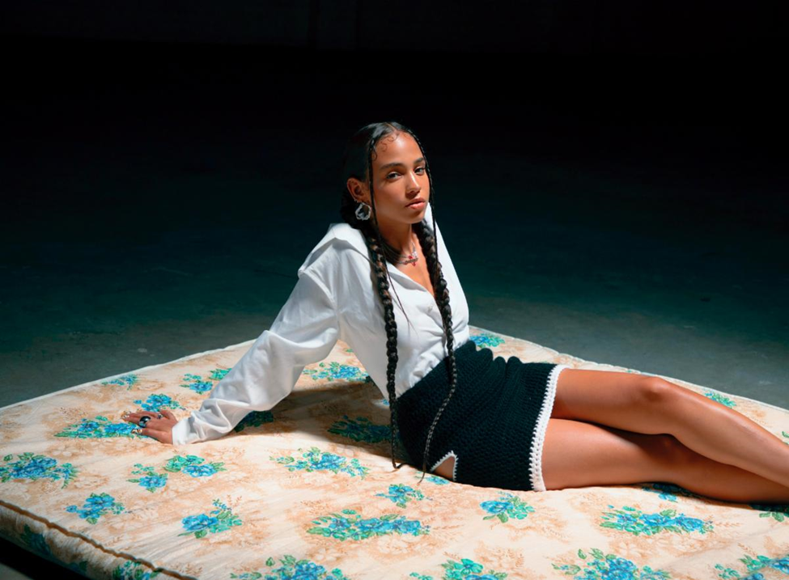
María Isabel by Louisa Meng

"a masterful lyricist who is rooted in the mind of a poet"
Flaunt Magazine

"Airy R&B + María Isabel's satiny vocals = heaven"
NYLON

"keeps impressing with every new release"
Pigeons & Planes

"casually excellent"
Stereogum

"sultry love letters disguised as songs lacquered with Reggaeton flair"
V Magazine

September 10 (Los Angeles, CA) - Today, Dominican-American artist María Isabel releases her new EP i hope you're very unhappy without me via Warner Records. The project follows the release of the video for her lead single "Baby. . .," earlier this week, which Stereogum described as "shadowy, swooning pop and R&B." The project continues to hone the sound María established with her breakout 2020 debut EP Stuck in the Sky, a bilingual amalgamation of the pop and R&B she grew up listening to in Queens, establishing herself as a leading Latinx voice in contemporary R&B.

The project precedes María's run of headlining North American tour dates including back-to-back hometown shows at Baby's All Right in Brooklyn, and shows in LA, DC and Toronto. For more information and ticket purchase links, visit: https://www.mariaisabelmusic.com/tour.

Listen to i hope you're very unhappy without me above, see project details and full tour routing below, and stay tuned for more from María Isabel coming soon.

Upcoming Tour Dates
9/14 - Portland, OR @ Holocene*
9/17 - San Francisco, CA @ Brick & Mortar Music Hall*
9/18 - Sacramento, CA @ Holy Diver*
9/20 - Los Angeles, CA @ The Moroccan Lounge*(SOLD OUT)
9/21 - Santa Ana, CA @ The Observatory
9/26 - Washington, DC @ Songbyrd
9/28 - Brooklyn, NY @ Baby’s All Right (SOLD OUT)
9/29 - Brooklyn, NY @ Baby’s All Right
10/1 - Toronto, ON @ Drake Underground
10/3 - Chicago, IL @ Schubas

Tracklisting
1. Left Alone
2. No Soy Para Ti
3. Lost In Translation
4. Baby...
5. De Na
6. Back of My Mind
7. Solitude
8. I Loved You

About María Isabel:
After releasing her debut single early last year, María has quickly cemented herself as an artist to watch in 2021. She was featured in the June/July issue of Vogue, and has also received early praise from Pigeons & Planes, Wonderland and NYLON among others. Her voice and lyrics are refreshingly vulnerable and intimate, masterfully capturing emotion in both English and Spanish across her songs. As a lifelong poet, María bares her passions, struggles and experiences through her songs, which often begin as poems - exploring topics such as mental health, family history, her Dominican-American heritage and relationships - serving as the foundation of her development as a singer-songwriter.

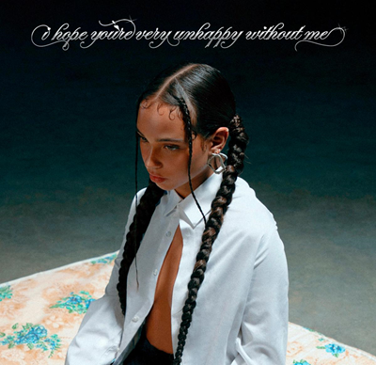

Connect with María Isabel:
Instagram | Twitter

(Download Hi-Res Assets HERE)

For María Isabel press inquiries contact:
Ceri Roberts, Warner Records | ceri.roberts@warnerrecords.com
Nick Dierl, Orienteer | nick@orienteer.us
Kevin Cordon, Orienteer | kevin@orienteer.us

