GRAMMY® AWARD-WINNING MASTODON ANNOUNCE 2021 CO-HEADLINE TOUR WITH OPETH WITH SPECIAL GUEST ZEAL & ARDOR

NEW ALBUM HUSHED AND GRIM OUT OCTOBER 29 VIA REPRISE RECORDS

NEW TRACK “PUSHING THE TIDES” AVAILABLE NOW
LISTEN HERE / WATCH HERE
PRE-ORDER HERE

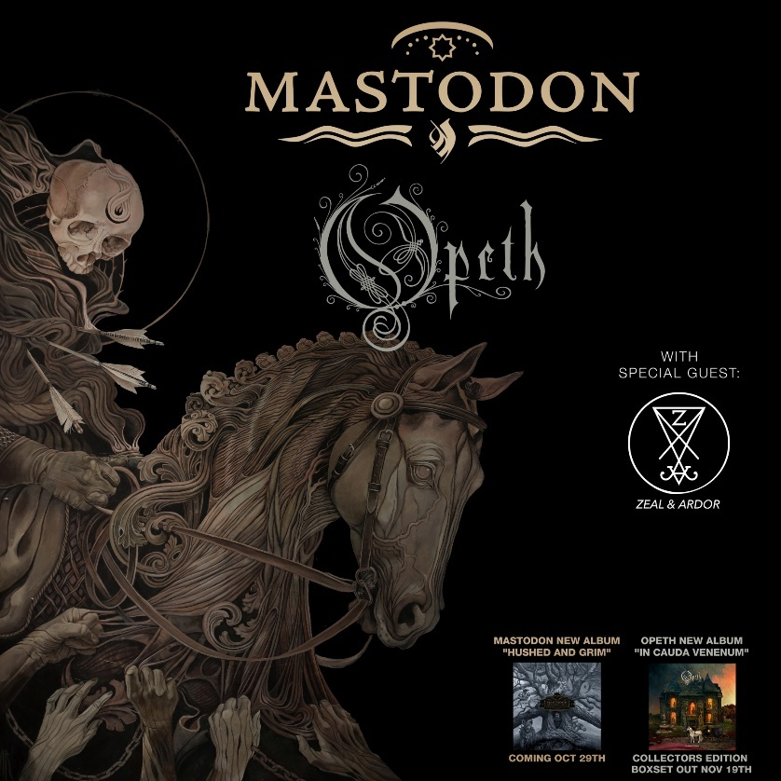

September 14, 2021 (Los Angeles, CA) – Making a grand return to the road this fall, Mastodon announce their 2021 co-headline tour with Opeth. It stands out as the GRAMMY® Award-winning Atlanta heavy rock quartet’s first full-scale North American run since 2019. The tour kicks off on November 16 in Asheville, NC at ExploreAsheville.com Arena, visits iconic theaters and arenas coast-to-coast, and comes to a close on December 5 in Denver, CO at Mission Ballroom. Zeal & Ardor open all shows as the evening’s special guest.

Special Blabbermouth.net and KNOTFEST.com presales begin tomorrow Wednesday, September 15 at 10am local time and run for 36 hours through Thursday, September 16, 10pm local time. Local, venue, promoter, and radio presales follow on Thursday, September 16 at 10am local time and last until 10pm local time. General onsale launches on Friday, September 17 at 10am local time. Check out the full confirmed itinerary below, including a handful of festival dates. Click here for ticket and tour information.

Last week, Mastodon revealed the details for their anxiously awaited ninth full-length album, HUSHED AND GRIM, arriving on October 29, 2021 via Reprise Records. It is available for pre-order at all digital retailers and in vinyl and physical configurations here. They also shared a new track entitled “Pushing The Tides.” Click here to stream and here to view/share the new video.

Closing a four-year gap, this notably marks the heavy rock quartet’s first double album and first new record since 2017’s Emperor of Sand, which netted the Atlanta band a GRAMMY® Award in the category of “Best Metal Performance” — their first win for the five-time nominees. EOS also bowed at #1 on the Billboard Top Album Sales chart, #1 on the Billboard Hard Rock Chart, and #7 on the Billboard Top 200 as “Show Yourself,” from EOS marked their highest entry at Active Rock, reaching #4.

HUSHED AND GRIM was recorded in their hometown of Atlanta, over the course of the past 12 months with producer David Bottrill (Tool, Rush, Muse, Peter Gabriel). Their most ambitious body of work to date, each of 15 tracks, survey the sonic landscapes of rock, psychedelia, punk, metal, alternative, and prog threaded together by the innately expressive musical interplay of these four virtuosic musicians. An atmosphere of very real loss, loneliness, and longing permeates through the trio of cathartic vocals as they musically say goodbye to old friend, confidant, and longtime manager the late Nick John by architecting a magnum opus that bears the influence of his eternal memory.

HUSHED AND GRIM represents the next step on Mastodon’s endless path of natural evolution. They’ve once again progressed exponentially as songwriters and musicians who transcend genres while unapologetically refusing to conform and preserving the integrity that transformed them into an iconic and influential forces in modern rock music. By removing boundaries and creating in a free form they evolved with a combination of newfound melodic confidence and their signature musical intricacy intact. In the end, HUSHED AND GRIM is hard-hitting, hypnotic, and heart-wrenching.

# indicates festival appearance – not part of co-headline dates:
#Oct 10 Sacramento, CA Aftershock
#Nov 14 Daytona Beach, FL Welcome to Rockville

Mastodon Co-headline w/ Opeth:
Nov 16 Asheville, NC ExploreAsheville.com Arena
Nov 18 Boston, MA Wang Theater
Nov 19 Albany, NY Palace Theatre
Nov 20 New York City Hammerstein Ballroom
Nov 21 Washington, DC Anthem
Nov 23 Nashville, TN The Ryman Auditorium
Nov 24 Atlanta, GA The Eastern
Nov 26 Austin, TX ACL Live
Nov 27 Dallas, TX Southside Music Hall
Nov 28 Houston, TX Smart Financial Centre @ Sugarland
Nov 30 Mesa, AZ Mesa Amphitheater
Dec 01 Los Angeles, CA Hollywood Palladium
Dec 02 Oakland, CA Fox Theater
Dec 04 Salt Lake City, UT Union
Dec 05 Denver, CO Mission Ballroom

HUSHED AND GRIM Tracklisting:
- Pain With An Anchor
- The Crux
- Sickle And Peace
- More Than I Could Chew
- The Beast
- Skeleton Of Splendor
- Teardrinker
- Pushing The Tides
- Peace And Tranquility
- Dagger
- Had It All
- Savage Lands
- Gobblers Of Dregs
- Eyes Of Serpents
- Gigantium

About Mastodon:
GRAMMY® Award-winning band Mastodon continue to chart their own course through their highly successful music career. Founded in Atlanta, GA during 2000 by Troy Sanders (bass/vocals), Brent Hinds (guitar/vocals), Bill Kelliher (guitar) and Brann Dailor (drums/vocals), the group have unleashed a series of influential albums. Rolling Stone notably cited 2004’s Leviathan on its coveted The 100 Greatest Metal Albums of All Time. Meanwhile, Crack The Skye closed out 2009 on year-end lists by everyone from TIME to SPIN. They delivered three consecutive Top 10 debuts on the Billboard Top 200 with The Hunter [2011], Once More ‘Round the Sun [2014], and Emperor of Sand [2017]. “Sultan’s Curse” notably garnered their first GRAMMY® Award in the category of Best Metal Performance. Mastodon have been nominated for GRAMMY’S® five times to date. The group commemorated their late manager Nick John with their 2019 take on “Stairway To Heaven,” affectionately entitled “Stairway To Nick John.” Initially released for Record Store Day, all proceeds benefit the Hirschberg Foundation For Pancreatic Cancer Research. Their evolution continues later this year, with their ninth full-length offering for Reprise Records produced by David Bottrill [Tool, Rush], HUSHED AND GRIM.

About Opeth:
Sweden’s pioneers of death and progressive metal, OPETH, formed in 1989 and have been widely recognized as one of the genre’s most innovative and influential bands over the course of 13 landmark albums. Rolling Stone says, “Opeth have been one of the bands who have defined the sound of modern metal. From their 1995 debut, Orchid, a striking amalgam of [Mikael] Åkerfeldt’s growled vocals and lush, progressive song structures, through 2001 extreme-prog masterpiece Blackwater Park – which landed at number 55 on Rolling Stone‘s 100 Greatest Metal Albums list and at 28 on our 50 Greatest Prog Rock Albums tally – Opeth have demonstrated a willingness to color outside arbitrary subgenre lines.” The band’s latest record, 2019’s In Cauda Venenum, continued their lauded evolution, delving further into the far reaches of the progosphere and was highly praised on End of Year Lists by the likes of Decibel, Loudwire, Consequence and Rolling Stone. Released in both Swedish and English languages, the record features a number of standout tracks like “Hjärtat Vet Vad Handen Gör" / "Heart In Hand" and “Svekets Prins” / “Dignity” among others.

# # #

Contacts:
Mastodon: Rick Gershon at Warner Records / Reprise Records
rick.gershon@warnerrecords.com

Opeth: Austin Griswold at Secret Service PR austin@secretservicepr.com

Follow Mastodon:
Website | Facebook | YouTube | Twitter | Instagram | Spotify | Press Materials

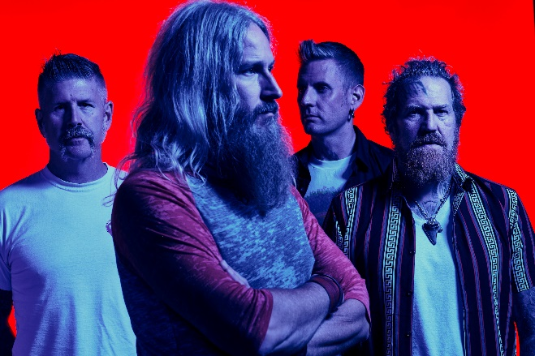
(Click here for Hi-res image by Clay McBride)

