MOTHER MOTHER SET TO PERFORM ON THE LATE LATE SHOW WITH
JAMES CORDEN TONIGHT

NEW SINGLE “SICK OF THE SILENCE” AVAILABLE FRIDAY FROM THEIR FORTHCOMING ALBUM INSIDE

2022 World Tour Extended Due to Overwhelming Demand

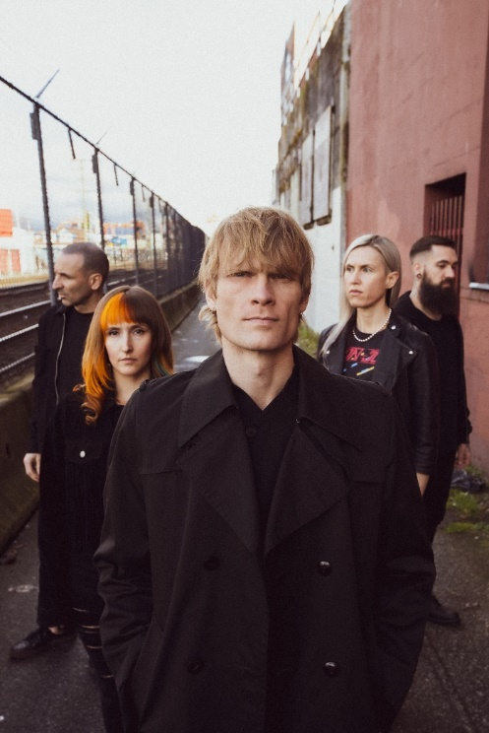
(Click here for Hi-res)

June 10, 2021 (Los Angeles, CA.) – Vancouver’s alt-rock giant MOTHER MOTHER will perform tonight on The Late Late Show with James Corden. The band will mark the moment by debuting the propulsive new single “Sick of theSilence” from their highly anticipated forthcoming album INSIDE, set for release on June 25 via Warner Records.

Tune in tonight at 12:37 AM on CBS stations to witness the live debut of their new single “Sick of the Silence.” Thetrack will be available everywhere tomorrow, and fans can click here now to pre-save / pre-add INSIDE.

Of the new song, frontman Ryan Guldemond says, “I realized that writing an album about self-betterment wouldn’t be honest unless I did some of that work myself, so a disciplined meditation schedule became a part of my routine. I was struck by just how noisy my mind was during the first half of 2020. It was as though the quietude of the world amplified the cacophony within. Feeling fed up with my meditation practice and the whole new-age/self-help ideology, I wrote “Sick Of The Silence,” a loud and aggressive song. Funnily enough, it helped to quell the negative voices and brought about some of the stillness I was seeking.”
Teasing out the album, the group kicked off this chapter with “I Got Love” and “Stay Behind.” The video for “I Got Love” was created by over 4,000 fan submissions from around the world. To date, these two tracks cumulatively tallied 7 million-plus streams to date and garnered international critical acclaim, as well as a #1 radio hit for five weeks running in Canada. These songs along with “Forgotten Souls” and “Pure Love” have already eclipsed 10 million-plus cumulative streams in advance of the album’s arrival.

The band have moved from strength to strength through 2021, selling out over half of their upcoming 2022 world tour within days, extending the anticipated international headline run by adding new dates and upgrading venues in several major markets. In unprecedented fashion, shows on multiple continents have sold out over seven months prior to launch. The expanded itinerary sees the band adding a newly announced show at New York’s freshly renovated Irving Plaza, among others. A second show in London, UK at The O2 Forum has been added on March 22 as their March 16 show at Heaven sold out immediately.
“We are absolutely blown away to see so many sellouts this far in advance and would like to give a huge shoutout to all the fans. We are so grateful and appreciative of the support. Our favorite place to be has always been the stage, in the amazing company of our fans. We can’t wait to see and sing along with everyone again,” says Guldemond.

MOTHER MOTHER, comprised of Ryan Guldemond, Molly Guldemond, Jasmin Parkin, Ali Siadat and Mike Young, has had a whirlwind decade; over 1.3 billion streams and views, more than 15 million monthly listeners and counting on digital platforms and 2.5 million Shazam searches. The band had a recent feature in Rolling Stone, and made several appearances of late in Billboard’s Emerging Artist Chart, as well as topping Lyric Find’s global and US lyric search charts. In their native Canada, MOTHER MOTHER has had many top 10 singles on the alternative radio charts, including #1’s for weeks on end and the crown of most airplay for any alternative act at radio for multiple years running. Globally, the band’s avid fanbase continues to grow exponentially, as their presence on TikTok organically exploded during the fall of 2020 during lockdown. A variety of songs from O My Heart and Touch Up were used virally on the platform over 325 million times, resulting in millions of streams and new followers on streaming platforms and socials.

INSIDE Track list:
- Seven
- Two
- Sick of the Silence
- Forgotten Souls
- Pure Love
- Weep
- I Got Love
- Stay Behind
- The Knack
- Girl Alone
- Like a Child
- Breathe
- Until it Doesn’t Hurt
- Inside

2021 Tour Dates:
Sept 19 Riot Fest Chicago, IL
Oct 03 Austin City Limits Music Festival Austin, TX
Dec 02 The Commodore Ballroom Vancouver, BC
Dec 03 The Commodore Ballroom Vancouver, BC
Dec 04 The Commodore Ballroom Vancouver, BC (early show, all ages)
Dec 04 The Commodore Ballroom Vancouver, BC (late show)

2022 Tour Dates:
Jan 07 White Oak Music Hall Houston, TX
Jan 08 Scoot Inn Austin, TX – SOLD OUT
Jan 09 The HiFi Dallas, TX – SOLD OUT
Jan 11 The Van Buren Phoenix, AZ
Jan 12 Music Box San Diego, CA
Jan 13 Regent Theater Los Angeles, CA - SOLD OUT
Jan 15 The Fillmore San Francisco, CA - SOLD OUT
Jan 17 Wonder Ballroom Portland, OR - SOLD OUT
Jan 18 Neptune Theatre Seattle, WA - SOLD OUT
Jan 21 Summit Denver, CO - VENUE UPGRADED
Jan 23 Metro Chicago, IL – SOLD OUT
Jan 25 Saint Andrew’s Hall Detroit, MI – SOLD OUT
Jan 26 Beachland Ballroom Cleveland, OH - SOLD OUT
Jan 28 Town Ballroom Buffalo, NY
Jan 30 Paradise Rock Club Boston, MA - SOLD OUT
Feb 01 The Foundry Philadelphia, PA (early show) - SOLD OUT
Feb 01 The Foundry Philadelphia, PA (late show) – SOLD OUT
Feb 02 Irving Plaza New York City, NY
Feb 04 9:30 Club Washington, DC
Feb 05 The Underground Charlotte, NC - SOLD OUT
Feb 06 The Masquerade (Heaven) Atlanta, GA - VENUE UPGRADED
Feb 22 Tavastia Helsinki, Finland - SOLD OUT
Feb 24 Nalen Klubb Stockholm, Sweden - SOLD OUT
Feb 26 Parkteatret Oslo, Norway - SOLD OUT
Feb 27 VEGA Small Hall Copenhagen, Denmark - SOLD OUT
Mar 01 Stage Club Hamburg, Germany – SOLD OUT
Mar 02 Lido Berlin, Germany - SOLD OUT
Mar 04 Paradiso Noord Amsterdam, Netherlands (early show) - ADDED SHOW
Mar 04 Paradiso Noord Amsterdam, Netherlands (late show) – SOLD OUT
Mar 05 Rotonde Brussels, Belgium - SOLD OUT
Mar 06 Kantine Cologne, Germany – VENUE UPGRADED
Mar 08 Ampere Munich, Germany – SOLD OUT
Mar 09 Santeria Toscana 31 Milan, Italy
Mar 11 Razzmatazz 2 Barcelona, Spain
Mar 12 Sala Moby Dick Madrid, Spain - SOLD OUT
Mar 14 Les Etoiles Paris, France - SOLD OUT
Mar 16 Heaven London, UK - SOLD OUT
Mar 17 Garage Glasgow, Scotland - SOLD OUT
Mar 20 Olympia Dublin, Ireland - SOLD OUT
Mar 22 The O2 Forum London, UK - ADDED SHOW

For additional details, go to: https://www.mothermothersite.com/

Follow MOTHER MOTHER
Official Site | Facebook | Twitter | Instagram | YouTube | Spotify | Press Materials

(Click here for INSIDE album cover art)

For further information, contact Rick Gershon at Warner Records:
Rick.Gershon@warnerrecords.com

