NEIL YOUNG ANNOUNCES OFFICIAL RELEASE SERIES VOLUME 4 BOX SET
VIA REPRISE RECORDS ON APRIL 29TH

CD and Vinyl Box Sets Include Hawks & Doves, Re·ac·tor,
This Note’s for You, and the Eldorado EP, Previously Unreleased In the US
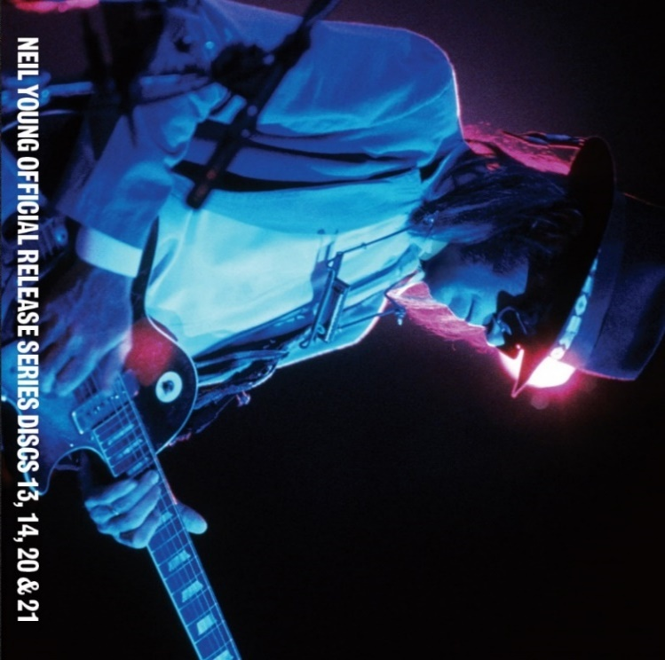
(Click here for hi-res image)

March 18, 2022 (Los Angeles, CA) – Today, Neil Young announces the release of the fourth installment in his Official Release Series (ORS): a box set that includes his classic ‘80s records Hawks & Doves, Re•ac•tor, and This Note’s for You, as well as his Eldorado EP, previously released only in Japan and Australia. Both vinyl and CD box sets will be available for pre-order today and out on April 29th. Fans can purchase the ORS Vol 4 CD box set through all retailers; the vinyl box set will be available at indie stores and The Greedy Hand Store at Neil Young Archives (NYA). All Greedy Hand Store purchases of ORS Vol 4 box sets come with free hi-res digital audio downloads from the Xstream Store at NYA.
The ORS Vol 4 collects an eclectic set of decade-spanning sounds. Hawks & Doves (1980) revisits his folk roots and explores some of his most country-leaning offerings; the blistering Re•ac•tor (1981) showcases a stomping set of heavy, overdriven rock with Crazy Horse; and This Note’s for You (1988) casts Young as a big band leader, belting out intricately arranged blues. The Eldorado EP (1989) is full of feral distortion and earthy crunch featuring Young backed by The Restless (Chad Cromwell and Rick Rosas). It includes two thundering tracks — “Cocaine Eyes” and “Heavy Love”— not available on any other album. Eldorado will launch on most major DSPs upon the release of the box sets. Those who pre-order ORS Vol 4 now will receive an instant download of “Cocaine Eyes.”
The other three albums included in the ORS Vol 4 box sets are currently available digitally at Neil Young Archives and most major DSPs.
Only at NYA can you find Young’s music in the highest possible digital audio resolution alongside a seemingly infinite store of archival files. It’s also the home of Young’s virtual daily newspaper, The Times Contrarian, and The Hearse Theater, where you can see rare footage and stream live shows. NYA is a fittingly sprawling repository for Young; few artists—perhaps none—have explored such a vast spectrum of sounds and styles over more than half a century. ORS Vol 4 collects a large swath of his diverse and compelling ‘80s work, testifying to the legendary songwriter’s gift for sonic shape-shifting.

ORS Vol 4 Track Listing:
Hawks & Doves:
- Little Wing
- The Old Homestead
- Lost in Space
- Captain Kennedy
- Stayin’ Power
- Coastline
- Union Man
- Comin’ Apart at Every Nail
- Hawks & Doves

Re•ac•tor
- Opera Star
- Surfer Joe and Moe the Sleaze
- T-Bone
- Get Back on It
- Southern Pacific
- Motor City
- Rapid Transit
- Shots

This Note’s For You
- Ten Men Workin’
- This Note’s for You
- Coupe de Ville
- Life In The City
- Twilight
- Married Man
- Sunny Inside
- Can’t Believe Your Lyin’
- Hey Hey
- One Thing

Eldorado
- Cocaine Eyes
- Don’t Cry
- Heavy Love
- On Broadway
- Eldorado

# # #

For further information, contact Rick Gershon at Warner/Reprise Records:
Rick.Gershon@warnerrecords.com

Follow Neil Young:
Official | Press Materials

