NEIL YOUNG RELEASES
RETURN TO GREENDALE ALBUM AND FILM TODAY
Listen To “Be The Rain” Here And Here To Watch

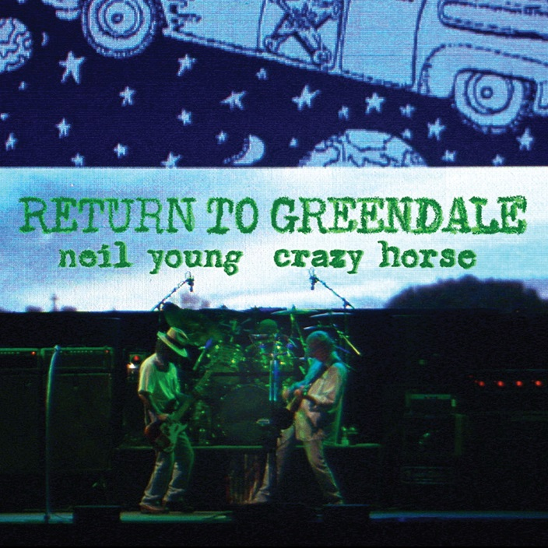
(Click here for hi-res artwork)

November 6, 2020 (Los Angeles, CA) — Today, NEIL YOUNG releases his multi-faceted live concert experience Return To Greendale. Much more than a live album and performance film, this presentation of the historic 2003 tour in support of his 25th studio album Greendale, is a definitive edition in terms of a full-blown presentation as rock show with a narrative stage play acted out in real time with over 20 people on stage at certain points during the show. Return To Greendale is powered by themes of environmentalism and corruption, are even more topical today than it was in 2003. Click here to stream “Be The Rain,” and here to view and share the video.

The songs and performance remain poignant as ever, featuring Young with Crazy Horse, the Toronto recording captures the epic experience of Young’s small-town, rural rock opera. The multimedia exploit seamlessly blended Young’s powerful lyrics and Crazy Horse’s heavy blues thrash with musical theatre, as actors joined the band onstage to play out Greendale’s narrative as it unfolded.

Return to Greendale is available in several formats. The limited-edition deluxe box set includes a Blu-ray of the concert, two LPs and two CDs, and a DVD of Inside Greendale, a documentary capturing the making of the album. It will also be available separately on double vinyl, a two-CD set, and digitally from the Xstream© store at Neil Young Archives (NYA) and at all major DSPs. Inside Greendale features footage of Young and Crazy Horse in the studio, mixed with segments from 2003’s Greendale fictional film. Both Inside Greendale and the concert film are directed by Bernard Shakey and produced by L.A. Johnson (Human Highway, Rust Never Sleeps). Click here to order Return To Greendale. Purchasers of Return To Greendale from the Greedy Hand Store also receive a free hi-res digital audio download.
The story of Greendale follows multiple generations of the Green family as they go about their lives in a fictional California town. Through the perspectives of multiple characters—Grandma, Grandpa, Edith, Earl, the doomed Jed, and eco-warrior Sun Green, among them—Young tells a poignant story about small-town America and the need for immediate action to save the environment. That need, of course, has only become more urgent. On Return to Greendale, the 10 songs from Young’s powerful original album are performed in sequence, with a cast of actors speaking the sung words, adding to the already blistering intensity of the performance.

Return to Greendale track listing for audio and Blu-ray:

1. Falling from Above
2. Double E
3. Devil’s Sidewalk
4. Leave the Driving
5. Carmichael
6. Bandit
7. Grandpa’s Interview
8. Bringin’ Down Dinner
9. Sun Green
10. Be the Rain

Neil Young Archives is the first totally immersive fan-experience website and remains the only portal for all things Neil Young.

# # #

For further information, contact Rick Gershon at Warner Records:
818-953-3473 / Rick.Gershon@warnerrecords.com

Official Site/NYA:
neilyoungarchives.com

Press materials:
https://press.warnerrecords.com/neilyoung/

