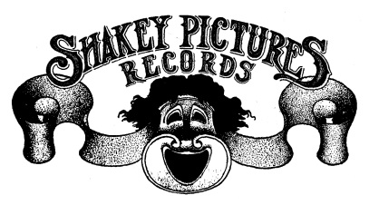

NEIL YOUNG TO RELEASE SONGS FOR JUDY ON CD/DIGITAL NOVEMBER 30 AND ON VINYL DECEMBER 14 VIA SHAKEY PICTURES RECORDS DISTRIBUTED BY REPRISE RECORDS

Twenty-Two Song Live Acoustic Set from 1976
Pre-Orders Begin Today

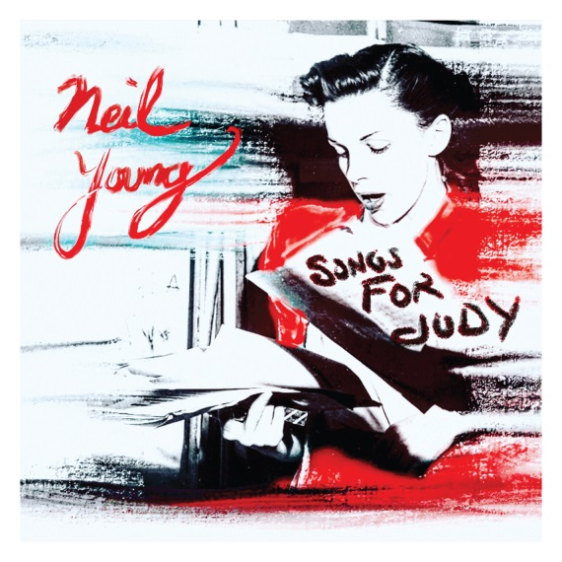

October 19, 2018 (Los Angeles, CA) – Neil Young is set to release Songs For Judy on CD and digitally on November 30, while the vinyl edition will follow on December 14. Songs For Judy is the debut release on Shakey Pictures Records, Young’s own imprint distributed by Reprise Records. The album is available for pre-order beginning today. Songs for Judy is available in hi-res at NYA, Neil Young Archives.com. Those who pre-order will receive an instant download of the track “Campaigner”, recorded live in Boston, November 22, 1976. Click here to read Notes About The Recording, courtesy of Cameron Crowe and Joel Bernstein, who curated this collection. Click here to purchase Songs For Judy .

Songs For Judy is a thoroughly engaging collection of live acoustic performances culled from Neil’s November 1976 solo tour and features twenty-two songs recorded at various cities along the tour. This song cycle of live recordings is particularly powerful and unique. Young had spent much of the year traveling around the world on tour with Crazy Horse. When touring on his own, he recharged and focused on songs that would not surface in recorded form for several years. Of the albums many treasures, “No One Seems To Know” would not see the light of day until now and it remains unreleased in any other iteration.

The raw versions of the tracks found on Songs For Judy reflect an artist completely unvarnished and unafraid to allow the songs to breath and to find their own shape when performed in a solo setting. Songs written in that era would come into focus and then seemingly disappear only to re-enter Young’s orbit somewhere down the road. “White Line” and “Give Me Strength” are such examples of finding the light in 1990 and 2017 respectively. It’s also fascinating to hear Young revisit early gems such as Springfield’s “Mr. Soul” (’67), “Here We Are In The Years” (’68), and “The Losing End” (’69) from some of his earliest solo recordings which remain as timeless as ever.

Songs For Judy captures lightning in a bottle, illuminated for all time and available on vinyl, CD and on Youngs’ Xtream hi-res streaming service exclusively found on neilyoungarchives.com.

Songs For Judy Tracklist:

Songs For Judy Intro Atlanta, GA Nov 24 (late show)
Too Far Gone Boulder, CO Nov 06
No One Seems To Know Boulder, CO Nov 07
Heart Of Gold Fort Worth, TX Nov 10
White Line Fort Worth, TX Nov 10
Love Is A Rose Houston, TX Nov 11
After The Gold Rush Houston, TX Nov 11
Human Highway Madison, WI Nov 14
Tell Me Why Chicago, IL Nov 15 (late show)
Mr. Soul New York, NY Nov 20 (early show)
Mellow My Mind New York, NY Nov 20 (early show)
Give Me Strength New York, NY Nov 20 (late show)
Man Needs A Maid New York, NY Nov 20 (late show)
Roll Another Number Boston, MA Nov 22 (late show)
Journey Through The Past Boston, MA Nov 22 (late show)
Harvest Boston, MA Nov 22 (late show)
Campaigner Boston, MA Nov 22 (late show)
Old Laughing Lady Atlanta, GA Nov 24 (early show)
The Losing End Atlanta, GA Nov 24 (late show)
Here We Are In The Years Atlanta, GA Nov 24 (late show)
The Needle And The Damage Done Atlanta, GA Nov 24 (early show)
Pocahontas Atlanta, GA Nov 24 (late show)
Sugar Mountain Atlanta, GA Nov 24 (late show)

# # #

For further information, contact Rick Gershon at Reprise Records Publicity:
818-953-3473 / rick.gershon@wbr.com

Official Site/NYA:
neilyoungarchives.com

Press Materials:
http://press.wbr.com/neilyoung

