NEIL YOUNG ARCHIVES
LAUNCHES REVOLUTIONARY HI-RES STREAMING APP & MEMBERSHIP SERVICE

A Never-Before-Available Array of Exclusive Content Offered in the
Highest-Resolution Audio

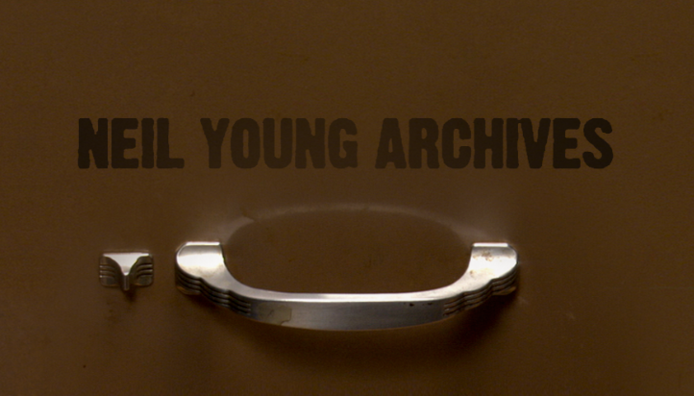
neilyoungarchives.com

December 20, 2018 – (Los Angeles, CA) NEIL YOUNG is pleased to announce the official launch of the Neil Young Archives (NYA) revolutionary website and Hi-Res mobile app (available on iPhone now and Android soon) as a membership service. A first-of-its-kind musician’s website that offers the finest audio quality available anywhere online. The Neil Young Archives website and app will be launched as both a limited free subscription and a $1.99 per month/$19.99 per year unlimited subscription.
“I want to share with you that I have made a place for my music to live,” Young said of the NYA in a recent post. “It will also be the place where I live on the web.”
Created over the course of years by Young and a small team (with support from Warner Bros. Records), the NYA is the only interactive and in-depth website of its kind in that it is a dedicated and comprehensive digital archival service, the scope of which will fascinate all those who log onto it. NYA has operated since last December in beta mode and received an overwhelming 1.2 million visitors (and over 22 million page views).
The Guardian calls NYA, “A revolution in fandom” and “The first groundbreaking yoking of technology to archival content in more than 30 years.” Click HERE to read the complete story.
Parts of the site will remain free to all users, while paid members will be able to access “The Unlimited Neil Young Archives” and its host of services, including early access to “Best Seats in the House” for Neil Young’s upcoming shows, all records in hi-res, “surprise live streams from the Hearse Theatre,” movies, videos, art work, The Times- Contrarian daily newspaper, special offers on merchandise, hi-res downloads at low res prices, and much more.
“I wanted a place where my fans and I could hear my music from the very beginning, from the high school bands I was in, to my latest recordings – audio and visual,” Young says. “I wanted to be able to hear it all, all the sound I heard when I made those records and poured my heart and soul into every one, the good and the bad, the great and the ‘should be gone.’ They all live on NYA.”
Highest-Resolution of Any Streaming Music Service

Young’s passion for audio is well known, and he’s applied his ear for detail to the sonic aspect of NYA with the utmost care. The site streams its music using Xstream by NYA, developed by Young with OraStream technology. It’s capable of streaming at the original quality of master recordings, higher than other streaming services at 192 kHz/24 bit.
“If you want to hear my music and would like to have the option to listen to it with all the depth and glory of high resolution, it will be there,” Young says. “All my new records can be heard there first, before they get released anywhere else. New, unreleased albums from the archives and old, unreleased albums from the archives will always be heard there first. Our machine is a monster.”
Unlimited Subscription: $1.99/month, $19.99/year
● Full access to all NYA music in Xstream by NYA Hi-Res
● Listen to new and unreleased recordings on NYA first - before anywhere else
● First in the world Hi-Res music store at low-res prices
● Neil Young Archives Hi-Res App where you can play all of Neil’s music and videos, navigate the
timeline and read the Times-Contrarian. (iOS available now/Android available soon)
● Pre-sale concert tickets. Best seats for NYA members are available in advance of public sale (yearly
subscribers)
● Livestream concerts
● Full access to all NYA videos and content and first viewing of many rare unreleased videos
● Full access to the Hearse Theater – featuring Shakey Pictures movies, rare live performances and
Videos
● NYA TIMES CONTRARIAN daily newspaper – “Quality Whether You Want It or Not” – Ever wonder how a publication would read if Neil Young was the editor? This is his news outlet.
- All NYA music news
- Playlists
- Letters to the editor
- World News Viewpoint
- Lincvolt updates
Free Subscription
● Browse NYA
● Listen to the Featured Album and the Song of the Day
● First in the world Hi-Res music store at low-res prices
● Neil Young Archives Hi-Res App. Listen to song of the day, featured album, navigate the timeline and read the Times-Contrarian. (iOS available now/Android coming).
● Browse info cards (photos, art, documents, memorabilia, press)
● Experience Xstream by NYA Hi-Res
● NYA TIMES CONTRARIAN daily newspaper – “Quality Whether You Want It or Not” – Ever wonder how a publication would read if Neil Young was the editor? This is his news outlet.
- All NYA music news
- Playlists
- Letters to the editor
- World News Viewpoint
- Lincvolt updates

Click HERE for further description of how to get around the ever expanding NYA

TIMELINE
Scrolling through The Timeline will reveal fascinating facts, details and ephemera. Currently starting at 1959 and continuing on to the present, The Timeline can let you know what happened on dates in both world history and Young’s career – songs, albums, tours, live performances (on March 21, 1994 he played “Philadelphia” on the Academy Awards for example), it’s all here and only here.
Visit the virtual File Cabinet for the Song of the Day, each one personally selected by Neil. Members can hear and feel the music, dig deep for lyrics and rare photos, find detailed recording information and memorabilia; a treasure trove.
“There are files and files for years and years, all full of music,” says Young. “Albums and tracks, bits and pieces, manuscripts and art, film and video. I live there.”
“Each song is being backed up with the archival material that relates to it and to the creation of it, from song writing to band jams, the history of this music is there. It’s never finished – it is huge and growing. We work night and day expanding the window you can see this archival stuff through.”
“Come and visit the cabinet and take a look inside. If you like my music, this should be a good place to wander and spend the light and dark hours. You can always be there. This place is made for you to get the best of my work. I appreciate you and want you to always have the first choice.”
“Hope to see you there.”
# # #

For further information, contact Rick Gershon at Reprise/ Warner Bros. Record Publicity:
818-953-3473 / rick.gershon@wbr.com

Official Site/NYA:
neilyoungarchives.com
Twitter - @NeilYoungNYA
Instagram - @NeilYoungArchives
Facebook - @NeilYoungArchives

Press materials:
http://press.wbr.com/neilyoung

