**Neil Young Releases *The Times*, An Brand-New Amazon Original EP, Released in High Quality Audio Only on Amazon Music HD**

**Stream the Full EP on Amazon Music HD** [**HERE**](http://amzn.to/NeilYoung) **and Purchase the CD Edition of the EP Wherever Music Is Sold**

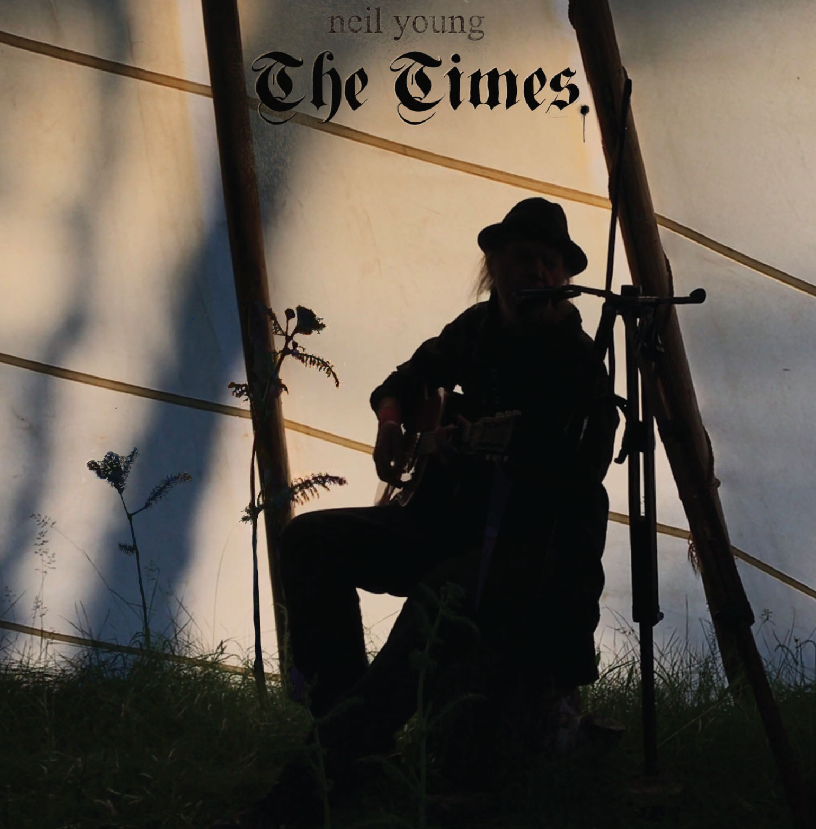

**September 18, 2020:** Today, Neil Young releases *The Times*, a brand-new Amazon Original EP streaming on Amazon Music HD in high quality audio, and currently available in CD format wherever music is sold. Featuring music originally broadcast as a part of the “Porch Episode” of Neil Young’s livestreamed Fireside Sessions, *The Times* EP is a politically-charged collection of classics spanning Neil Young’s catalog, including iconic protest songs like “Ohio,” “Alabama,” “Southern Man,” “Campaigner,” and more. The EP also features “Lookin’ For A Leader 2020,” a lyrically revised and impassioned update to “Looking for a Leader,” which was originally released on Young’s 2006 masterpiece *Living with War*. The EP also features Young’s *Homegrown* original “Little Wing” and a cover of Bob Dylan’s “The Times They Are A-Changin’.” Listen [here](http://amzn.to/NeilYoung).

“I'm on Amazon Music because no one delivers better sound to the masses,” said Neil Young.

*The Times* EP is now available to Amazon Music HD customers in HD and Ultra HD on Amazon Music HD, Amazon Music’s high-quality streaming service. Amazon Music HD offers the highest-quality listening experience available, with more than 60 million songs available in High Definition (HD), millions of songs in Ultra HD, and a growing catalog of 3D Audio. Amazon Music HD was launched a year ago in the U.S., U.K., Germany, and Japan, and earlier this month, the service expanded to France, Italy, Spain, Austria, and Canada.

Young worked with Niko Bolas to prepare the “Porch Episode” recordings for official release, ensuring that each song was delivered with a bit depth of 24 bits and a sample rate of 48 kHz. Like all music featured on Amazon Music HD, all songs on *The Times* EP were delivered using FLAC, a lossless digital audio format intended to preserve the quality of the original recording. In addition, the full “Porch Episode” video is now available on Prime Video and can be watched [here](https://www.amazon.com/dp/B08J6P43TV). Physical copies of *The Times* EP are also available at Amazon.com and other major retailers now.

**Listen to *The Times* HERE:**

<http://amzn.to/NeilYoung>

**Embed Code:**

<iframe id='AmazonMusicEmbedB08DXSBKL7'src='https://music.amazon.com/embed/B08DXSBKL7/?id=MzFtD6J688&marketplaceId=ATVPDKIKX0DER&musicTerritory=US' width='100%' height='290px' style='border:1px solid rgba(0, 0, 0, 0.12);max-width:500px'></iframe>

Neil Young’s Amazon Original EP comes following the release of ***Homegrown***—one of Neil Young’s most storied and sought-after albums ever—on Reprise Records. Often referred to by fans as one of Young’s mysterious, great “lost albums,” the twelve studio tracks were originally recorded in analog in 1974 and 1975 and mixed to original stereo master tapes. Released earlier this summer, the original mixes were restored with love and care by John Hanlon, and mastered by Chris Bellman at Bernie Grundman Mastering, making *Homegrown* a completely original album.

Young has also worked extensively throughout 2020 with Daryl Hannah to produce a series of livestreamed Fireside Sessions, featuring warm, intimate performances from Young, as well as some surprising setlists. Hailed by Rolling Stone as one of the “Best Livestreamed Performances So Far,” The Fireside Sessions are available on Young’s innovative, comprehensive website [neilyoungarchives.com](https://www.neilyoungarchives.com).

Amazon Music listeners can listen to *The Times* by simply asking, “Alexa, play the new album by Neil Young” in the Amazon app for iOS and Android and on Alexa-enabled devices. In addition to Neil Young, Amazon Music listeners can access hundreds of [Amazon Originals](http://amzn.to/bestoforiginals) featuring both emerging and established artists across numerous genres, available to stream and purchase only on Amazon Music.

***The Times* Tracklist:**

1. Alabama

2. Campaigner

3. Ohio

4. The Times They Are A-Changin’

5. Lookin’ for a Leader 2020

6. Southern Man

7. Little Wing

**For more information, please contact:**

David Marek // Amazon Music

[davmarek@amazon.com](mailto:davmarek@amazon.com)

Rick Gershon // Reprise / Warner Records

[rick.gershon@warnerrecords.com](mailto:rick.gershon@warnerrecords.com)

**Follow Neil Young**

[**NYA**](https://neilyoungarchives.com/)

**/var/folders/kf/v6dntks955j4xr91961zp0200000gp/T/com.microsoft.Word/WebArchiveCopyPasteTempFiles/cidimage003.jpg@01D4F910.A5DA5810**