**PATRICK DRONEY ADDS MORE TOUR STOPS AMID MULTIPLE**

**SOLD OUT SHOWS**

**Tickets For Philadelphia And San Francisco On Sale Today**

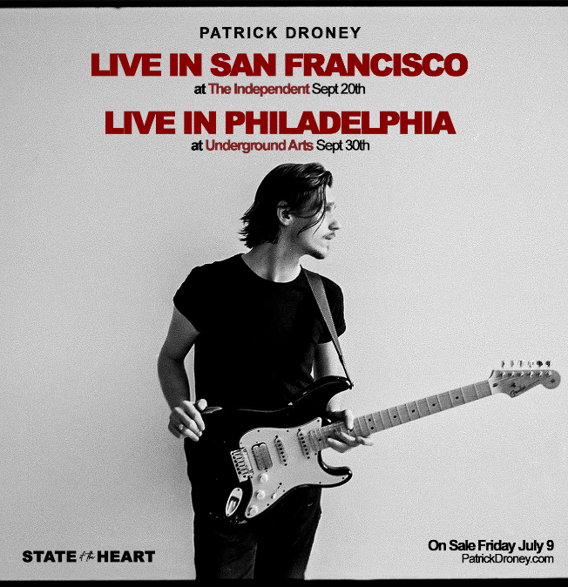 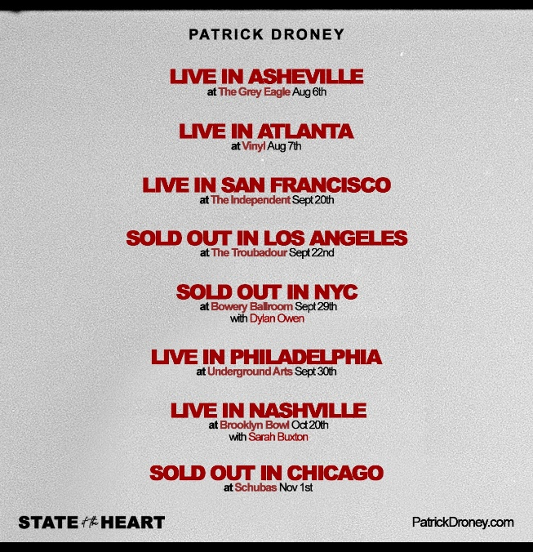

**July 9, 2021 – (Los Angeles, CA.) --** Breakout singer/songwriter and celebrated artist **Patrick Droney**continues to expand his summer tour amid multiple sold out shows coast-to-coast. As his "new chapter is already resonating with audiences,” (***American Songwriter***) evidenced with selling-out famed venues including NYC’s The Bowery Ballroom, LA’s Troubadour and Chicago’s Schubas, the fast-rising Warner Records artist announced additional shows in **San Francisco on September 20** and **Philadelphia on September 30**. Tickets for new shows are on sale now. Click [**here**](http://www.patrickdroney.com) for further information.

The tour supports **STATE OF THE HEART**, Droney’s debut “gem of an album” (***People***), available now via Warner Records. Amassing over 21.6 million streams and an electrifying performance on ***The Late Show With Stephen Colbert*** since its release, the album’s "rocking tracks and meaningful moments” (***American Songwriter)*** continue to receive overwhelming acclaim from fans and critics. Click [**here**](https://www.youtube.com/watch?v=nB3bVGUHiSA) to view and share that live version of **“When The Light Go Out”** from the album.

"I couldn’t be more thrilled to bring this body of work onto the stage,” Droney shared. "*State of the Heart* came to form in an era where performance conversation wasn’t possible, so all of that energy was poured into the making this record. The very heart of what I do is live performance and I know so many inspired moments will come from that human connection in these venues that are so dear to me. I know not a single second will be taken for granted."

***+ Indicates supporting Sheryl Crow***

***\* Indicates Dylan Owen as show support***

***\*\* Indicates Sarah Buxton as show support***

**On Tour with Patrick Droney:**

Aug 06 The Grey Eagle Asheville, NC

Aug 07 Vinyl Atlanta, GA

**+** Sep 03 Eastern Idaho State Fair Blackfoot, ID

Sep 20 The Independent San Francisco, CA

Sep 22 Troubadour Los Angeles, CA - **SOLD OUT**

**\***Sep 29 The Bowery Ballroom New York City - **SOLD OUT**

Sep 30 Underground Arts Philadelphia, PA

**\*\***Oct 20 Brooklyn Bowl Nashville, TN

Nov 01 Schubas Chicago, IL -**SOLD OUT**

**About Patrick Droney:**

Growing up in South Jersey, Droney’s career began with a bang, as at age 13 he won a Robert Johnson New Generation Award as “Best Young Blues Guitarist” and began sharing stages with the likes of B.B. King, James Brown, The Roots, Taj Mahal, Macy Gray, and Elvis Costello. Droney became enamored of New York City at an early age, gigging frequently in esteemed Manhattan clubs and eventually attending the Clive Davis Institute of Recorded Music at NYU. He moved to LA and signed a publishing deal, and in 2018 relocated to Nashville to craft a self-titled EP, also making his TV debut on Late Night with Seth Meyers, performing at Barclays Center for Tidal X, and seeing his song “High Hope” featured on Grey’s Anatomy. After signing to Warner Records in 2019, he appeared at Bonnaroo and ACL, collaborated with Kygo, released the first half of his debut, and recently reached the 60 million streams milestone. With a résumé that reads like a dream, and after extensive touring and playing onstage with some of the all-time legends of blues, pop, rock, and soul, Droney released a debut album of his own — [***STATE OF THE HEART***](https://open.spotify.com/album/2kqqKq8hxUDp0i1n0GpsgX) — available now.

**# # #**

**Contacts:**

**Warner Records**

**Rick Gershon /** [**Rick.Gershon@warnerrecords.com**](mailto:Rick.Gershon@warnerrecords.com)

**Patrice Compere /** [**Patrice.Compere@warnerrecords.com**](mailto:Patrice.Compere@warnerrecords.com)

**The GreenRoom**

**Kristie Sloan /** [**kristie@thegreenroompr.com**](mailto:kristie@thegreenroompr.com)

**Tyne Parrish /** [**tyne@thegreenroompr.com**](mailto:tyne@thegreenroompr.com)

**Follow Patrick Droney:**

[**Instagram**](https://www.instagram.com/patrickdroney/?hl=en) **|** [**YouTube**](https://www.youtube.com/user/patrickdroney/featured) **|** [**Twitter**](https://twitter.com/patrickdroney) **|** [**Facebook**](https://www.facebook.com/patrickdroney/) **|** [**Website**](https://www.patrickdroneymusic.com/) **|** [**Press Materials**](https://press.warnerrecords.com/patrickdroney/)

