BELLA POARCH SMASHES RECORDS WITH DEBUT SINGLE “BUILD A BITCH”
ON WARNER RECORDS

#1 ON GLOBAL + U.S. YOUTUBE VIDEO CHART &
BIGGEST DEBUT EVER FOR A NEW ARTIST WITH OVER 75 MILLION VIEWS

“cute and furious” – The New York Times

‘“Build a Bitch” is an audacious, darkly comic slice of new-school pop” – Billboard

“Deftly dismantling the impossible standards of beauty that we are put under, it’s also incredibly catchy” – VOGUE

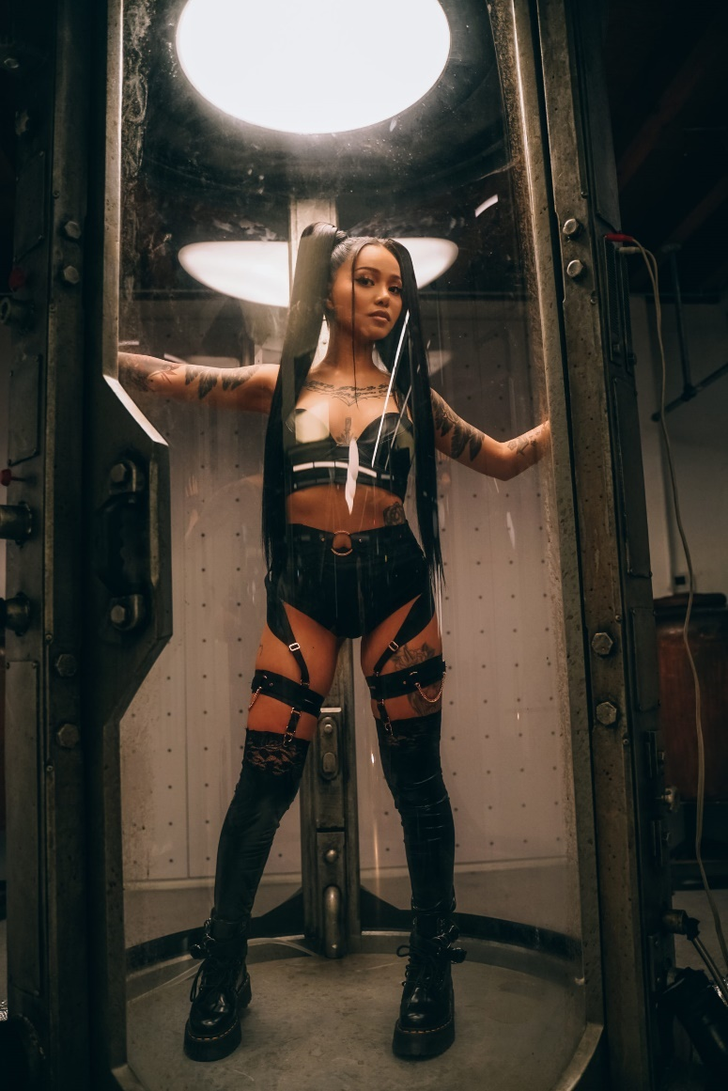

May 24, 2021 (Los Angeles, CA) – After taking over the internet as the third-biggest TikTok star and #1 Asian-American influencer in the world, Bella Poarch is continuing to break records left and right with the release of her debut single “Build a Bitch.” The acclaimed video, directed by Andrew Donoho and creative directed by Sub Urban, scored the biggest debut ever on YouTube for a new artist, entering both the Global and U.S. YouTube Video charts at #1, with a whopping 75 million views and counting. Meanwhile at Spotify, “Build a Bitch” is rapidly climbing the charts, currently sitting at #26 on the Spotify Top 200 globally and #34 on the Top 200 Songs U.S. chart.

Bella says, “Being in the navy taught me a few things - patience, discipline, and family. To be honest, I can’t believe the reaction everything is getting and I’m so grateful to my fans for all of their support. I couldn’t have done this without them. They are my family. Mahal na mahal ko kayong lahat 💕”

"From the moment we spotted Bella Poarch, we knew we had a star on our hands. She’s already captivated millions around the globe by being her most authentic self, but now she’s able to let her true musical artistry shine," said Aaron Bay-Schuck and Tom Corson, co-Chairmen of Warner Records. "Bella has a distinct and clear vision and the raw, undeniable talent to see it through. All of us at Warner Records are excited to bring Bella’s world to life – and this is truly only the beginning.”

Watch the record-breaking “Build a Bitch” video HERE and stream “Build a Bitch” HERE.

About Bella Poarch
Infinitely fascinating and unpredictable, Bella Poarch is a true force of nature. Not only the world’s third-biggest TikTok star (with over 65 million followers and counting), the Filipino-American is a U.S. Navy veteran who’s created countless home recordings based on her emotional & raw life experiences. Originally hailing from a tiny farm in the Philippines, Bella first discovered her vocal gifts as a little girl and started performing at school talent shows despite her parents’ disapproval. She enlisted in the U.S. Navy at 17, where she proudly served working on helicopters and jets across the States and Japan, and ultimately landed in Hawaii as her contract was ending. Based on her friends’ suggestion, Bella downloaded TikTok in early 2020 and soon found a community who propelled her to the most-liked TikTok video of the year – an August 2020 post that’s accrued 50 million likes. By September 2020 she’d moved to L.A. to focus on her career goals a musician, and now, with her debut single “Build a Bitch,” produced by Sub Urban, and more music to come, Bella Poarch delivers her own diverse and alternative brand of dark pop.



###

For further information about Bella Poarch, please contact:
Ceri.Roberts@warnerrecords.com

Bella Poarch Press Materials:
press.warnerrecords.com/bellapoarch

Follow Bella Poarch:
Instagram | YouTube | Twitter | TikTok



