BENSON BOONE RELEASES EMOTIONAL DEBUT SINGLE AND VIDEO “GHOST TOWN”

SIGNED BY DAN REYNOLDS OF IMAGINE DRAGONS – BOONE PROMISES TO BE ONE OF THE BREAKOUT ARTISTS OF 2021

WATCH HERE

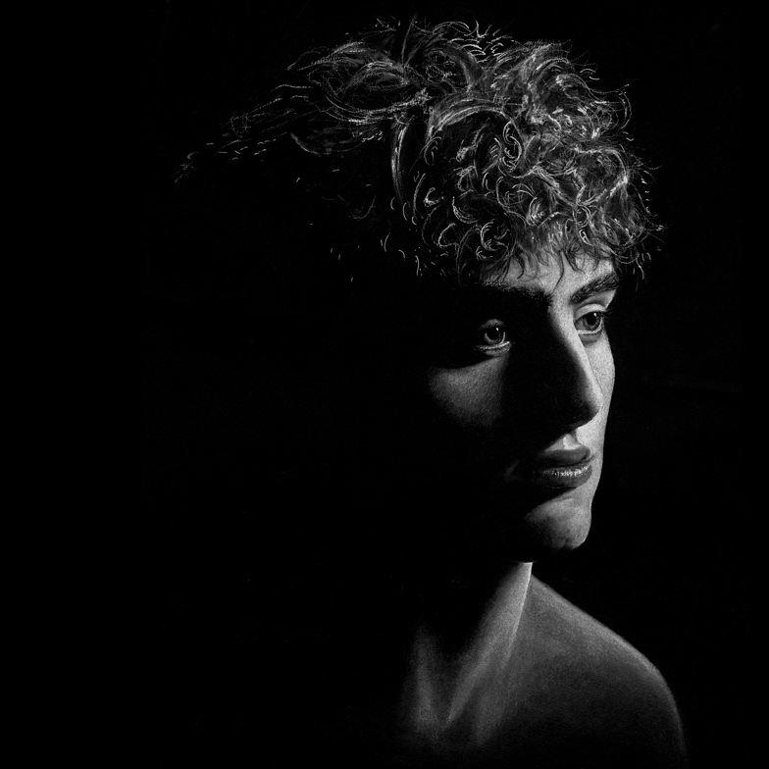

October 15, 2021 (Los Angeles, CA) – 19-year-old Benson Boone makes an auspicious debut today with a stunning single called “GHOST TOWN.” A poignant ballad with unflinchingly honest lyrics and soaring vocals, this is the calling card of a major new talent. “Maybe you’d be happier with someone else, maybe lovin’ me is the reason you can’t love yourself,” he sings over melancholy keys. “Before I turn your heart into a ghost town, show me everything we built so I can tear it all down.” Get it HERE via Night Street/Warner Records and watch the video HERE.

Benson penned “GHOST TOWN” based off emotions that were pulled from observing a friend’s toxic relationship and realizing development in his own emotional maturity. “I saw that from an outside perspective and wondered what they could have done differently,” the newcomer from Monroe, Washington explains. “Love can hurt more than it can help. Sometimes the best way of showing someone you care is by letting them go.”

Incredibly, the teenager was completely unaware of his prodigious talent until asked to join a band for his school talent show. Boone wowed everyone in the audience including himself and suddenly found his purpose. An audition for American Idol followed, but he withdrew despite being lavished with praise from judges. “It was a very hard choice,” Boone admits. “I didn't want to show the world someone I'm not.”

That desire for authenticity fuels every aspect of Boone’s artistry. From the hand-drawn “GHOST TOWN” cover to the black-and-white music video, which was filmed in his hometown with a little help from his real-life friends, the singer/songwriter doesn’t want there to be any buffer between him and the listener. Signed and mentored by Imagine Dragons lead singer and founder of Night Street Records Dan Reynolds, Boone promises to be one of the breakout artists of 2021.

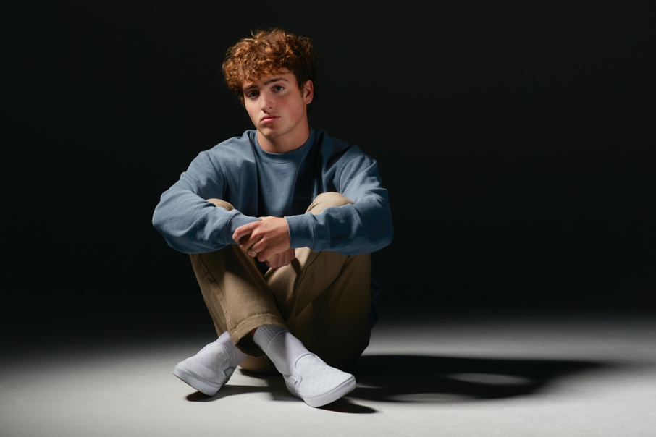
PHOTO CREDIT: JONATHAN WEINER
DOWNLOAD PRESS PHOTO HERE

FOLLOW BENSON BOONE:
TikTok | Instagram | Twitter | Facebook | YouTube

For more information, please contact:
Darren Baber | Warner Records
Darren.Baber@warnerrecords.com
