BRANDY CLARK CONFIRMS
“THE ART OF THE STORYTELLER” GLOBAL HEADLINE TOUR
“CMT CROSSROADS: LEANN RIMES & FRIENDS” PERFORMANCE AIRING APRIL 14
NOMINATED FOR SONG OF THE YEAR AND BEST AMERICAN ROOTS PERFORMANCE AT 64TH GRAMMY AWARDS
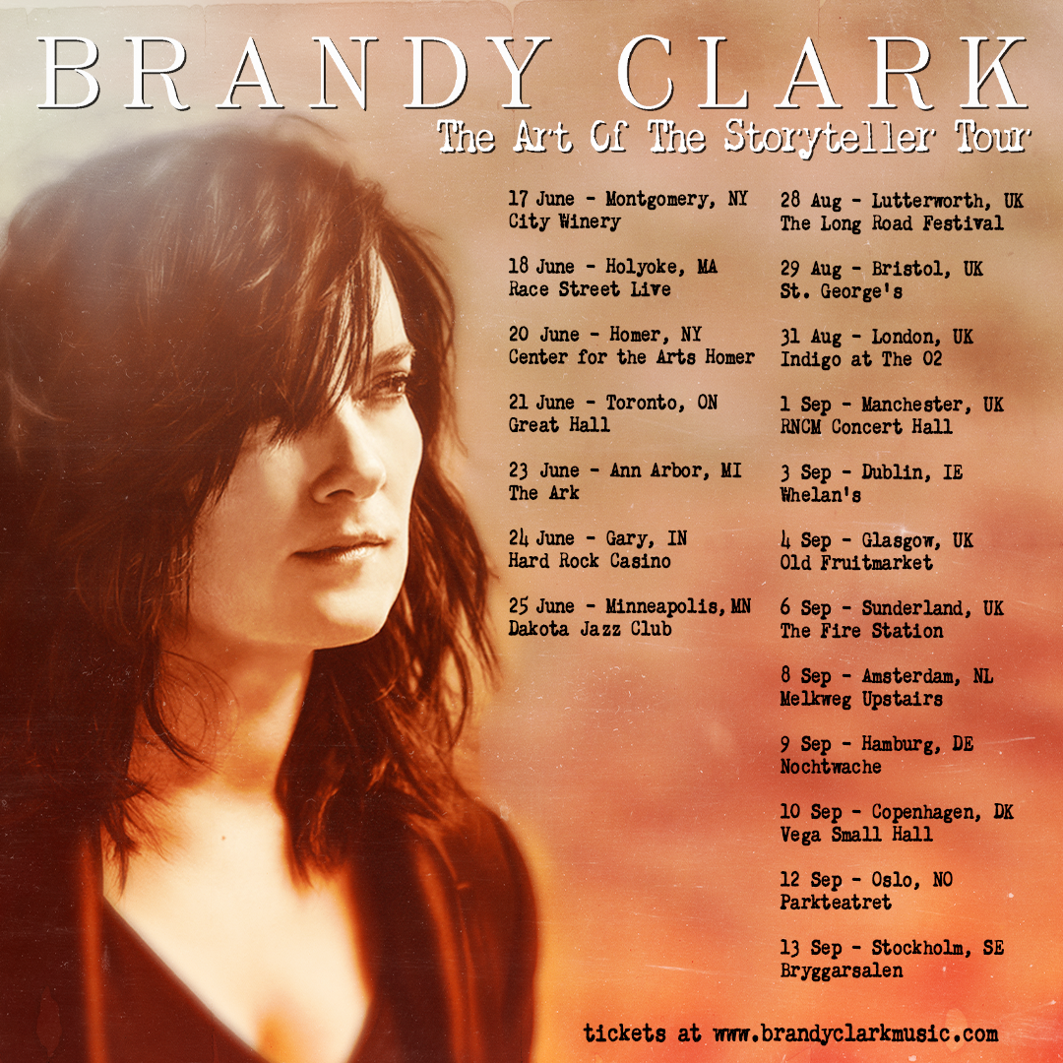
March 28, 2022—10x GRAMMY-nominee Brandy Clark will embark on her global “The Art of the Storyteller Tour” this summer with headline dates in the U.S., Canada and Europe. See below for complete itinerary. Pre-sale tickets for the upcoming dates go on-sale this Tuesday, March 29 at 10:00am local time. Details for how to access the pre-sale can be found at www.brandyclarkmusic.com/tour. Tickets will go on-sale to the general public this Thursday, March 31 (UK/Europe) and Friday, April 1 (US/CAN).
Clark will also perform as part of “CMT Crossroads: LeAnn Rimes & Friends,” airing April 14 at 8:00pm ET/7:00pm CT in celebration of Rimes’ 25th career anniversary. In addition to Clark and Rimes, the all-female event lineup will also feature Ashley McBryde, Carly Pearce and Mickey Guyton performing songs from throughout Rimes’ career.
The upcoming performances add to a landmark year for Clark, who is nominated for two awards at the 64th Annual GRAMMY Awards: Song of the Year (“A Beautiful Noise” performed by Alicia Keys and Brandi Carlile) and Best American Roots Performance (“Same Devil” featuring Carlile). The live awards ceremony will be broadcast Sunday, April 3 at 8:00pm ET/7:00pm CT on CBS.
A ten-time GRAMMY nominee and CMA Awards “Song of the Year” recipient, Clark is one of her generation’s most respected and celebrated songwriters and musicians. Her songs include Kacey Musgraves’ “Follow Your Arrow,” Miranda Lambert’s “Mama’s Broken Heart,” The Band Perry’s “Better Dig Two” and Hailey Whitter’s “Ten Year Town.” Her past three solo albums—2020’s Your Life is a Record, 2016’s Big Day in a Small Town and 2013’s 12 Stories—each garnered immense critical acclaim landing on “Best of the Year” lists at New York Magazine, Billboard, NPR Music Entertainment Weekly, Rolling Stone, Stereogum, etc. NPR Music calls her, “a storyteller of the highest caliber,” Rolling Stone asserts, “a country visionary…the consolation of a beautiful voice delivering a well-built song, cold truth rising from it like fog off dry ice,” while Slate declares, “one of the greatest living short-story-song writers in country (which really means in any genre)” and The New Yorker praises, “No one is writing better country songs than Brandy Clark is.”
“THE ART OF THE STORYTELLER TOUR”
June 17—Montgomery, NY—City Winery
June 18—Holyoke, MA—Race Street Live
June 20—Homer, NY—Center for the Arts Homer
June 21—Toronto, ON—Great Hall
June 23—Ann Arbor, MI—The Ark
June 24—Gary, IN—Hard Rock Casino
June 25—Minneapolis, MN—Dakota Jazz Club
August 28—Lutterworth, UK—The Long Road Festival
August 29—Bristol, UK—St. George’s
August 31—London, UK—Indigo at the O2
September 1—Manchester, UK—RNCM Concert Hall
September 3—Dublin, Ireland—Whelan’s
September 4—Glasgow, UK—Old Fruitmarket
September 6—Sunderland, UK—The Fire Station
September 8—Amsterdam, Netherlands—Melkweg Upstairs
September 9—Hamburg, Germany—Nochtwache
September 10—Copenhagen, Denmark—Vega Small Hall
September 12—Oslo, Norway—Parkteatret
September 13—Stockholm, Sweden—Bryggarsalen
www.brandyclarkmusic.com

