

**THE FLAMING LIPS TO RELEASE NEW ALBUM *KING’S MOUTH* AS A RECORD STORE DAY EXCLUSIVE ON APRIL 13TH**

**ONLY AVAILABLE ON LIMITED-EDITION VINYL**

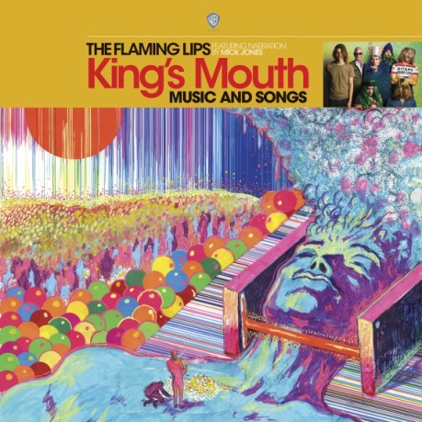

**February 28, 2019 (Los Angeles, CA) –** [**THE FLAMING LIPS**](http://www.flaminglips.com)will exclusively release their 15th studio album, ***King’s Mouth*** (Warner Bros. Records)**,** as a 12-inch colored vinyl on this year’s [**Record Store Day**](http://www.recordstoreday.com)—Saturday, April 13th. Limited to 4,000 copies, the special solid gold vinyl serves as the only version of the title in the marketplace until July. Get it in participating record stores across the country! This also notably marks the first new music from the band since 2017’s ***Oczy Mlody***.

***King’s Mouth*** sees the iconoclastic outfit once again tread uncharted territory. These twelve new originals are threaded together by cinematic narration courtesy of **The Clash’s** **Mick Jones**. Additionally, the music parallels front man **Wayne Coyne’s** immersive art installation of the same name.

Introduced in 2015, the installation has showcased its psychedelic visuals and soundscapes through North America in museums such as [***Meow Wolf***](https://meowwolf.com/2018/04/30/kings-mouth-wayne-coyne) in Santa Fe, NM, the[***American Visionary Art Museum***](http://www.avam.org/our-visionaries/wayne-coyne.shtml) in Baltimore, MD, the [***Pacific Northwest College of Art***](https://www.youtube.com/watch?v=9jywtWZUt6Y) in Portland, OR and Wayne’s own creative space, [***The Womb***](https://www.facebook.com/wombgallery/)**,** in Oklahoma City, OK. Click [**here**](https://www.neuhauspress.com/dark-water) for additional information. A true handcrafted marvel, it consists of a giant metallic head that welcomes spectators inside. Once inside of the foam month, an LED lightshow begins in tandem with music from the album. Now, the record doubles as the sonic companion to the exhibit and allows fans to experience the aural side at any time.

Further expanding this multi-faceted world and detailing a fascinating creation myth, the accompanying literary tome, ***King’s Mouth: Immerse Heap Trip Fantasy Experience tells the story of the King’s Mouth through words and visuals by Coyne*,**adds yet another dimension to the project, which ranks among the band’s most ambitious thus far.

About the vision, Coyne wrote, *“The King’s Mouth immersive/child-like qualities are born from the same spark and womb as The Flaming Lips live performances. The King’s Mouth adventure was made for humans of all sizes, ages, cultures, and religions.”*

**THE LIPS**just teamed up with The Colorado Symphony Orchestra for an encore performance of their seminal and celebrated 1999 offering,[***THE SOFT BULLETIN***,](https://en.wikipedia.org/wiki/The_Soft_Bulletin) from top-to-bottom at Denver’s Boettcher Concert Hall. This follows up their original 2016 performance of ***THE SOFT BULLETIN*** together at Red Rocks Amphitheatre—noted by critics as one of the most important events ever held at Red Rocks in their 75-year history.

Additionally, the group continues its ongoing podcast **THE SORCERER’S ORPHAN: A SONG BY SONG HISTORY OF THE FLAMING LIPS**, with **Episode 5** **“She Don’t Use Jelly”**—available now. Check out the latest episode [**HERE**](https://itunes.apple.com/us/podcast/sorcerers-orphan-a-song-by-song-history-of-the-flaming-lips/id1398604916?mt=2&i=1000429994986). Catch up on previous episodes [**HERE**](https://itunes.apple.com/us/podcast/sorcerers-orphan-a-song-by-song-history-of-the-flaming-lips/id1398604916?mt=2)**.**

**Click**[**HERE**](https://wbr.ec/fl-greatest-hits)**to purchase or stream the *Greatest Hits Vol. 1*and *Greatest Hits Vol. 1 Deluxe Edition*.**

**Click**[**HERE**](http://smarturl.it/TFL_D2CHitsMerch)**for exclusive merchandise.**

**Restless/Rhino reissues available now:**

[**https://rh-ino.co/stufl6cd**](https://rh-ino.co/stufl6cd)

**# # #**

For further information on The Flaming Lips contact:

**Rick Gershon** at Warner Bros. Records 818-953-3473 / [**rick.gershon@wbr.com**](mailto:rick.gershon@wbr.com)

**Follow The Flaming Lips:**

Website: [**www.flaminglips.com**](http://www.flaminglips.com/)

Twitter: [**@TheFlamingLips**](https://twitter.com/theflaminglips)

Facebook: [**Facebook.com/FlamingLips**](http://www.facebook.com/FlamingLips)

YouTube: [**YouTube.com/FlamingLips**](http://www.youtube.com/FlamingLips)

**Press Materials:**

**press.wbr.com/flaminglips**

