GRIFF RELEASES BRAND NEW SONG “SAY IT AGAIN”
LISTEN HERE TO THE UK ARTIST TO WATCH

"Multicultural, multi-hyphenated, and multi-talented...four walls can’t confine this utterly unique teenager."
- Vogue

"GRIFF is the hottest new artist to come out of the UK since Dua Lipa." - V Mag

“…the hottest thing out of the UK since beans on toast.”- Flaunt

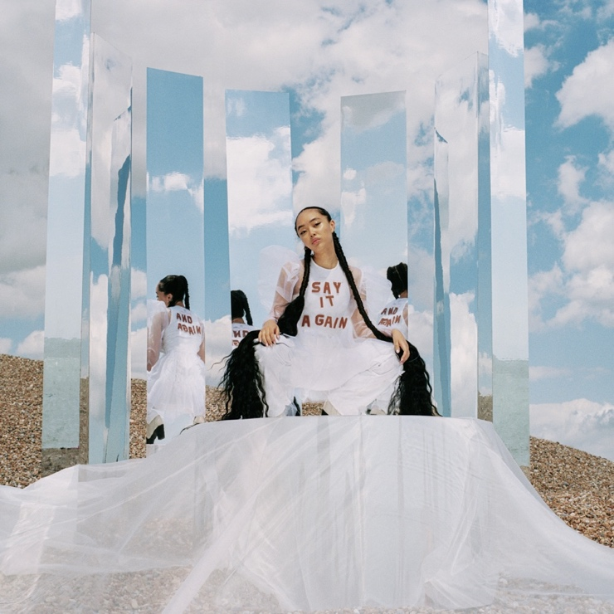
July 31, 2020 (Los Angeles, CA) – 19-year-old UK musical prodigy GRIFF releases her new song “Say It Again,” today via Warner Records. Listen to GRIFF’s latest empowering pop anthem HERE.
“Say It Again” is a deeply honest account of the ups and downs of modern teenage life and is a mantra of solidarity and female friendship. "When I wrote 'Say It Again,’ a lot of my girlfriends were going through mental health issues, and I felt so helpless. So this song is basically my helpless self-trying to reassure a friend who's going through a really difficult time,” explained GRIFF.
“Say It Again” follows the release of the up-tempo breakup anthem “Forgive Myself” in May and February’s beautifully stripped back ballad “Good Stuff,” a personal account about her family fostering children. The songstress graduated high school and released her debut Mirror Talk EP in 2019 which garnered worldwide acclaim and featured stand out tracks “Mirror Talk” and “Paradise.”

GRIFF is a one-woman production, songwriting and visual powerhouse, who on the strength of her early releases is honing future-pop powers and is on her way to becoming a next-generation type of pop star. Born to Chinese and Jamaican parents just outside Watford, United Kingdom, she started making music by borrowing her brother’s Logic; teaching herself how to produce and write songs. GRIFF has the type of curiosity and creativity that draws no boundaries between making beats, sewing her own clothes, or shooting videos and live visuals out of her home studio. Her fearlessness and multi-disciplined approach to creating, coupled with the hopes and fears of any 19 year old, make GRIFF truly special and an artist to watch in 2020.

###
For more information please contact Warner Records Publicity:
National: Darren Baber | Darren.baber@warnerrecords.com

Regional: Bre Flores | Breanne.flores@warnerrecords.com

Follow GRIFF
Press Materials | YouTube | Instagram | Twitter | Facebook

