2021 UK ARTIST TO WATCH GRIFF PREMIERES BRAND NEW SINGLE “BLACK HOLE” - LISTEN HERE
"Multicultural, multi-hyphenated, and multi-talented...four walls can’t confine this utterly unique teenager."
- Vogue
“Move over Dua Lipa, because Griff is well on her way to becoming the next face of British pop.” - Elle UK

"GRIFF is the hottest new artist to come out of the UK since Dua Lipa." - V Mag

“…the hottest thing out of the UK since beans on toast.”- Flaunt

January 19, 2021 (Los Angeles, CA) - Rising 19-year-old UK pop sensation GRIFF who was named “the next face of British pop,” by Elle UK releases her newest pop anthem “Black Hole,” via Warner Records. Listen HERE.

The release of “Black Hole” follows a breakout start to 2021 for Griff, who recently made the top 5 in the BBC’s prestigious Sound of 2021 poll and was also named one to watch by Amazon UK, MTV UK, ELLE UK and more. Griff was also recently hailed by Taylor Swift on social media after posting a cover of the superstar’s song “Exile” with Maisie Peters in December and appeared on Disney’s record-breaking Christmas ad campaign with the beautiful “Love Is A Compass.” The Ivor-nominated sensation also just performed her second ever London show with an incredible livestream takeover of the Tate Modern, watch it here.

An instant dark-pop anthem, “Black Hole” sees Griff head further down the rabbit-hole of modern teenage life in her own, already-distinct style. “I wrote this song as a bittersweet heartbreak track,” says the multi-hyphenated singer, producer, and DIY fashion designer. “I actually love how melodramatic it is, as there’s obviously not ‘a big black hole where my heart used to be,’ but the melodrama of the lyrics – over a really interesting beat – keeps the song fun, and not too serious.”

“Black Hole” confirms Griff’s arrival amongst the big leagues of British Pop. Born to Chinese and Jamaican parents just outside of Watford, England, she began making music by borrowing her brother’s Logic: teaching herself how to produce songs in secret from her classmates (many of whom only found out what Griff was up to when they heard her on the radio whilst she was in high school). Indeed, Griff has the type of curiosity and creative control that draws no boundaries between making beats, designing her own clothes, or shooting a music video on her iPhone during lockdown. While it's easy to forget, Griff's rawly vulnerable lyrics on tracks like “Black Hole” are a vivid reminder of how vast her potential still is. Here are acutely observed tracks on those of teenage friendship (“1,000,000 X Better”), mental health (“Say It Again”), stinging formative breakups (“Forgive Myself”) and the importance of family (see viral ballad “Good Stuff,” and its moving account of Griff’s family fostering kids). In Griff's hands, all these experiences are turned into something uniformly positive, and make her particular model of bedroom pop feel fitting for a legion of young girls to follow. In a pandemic – or a “Black Hole” – Griff’s future shines startlingly bright.

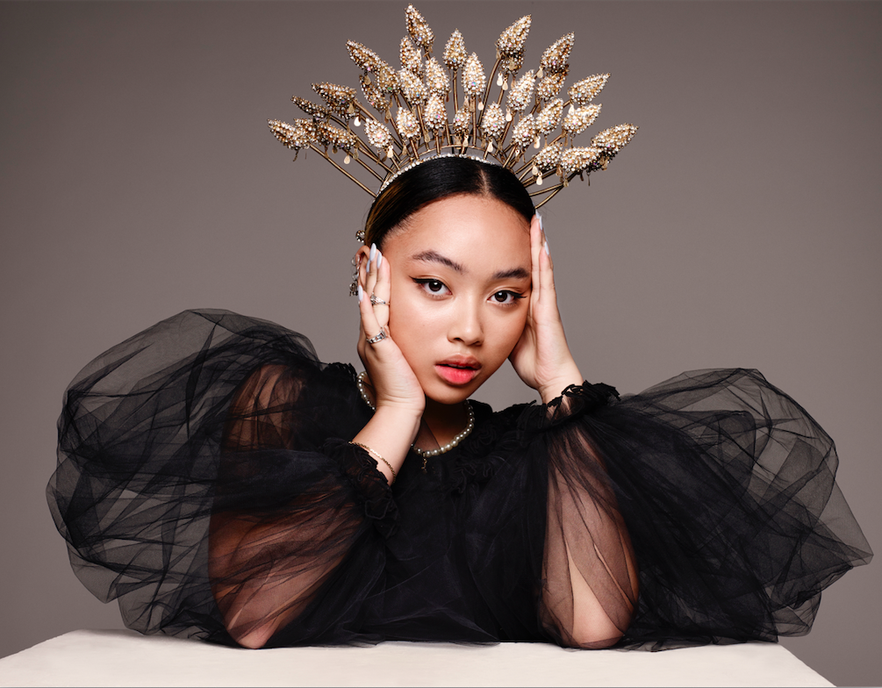
(Photo Credit: Jordan Rossi)

###
For more information please contact Warner Records Publicity:
National: Darren Baber | Darren.baber@warnerrecords.com

Regional: Bre Flores | Breanne.flores@warnerrecords.com

Follow GRIFF
Press Materials | YouTube | Instagram | Twitter | Facebook

