BRIT AWARD ‘RISING STAR’ WINNER GRIFF RELEASES NEW SONG AND VIDEO “ONE FOOT IN FRONT OF THE OTHER” - WATCH HERE
ONE FOOT IN FRONT OF THE OTHER MIXTAPE OUT JUNE 18th
“Griff is Pop’s Next Powerhouse” - Vogue

"GRIFF is the hottest new artist to come out of the UK since Dua Lipa." - V Mag

“…the hottest thing out of the UK since beans on toast.”- Flaunt

May 27th, 2021 (Los Angeles, CA) – Breakout UK star Griff releases brand new song and video “One Foot In Front Of The Other” via Warner Records today. Listen HERE and watch the video HERE. It is the title track from her forthcoming debut mixtape out on June 18th.

The song is an anthemic and vulnerable snapshot about feeling out of control, tackling life’s little things, and ultimately having faith in yourself. The track is brought to life on the mixtape’s iconic artwork, where Griff took tightrope-walking lessons to further represent a mixtape (she says) is all about “that feeling that you could fall at any second.”

The release follows Griff’s historic BRIT Awards debut earlier this month where she performed her current hit “Black Hole” and won the coveted ‘Rising Star’ Award, following in the footsteps of Adele, Sam Smith, Florence and the Machine, Ellie Goulding, Jorja Smith and more. Watch her stunning post-apocalyptic performance HERE.

Born to Chinese and Jamaican parents just outside of Watford, England, Griff began making music by borrowing her brother’s Logic: teaching herself how to produce songs in secret from her classmates, many of whom didn’t find out until she released her 2019 debut EP The Mirror Talk. The singer, songwriter, producer and DIY fashion designer has shown the type of creativity and curiosity that can still flourish even under challenging circumstances. In 2020, during the pandemic, she released multiple singles, collaborated with electronic duo Honne and superstar producer/DJ Zedd, led her voice to the Disney and Make a Wish annual holiday campaign, took over London’s Tate Modern for her first ever livestream, and founded her own popular ‘Against the Clock’ video series. Griff has not slowed down in 2021. She began the year shortlisted for the BBC’s Sound of 2021 poll, she made her TV debut in the U.S. on Late Night With Seth Meyers and in the UK on Later...With Jools Holland, before gracing all new heights at the BRIT Awards ahead of the release of One Foot In Front Of The Other.

Griff continues her road to superstardom with a headline UK tour in October and more to come soon.

One Foot In Front Of The Other is available to preorder HERE, with bundles including personalized + signed vinyl, tape, CD, plus exclusive merch designed by Griff.

One Foot In Front of the Other track listing:
- Black Hole
- One Foot in Front of the Other
- Shade of Yellow
- Heart of Gold
- Remembering My Dreams
- Earl Grey Tea
- Walk

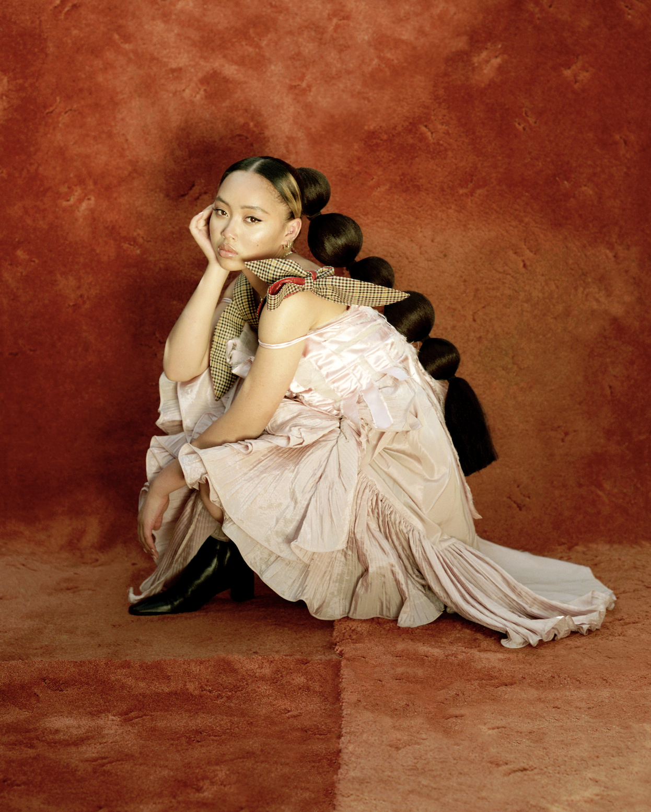
(Photo credit: Zachary Chick)

###
For more information, please contact:
Darren Baber | Darren.baber@warnerrecords.com

Follow GRIFF
Press Materials | YouTube | Instagram | Twitter | Facebook

